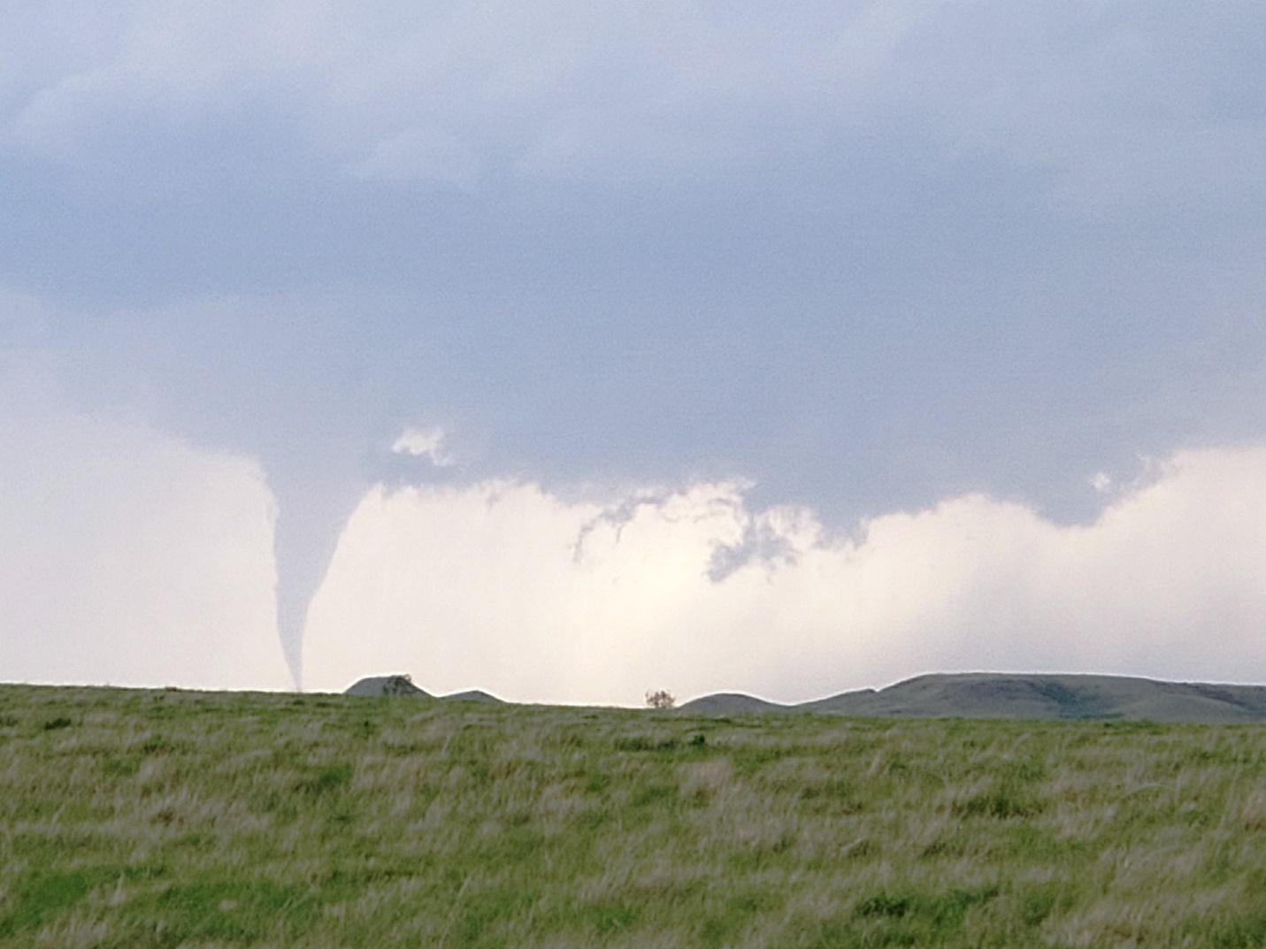

2021
Daily Chase Log
Silver Lining Tours – Tour 6

Day 1: June 6th, 2021
Travel day to get into position to chase. Drove from Denver, CO to Pierre, SD.
Miles for the day were: 521.1.
Day 2: June 7th, 2021
A chase day with low expectations. Starting in Pierre we headed northeast towards the North Dakota line. The forecast was for clusters of thunderstorms to form on the frontal segment northeast of a surface low situated in central South Dakota. The main threat was for strong winds and large hail, but the severe potential and tornado threat were mostly dependent on whether any isolated supercells might form away from the cluster. Knowing it was going to be a late show we meandered north on Rt. 83 and eventually stopped in Herried, SD for ice cream and waited for storms to initiate. After about two hours towers started going up but none looked especially exciting as we waited and waivered as to which to chase. Initially we headed back south towards Selby but the storms we were watching never really got going. Meanwhile to the north, larger towers were going up and decided to target them, heading back through Herried and crossing into North Dakota, then east on Rt. 11 through Ashley and eventually north on Rt. 56.
At this point the storms had already turned into a big cluster and all we could hope for was to get a look at the cells on the south side and hope that we might get a spin up out of an embedded mesocyclone as it went by. We stayed on 56 all the way through Kulm then east to Edgeley. At this point a tornado warning was issued on a cell that was part of the cluster that was passing just to our north, so we headed up 281 through Nortonville, getting to the intersection of Rt. 281 and Rt. 46 just south of Montpelier right as the cell got there. As we got into the heavy rain right next to the rotating area, we observed wrapping rain curtains and with visibility low couldn’t tell if we were in danger of driving right into a tornado, so we had to quickly stop, pull back, and then watch the cell go by.
After we backed off and waited we eventually concluded that we’d never be able to see anything embedded in the cluster so we decided to call it a day and headed back to Kulm and then west on 56. As we headed that way another tornado warning was issued for a new cell at almost the same location as our previous one, and we could see the blocky wall cloud in the distance, but it quickly wrapped up in rain and we had no way to get to it regardless. As we continued on and turned north on Rt. 30 we were treated to a nice mammatus display on the back end of the storms at twilight and stopped to take pictures a couple of times south of Streeter, then proceeded north until we hit I-94 and cruised west to our hotel in Bismarck. Along the way we stopped at a rest area to gas up and got to watch some great lightning on the rear flank of the cluster not too far to our east.
Miles for the day were: 436.6 miles for a total of 957.7 miles.

Day 2: 1630Z Convective Outlook, Tornado Probability, and Storm Report:
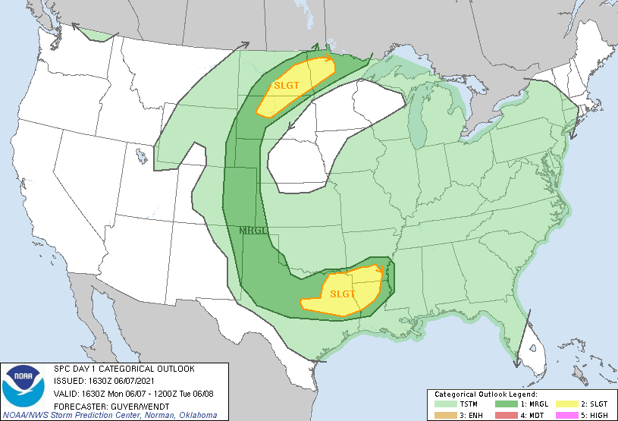
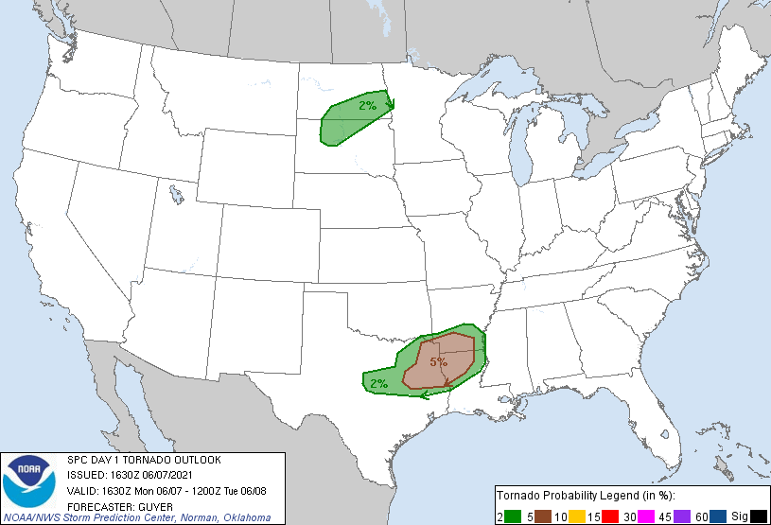
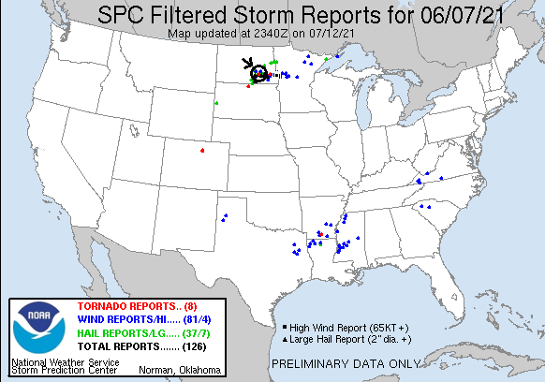
Day 3: June 8th, 2021
Today would be my first day of chasing on Montana in the over 20 years I’ve been at it. A shortwave trough coming over the Rockies was projected to trigger storms in the southern mountains of Montana with initial supercell potential with the possibility of big hail and isolated tornadoes before the storms transitioned to a more wind driven severe event later in the evening.
Starting in Bismarck, ND we headed west all the way into Montana, stopping for lunch in Glendive. Here we were a little split on whether to proceed west into Montana or north towards Sidney as storms were just starting to kick off well off to the west. Eventually we decided to split the difference and headed to Circle. Once we got there, we had cells forming well off to our west, some way up north, and the now some cells back towards Glendive where we’d just left. We hung out at a park on the west side of town but the storms to our west were struggling and after a while we decided to head back towards Glendive to intercepts the storms there.
As we got to Glendive there were a number of cells coming up from the south and crossing I-94. We moved to the north of Glendive up Rt. 16 and stopped and waited. One of the storms developed mid-level funnel just about right over us, but otherwise looked disorganized. The next cell coming up however had a nice smallish blocky wall cloud just off to our east. We were a bit torn about how to chase it as if we went north we wouldn’t be able to get ahead of the storm before it crossed Rt.16. as a result we elected to head east on I-94 and get east of the storm. We passed through a core and ended up stopping about half way to Wibaux to observe a storm just to our northeast with nice striations and an inflow band but it otherwise looked disorganized at the lower levels and was sucking in cold air, and a cell to our west was now looking better so we headed back west on I-94… then, that storm cycled down and another to our east looked better so we turned around again on I-94, this time heading all the way back into North Dakota. Then THAT storm died, and it was back towards Montana again, this time heading through a larger core with some small hail.
Eventually we concluded that the storms where we were would just cycle up and down and interfere with each other and decided to reposition to the north as there was a severe warned storm looking almost anchored near Wolf Point. We took Rt. 16 all the way to Sidney and then on all the way to Culbertson before turning west and stopping about halfway to Brockton, MT. By this time the storms had lined out and we were presented with a long, horizon-to-horizon shelf cloud to our west (and a TON of mosquitos in our faces).
After observing for a bit we raced the incoming line back to Sidney and our hotel. We won, but when the line got there about an hour later the gust front tore through town, shattering the sign of the hotel next to ours, taking tree limbs down, breaking the side windshield of one of our vans that was out trying to rescue some of the guests who’d gone off looking for food, and knocking the power out. The power was STILL out the following morning across most of the town.
Miles for the day were 567.2 for a trip total of 1524.9 miles
Day 3: 1630Z Convective Outlook, Tornado Probability, and Storm Report:
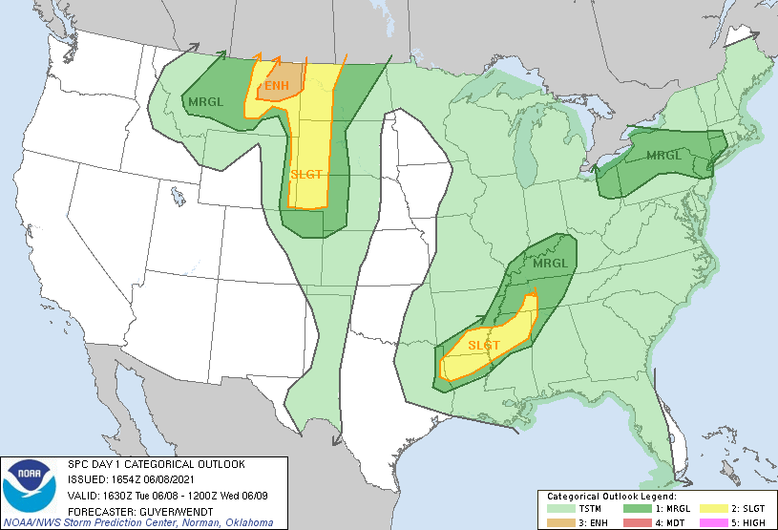
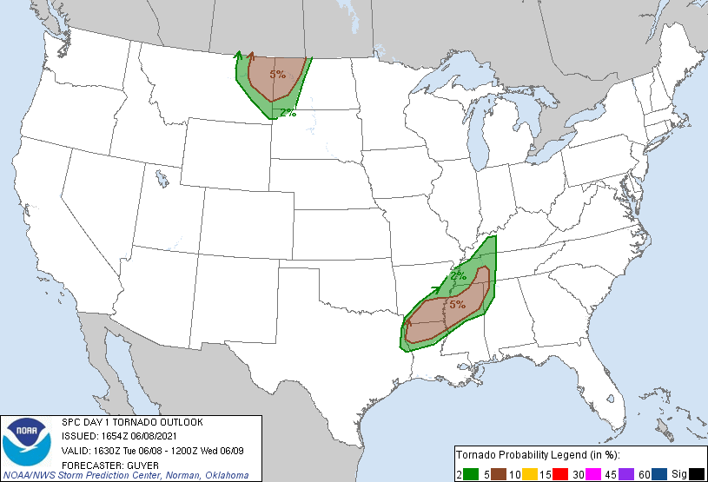
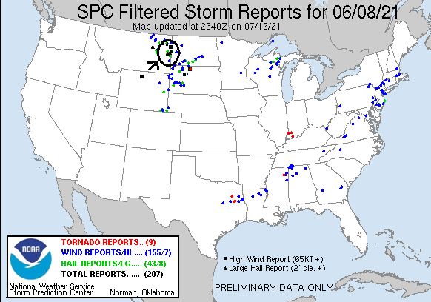
Day 4: June 9th, 2021
Starting in Sidney this was another of those “day before the day” chases. As had been the case throughout the entire trip the death-ridge over the central plains kept us north looking for flow. On this day that flow would be all the way over in central Montana, where scattered thunderstorms were forecast to occur over higher terrain in southwest Montana and then eventually move into north central Montana with supercell potential and a slight chance of isolated tornadoes due to backed surface winds and relatively high shear.
We headed out in the late morning (with the power still out) back up Rt. 16 to Culbertson and then west on Rt. 2 all the way to Havre, stopping for lunch in Glasgow on the way. Since we still had time, we checked into our hotels (there were two, had to split the group). After getting squared away, storms were now firing to our south and we headed east to get in front of them. We went as far as Harlem, then headed south on rt. 66 as our target storm was right off to the southwest. The area around us was almost entirely flat except for Antoine Butte straight to our south. As we headed south, crossing under the anvil precipitation of the storm at the tip of the core, we saw that the storm had developed a nice rain free base that was pretty low to the ground. We made it to Dry Lake and proceeded east on Lodge Pole Rd. (rt. 11), winding through mountain roads on the north side of the butte while the storm passed over Landusky on the south side. Passing through Lodge Pole, we headed southeast on rt. 15 and stopped just short of rt. 191 to observe the storm as it came over the butte. Any semblance of a wall cloud had apparently been disrupted by the butte, but the storm now had flying saucer-like structure and big hail as it closed on us. We let it get close until hail was falling near us then headed northeast on Rt. 191 to stay ahead. Pulling off on an unnamed road just north of Rd. 204, the storm was now a full-blown mothership with fantastic, striated structure and a big hail core. We once again waited until the hail was getting close and then scooted northeast on 191 to unpaved Veseth Road where we again stopped as the storm had become a fantastic rotating barrel heading straight at us. We stopped briefly to take pictures in the mud but even that was too long and soon we were on a mad dash in rain and hail to get out of the mud before we got completely stuck! Doing my best NASCAR driver imitation, we slipped and slid back to the main road, highlighted by driving up a very muddy hill with the tires sliding all over the place. After that excitement, we hightailed it up Rt.191 with the idea of getting back in front of the storm.
We made it all the way to Malta and then a bit up Rt. 2 and had a great distance view of our perfectly structured storm but then the next storm in line, approaching the same butte, went tornado warned and we decided to chase it even though it would be dark by the time we got there. We blasted back down 19 and then back up rt. 15 to almost to Lodge Pole again, turning northeast and stopping on rt. 11 to wait for the storm to come over the butte. As the storm approached in darkness you could see the striations at the mid-level and a weak inflow band but the rest of the storm was obscured by the butte, and soon we were in rain. Being that our position was a bit precarious with the updraft coming over the butte at us and being in the rain and dark, we elected to pull out and started our circuitous trek back to the hotel to avoid the hail core, going around the south side of the butte and then back north on rt. 66 through Landusky, back up to Harlem, and then west to Havre and the hotel.
A fun day’s chase! The structure of that storm was magnificent, best of the tour by far.
Miles for the day were 637.1 for a trip total of 2162 miles.

Day 4: 1630Z Convective Outlook, Tornado Probability, and Storm Report:
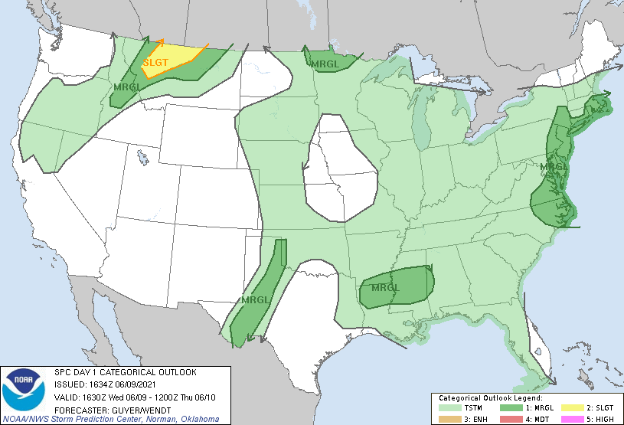
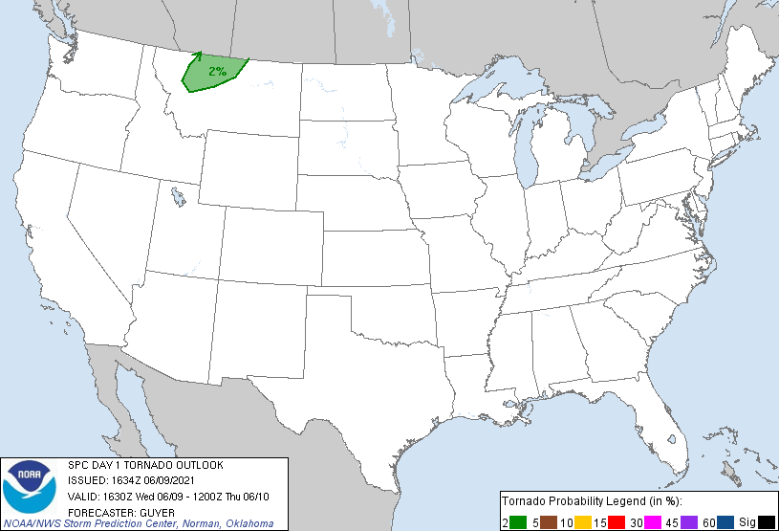
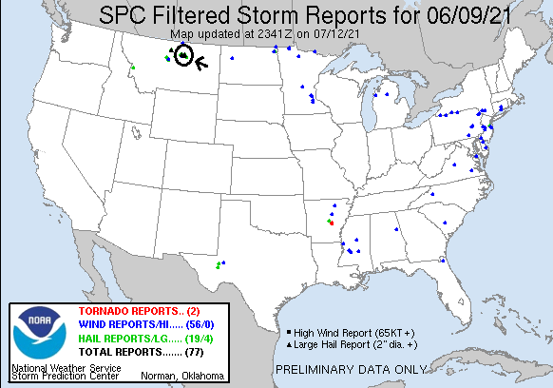

Day 5: June 10th, 2021
A moderate risk day with the threat focused along the ND/MT state line from Sidney, MT up to Canada. The forecast was for thunderstorms to form near a surface low in eastern Montana with abundant moisture and transiting into North Dakota with storm motion being to the north. In the early part of the evening the storms would be supercellular with strong winds, hail, and tornado potential before transitioning into a convective complex with strong winds. MLCAPE of 2000-3000 J/kg was expected. One key would be getting to the storms before they crossed the border into Canada.
We awoke in Havre with a Winter Storm Warning to our west in Glacier National Park and forecast temperatures in the 90’s to our east. We headed east on Rt.2, eventually passing into North Dakota 300 miles later. Stopping for food and fuel in Williston, we could see storms already forming to our west and moved out to intercept. We headed south out of town on Rt. 85 and then West on Rt. 200 all the way back into Montana, through Fairview, and a short distance up Rt. 201 to a ridge where we could watch the storms passing south to north. As we stopped there was a large mammatus field above us and a string of cells trucking north, though none were particularly strong or impressive. It seemed from where we were that the storms were not strengthening until they were almost in Canada, but now there appeared to be a pinch point to our south where one cell after the other was developing so we headed east back into North Dakota on 200, stopping on Cartright Road to have a look south at the precipitation core of our new target storm.
From where we were, we needed to get farther east so we proceeded on Rt. 200 back to Rt. 85 near Alexander and then south down Rt. 68 eventually stopping on 147th Ave, NW to now look straight west at the pinch point. Our target storm right on the initiation point was a nice embedded straited updraft with a big lowering. It eventually started moving off to the north and then another cell popped in the same place. Soon we had two precipitation cores with a rain-free updraft in between and then, tornado!! A nice stove pipe that persisted for several minutes about 5 miles to our west. After that tornado dissipated, we moved west on Rt. 68 to get closer and got a nice view of the next cell with classic supercell structure and a barber pole updraft. As the storm got closer we repositioned east, heading down Rt. 30 to the intersection of Rt. 27 and continuing to watch the mothership close in. Soon, it was a full-blown wedding cake with multiple tiers of striations, a beautiful storm! As the storm closed on us, we moved north on Rt. 27 to stay ahead of it, stopping about halfway to Rt. 85 under another nice mammatus field as the storm came to us.
We had to get out of the way so we headed east to Watford City for a bathroom break, then with another intense cell to our west headed right back over and south on Rt. 37 and in then in the distance, tornado #2! This one as a cone pretty close to the same place the first one had been, barely visible through the precipitation. We pulled in on 22nd street NW and watched it disappear, then headed west down the windy dirt road to find a hill to watch the storms from. We spent a good amount of time there with a bunch of locals watching cells head north, occasionally developing short lived wall clouds.
The storms began to look linear but one cell north of us was getting intense so we headed up back to Rt. 85 and over to Arnegard and a bit north on Rt. 29 to have a look, but the storms didn’t look great and we would have needed to find a way to cross the river, which there wasn’t one, to pursue, so we called it a night and headed to the hotel in Dickinson, ND.
Two tornadoes and a number of nicely structured supercells, a great chase day!
Miles for the day were 539.3 for a trip total of 2701.3 miles.

Day 5: 1630Z Convective Outlook, Tornado Probability, and Storm Report:
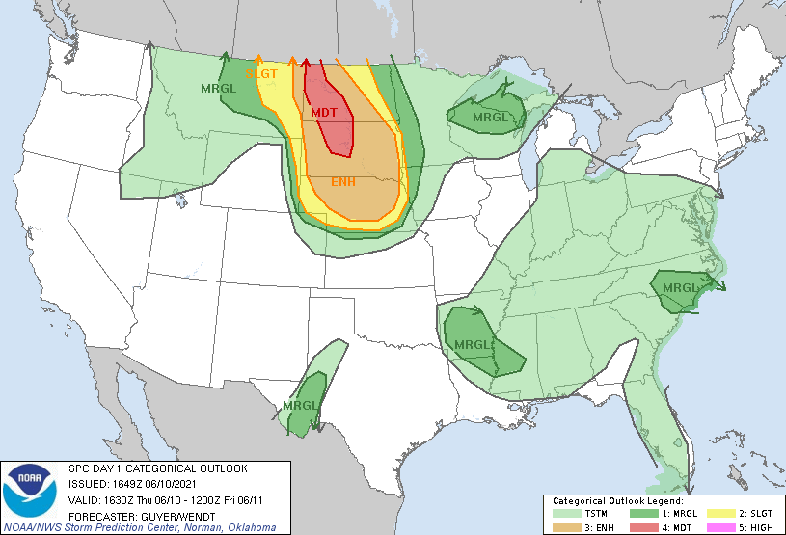
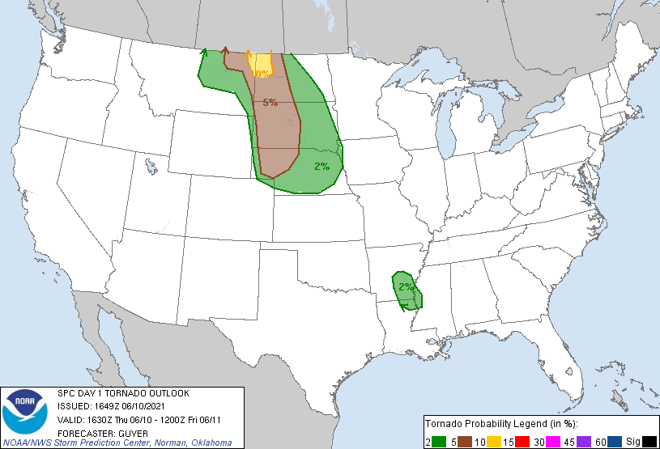
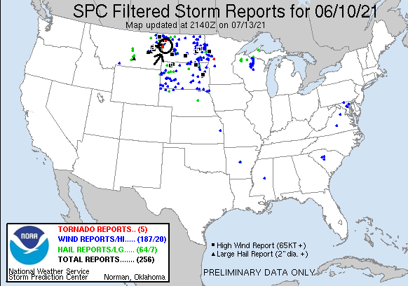
Day 6: June 11th, 2021
Travel day to get back to Denver, CO to finish tour.
Miles for the day were: 625.2 miles for a final trip total of 3326.5 miles.
We called this the Missouri River tour as we seemed to be along the river all tour in 3 states, both Dakotas and Montana. Going into the tour, the pattern looked dismal, with a death ridge over the central plains, so getting 4 chase days and 2 tornadoes was pretty good all things considered! Plus, I got my first two chase days in Montana. If only the tornadoes had been just a little farther west I could have gotten my first Montana tornadoes as well!

