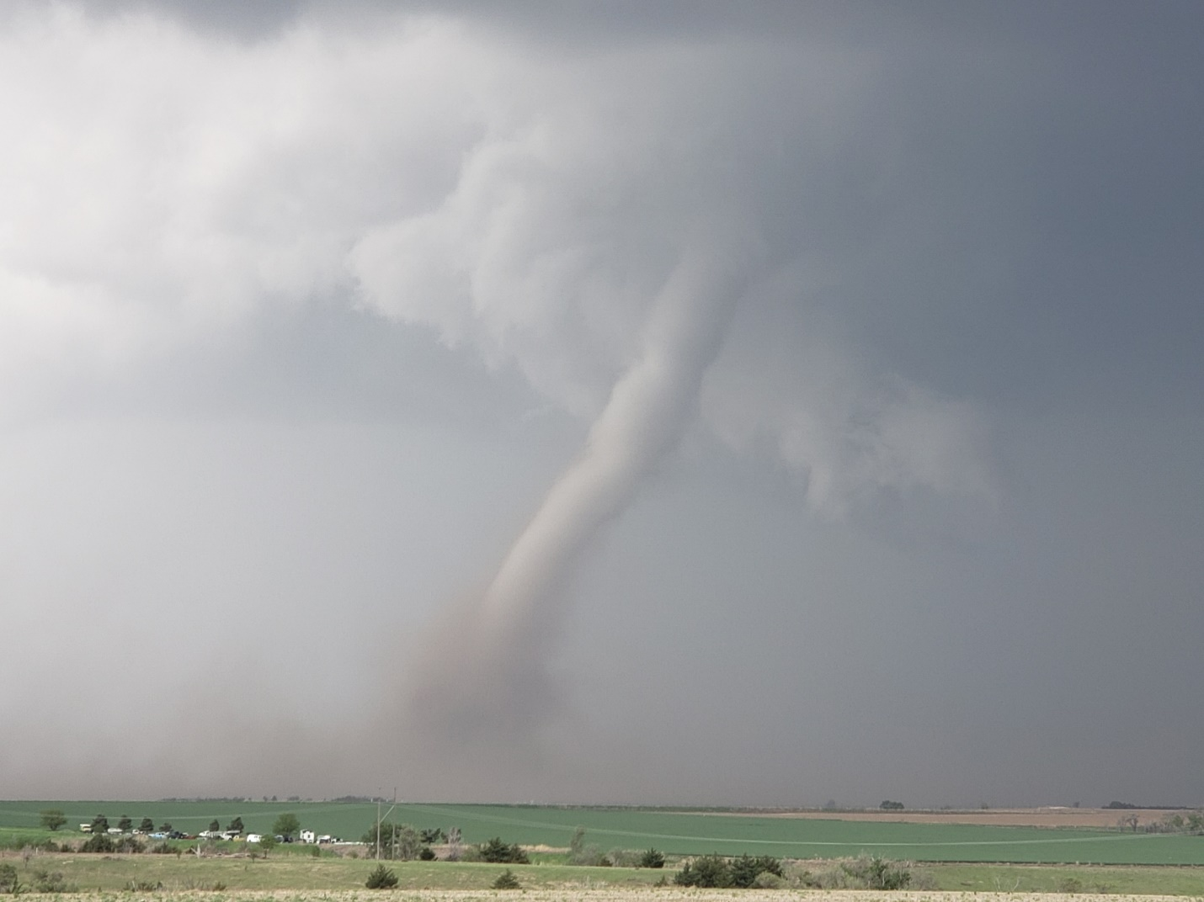

2019
Daily Chase Log
Silver Lining Tours – Prime Time Tour

Day 1: May 14th, 2019
Off day in Oklahoma City. After lunch we went to Bricktown in OKC and walked around for a while, then had dinner at Cattleman’s Steak House.
Miles for the day were: 21.3
Day 2: May 15th, 2019
Off day in Oklahoma City. After lunch Brad gave a forecasting primer to the guests, then I went down to Norman to see a friend I hadn’t seen for years.
Miles for the day were: 59.5 miles for a total of 80.8 miles.
Day 3: May 16th, 2019
A day that looked like not much was going to happen turned into a fun chase day! Starting in Oklahoma City, we targeted a sagging front in Nebraska, knowing that the target area would be where we wanted to be for the upcoming triple point the next day and we had to get up there anyway. With low expectations because of a lack of sheer and modest dewpoints, we traveled all the way from OKC to Ogallala, NE before stopping to decide what to do. When we got there, there was a severe, anchored storm about two hours to the north near Alliance which was the original plan to target, but as the storm was pulsing down and a new group of storms was forming to our south from Julesburg, CO to Imperial, NE, we waited a bit longer and then proceeded straight south toward a storm that was just getting to Imperial. We headed down Rt. 61 through and to the east of Grant and stopped to observe the first storm coming towards us. The results however were not impressive as the storm had very little lightning and nothing else to offer. We continued farther south, about half way to Imperial, and watched the storm to our south get a little more intense, and the storm to our west was showing signs of life as well. As the first storm got to us, we headed back east and out onto the dirt county roads north of Madrid. We stopped again as the storm to our west took over the show, with much more lightning and some motion under the updraft. Soon the rain was encroaching on our position and since we were on a dirt road, we had to run to keep from getting stuck in the mud.
As we stair-stepped north and east trying to get to pavement, we observed a good deal of blowing dust from the gust front and outflow, and later as we made it to pavement and headed up the road north to Paxton, observed a gustnado to our east that looked like it could have been a landspout, but had no visible connection to cloud base or funnel.
Up near Paxton, we stopped and watched the now linear storms come at us and produce a really cool shelf cloud, rolling and roiling towards us. We observed the great structure and intensifying lightning for a about 10 minutes before heading east to get to the tail end of the line, blasting down I-80 until we got to Hershey then heading south on Rt. 56C. Now the shelf cloud had taken on an orange tint and was massively electrified as the whoile line was now severe warned. As the cell directly to our south got closer, the storm intensified and soon had maxed out VIL’s, meaning big hail, coming straight at us. We blasted east just in time, catching a little hail but no damage. We continued east on I-80 all the way to Brady, stopping there to watch lightning in all directions, from little popcorn storms north of us, and the more robust line to out south. After about 15 minutes, we called it a day and made the easy trek to North Platte and the hotel.
Miles for the day were 773.1 for a trip total of 853.9
Day 3: 1630Z Convective Outlook, Tornado Probability, and Storm Report:
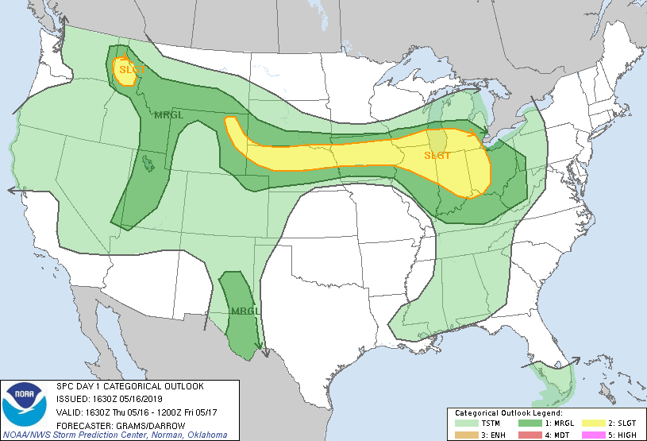
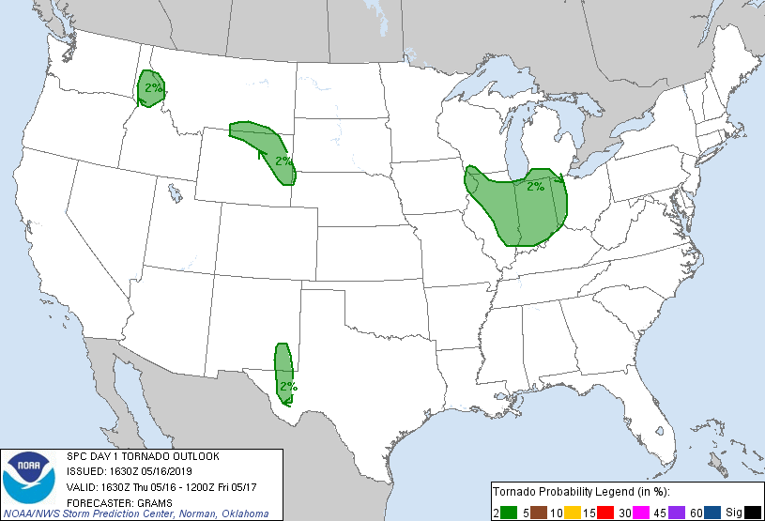
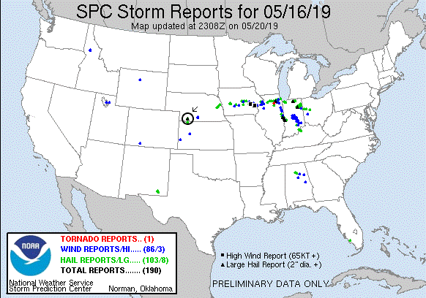
Day 4: May 17th, 2019
A great chase day rewarded by 2 tornadoes (some saw 3) and some adrenaline pumping close encounters! We started the day in North Platte with a general target northeast of the triple point near McCook, NE, with the intent to also keep an eye on storms forming further west along the Nebraska / Colorado border, or potentially needing to drop even further south into Kansas. We initially headed south on Rt. 83 down to McCook, but as storms were already firing west of us, we almost immediately turned around and headed back up to Wellfleet, west on Rt. 20 to Wallace, and then south on Rt. 25. We then stopped about 10 miles south of Wallace to consider our options: there were robust storms to the west coming off the Cheyenne Ridge, but we were concerned they would be high based. Meanwhile to our south there was a storm coming up from Goodland, KS struggling in bad air, but quickly moving into a far better environment. We ultimately decided to target that storm and headed south.
We proceeded down through Hayes Center, then east on Rt. 6 and south at Culbertson onto Rt. 17. As we closed on the Kansas border, the rock-hard eastern wall of the updraft of our rapidly intensifying storm became visible and we knew we’d made the correct choice of storms. We ended up stopping about 2.5 miles from the Kansas border just north of Rt. 704 and could see scud rising into the base of our storm, but as yet it was still fairly disorganized. We stayed with the storm moving back up Rt. 17 and turning off on Rt. 710 to stop and observe again. At this point the storm had a much more defined wall cloud and produced two decent funnels and showed intensifying rotation as the storm got close to us. The storm began to get the look that it could tornado at any time, but soon we were forced to move or risk being cut off by the hail core packing 2-3” hail, so we scooted north to stay ahead. We headed back up 17 and then east on Rt. 713 which unfortunately was dirt, watching behind us as the wall cloud showed more and more rotation. With the storm moving quickly northeast, we blasted east on the dirt road and then north on road 384 and thankfully back onto the pavement into McCook.
As we got to McCook, the tornado sirens were blaring and we decided to head north for a mile or two on Rt. 83 out of town to get a look before heading east. As soon as we turned north, we spotted a large dirt plume, RFD, and then north of that another… with a large funnel extending downward. Tornado! We quickly turned into a nice, empty parking lot near Heritage Hills Golf Course with a clear view to the west and observed the large tilted “Wizard of Oz” tornado churning up dirt about 3 miles west of town. The big white tornado moved northward with a large, dirty debris fan for several minutes, then roped out with a large kink and elongated funnel that stayed in one spot churning as the funnel stretched more and more northward before finally dissipating. We knew the storm was not done yet but now had some catching up to do so we beat feet east!
We now had considerable maneuvering to do in the very poor road network of southwest Nebraska and it would be nearly an hour before we were back in position. We blasted east on Rt. 6 almost all the way to Cambridge, temporarily losing our view of the wall cloud, then turned north on the paved Rt. 73A. We eventually intersected with Rt. 18 to head east…. Only to find that it was not paved!! This slowed our progress dramatically. We slugged our way east about 3.5 miles before turning north onto another dirt road heading towards Eustis. Around this time as we were about 5.5 miles SW of town, we were seeing more tornado reports and heard word of a dusty cone tornado in progress. Our view to the west, when we could see going up and down through little ravines, was of the old meso deteriorating and the new one with a large amount of dirt flying but no clear view of the tornado if it was still there (some guests said they could see it, and later I did see a picture one had taken that made it pretty clear. I did not). Continuing onwards, we descended into a gully, only to hear of another tornado in progress! We quickly turned up a side road and saw an elephant trunk tornado in the distance in the process of roping out for tornado #2 of the day! It only persisted for a minute or two then we were back to our trek in the dirt.
We finally made it to Eustis and back on pavement and quickly blasted west right towards the meso and met it just as it crossed Rt. 23 near Farnam. The wall cloud was spinning like crazy and it appeared that the storm might drop a tornado right in front of it but it never quite focused. We waited until the meso started to fade from view and then blasted east again to keep up. Later, there were several tornado reports from Farnam as the storm must have tornadoed right after it got out of our sight.
We passed through Eustis again and north on Rt. 21 with the wall cloud just to our west churning away. About 15 minutes past as we blasted up towards Cozad, racing the hook echo to town to prevent getting cut off. As we closed on the Interstate and a safe path east, the mesocyclone was quickly closing on our position and soon was almost right over us. In fact, from van 2 I was yelling over the radio that a satellite area of rotation appeared to literally be right over the lead van. The storm just beat us to the highway and soon we were punching the hook from the south with a big block wall cloud just to our northwest and crazy rising motion all around out. As we got to I-80 and started heading east, we were blasted by strong RFD winds that threatened to blow the van right off the left side of the highway with the wall cloud churning seemingly right outside the driver’s side window!
After that adrenaline moment, we headed east down I-80 (and later, there were more tornado reports in Cozad where we’d just had the close encounter) and got off again at road 428, blasting north right back at the mesocyclone we’d just left. We caught up again about 5 miles north of the highway and were once again in the bear’s cage right under the meso, with a huge plume of RFD dirt rising almost surreally to our east, and the wall cloud immediately to our northwest. Suddenly a huge gustnado blew up right to the left of the vans, immediately causing several guests to scream “Tornado!!” I could see the rotating plume of dirt, but not the cloud base, so I could not confirm myself but others could see that there was no connection to cloud base nor was there a funnel, so it was confirmed as a gustnado, not tornado. Still, some anxious, exciting moments! Ultimately, after heading east on road 761 to continue stair-stepping, we stopped the chase about 10 miles from the highway as the mesocyclone was getting away from us and there was no way to keep up with the road network north of the highway. Passing through Lexington back onto the highway, we were less than an hour from our hotel in Kearney and got there early enough to celebrate with a good meal and a beer at Old Chicago.
A really fun chase day! Two tornadoes, maybe 3, and a couple of very up-close moments under the mesocyclone. A pretty solid chase considering the road network. With better roads, I’m certain we could have gotten 4 or 5 tornadoes from the storm.
Miles for the day were 389.2 for a trip total of 1243.1
Day 4: 1630Z Convective Outlook, Tornado Probability, Storm Report, and McCook tornado damage summary:
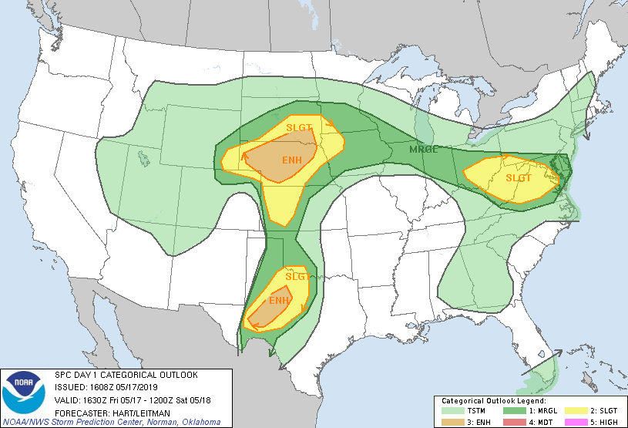
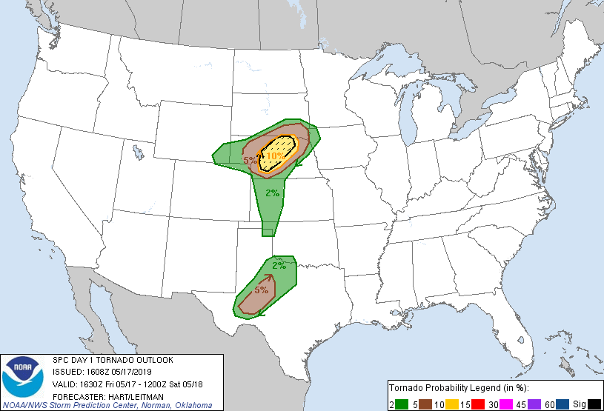
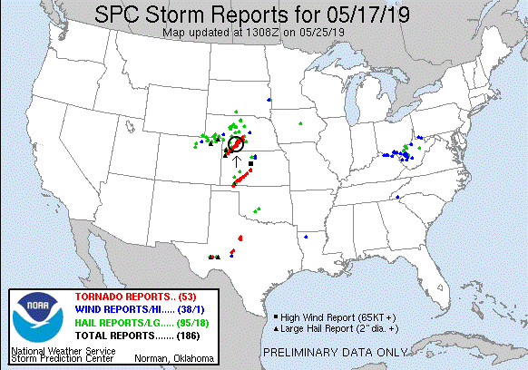
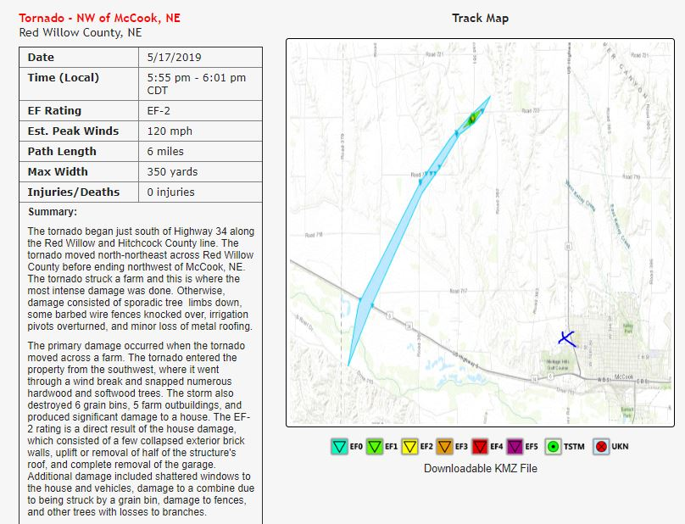
Day 5: May 18th, 2019
A long and frustrating chase day. With the system from the previous night still clearing out of the central plains, the trick was going to be to find some return instability behind the front. We ended up targeting the Woodward OK area hoping to find an outflow boundary intersecting with the dry line to give us a wind field we could work with. Heading out of Kearney, NE, we progressed straight south, stopping in Hays, KS for lunch, then continuing all the way down to Woodward before stopping again. After waiting for a bit in Woodward to see what developed, we decided to head briefly NW out of town on Rt. 412 to watch development on the dry line. We stopped a few miles out of town to assess the situation: We were right under a developing mesolow with the wind field reacting such that it was rotating around us, and storms were in every direction but overhead, creating a stadium effect. To the west and southwest, highly elevated storms on the dry line with a westerly surface wind. To the northwest there were legit storms, albeit in a cluster, along the boundary that draped WNW to ESE near Meade, KS, and to the east more high-based storms along a line in air that appeared to still be cold and stable from the previous day’s activity. After some time, we elected to go north to decide whether to go after the Meade storms or the eastern line. We proceeded back up Rt. 34 to the junction with Rt. 64 and then east towards storms near Alva, OK, keeping the Meade storms in mind. As we approached Tegarden it was pretty clear the storms to our east were a mess, so we abandoned ship on that option, turned around, and headed for Buffalo, OK to intercept the Meade storms which seemed to have the most remaining potential and were moving down the boundary as we’d hoped.
We made it all the way to Buffalo and stopped again to wait as the storm still didn’t look great to our northwest. We prepared to head further west, but then the storm burped out a bunch of cold air, producing a long arcus cloud racing away from the storm, and signaling that the show was over for that storm. Meanwhile, the stuff to the east was somehow still persisting and in fact was severe in a few places. So, we elected to blast back east for one last chance and also to make progress towards the hotel in Oklahoma City. We retraced our steps back through Tegarden as the segment in front of us had a number of hail reports and a couple of dubious mid-level funnel reports, then turned south on Rt. 281 to try and get around our target storm from the south. We proceeded through Waynoka as the storm still hadn’t cleared the road to the east. From our vantage heading down you could see the big arcus cloud emanating from the Meade storm now spanning a large part of the western horizon. We turned east on Rt. 412, and as we approached Orienta the storm produced a robust shear funnel at mid-levels that persisted for a few minutes. But the storm was also clearly weakening so we gave up and headed south at Orienta, stopping briefly south of town on Rt. 60 to photograph the colorful sunset.
Low expectations for the day ultimately panned out that way, with not much to show for our efforts.
Miles for the day were 637.2 for a trip total of 1880.3
Day 5: 1630Z Convective Outlook, Tornado Probability, and Storm Report:
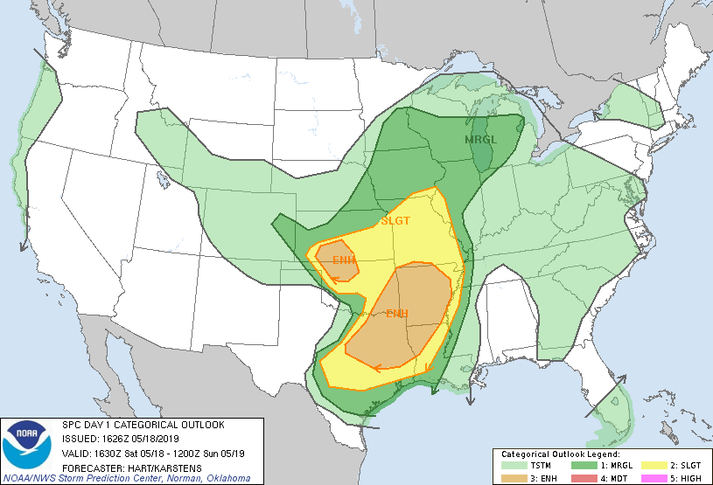
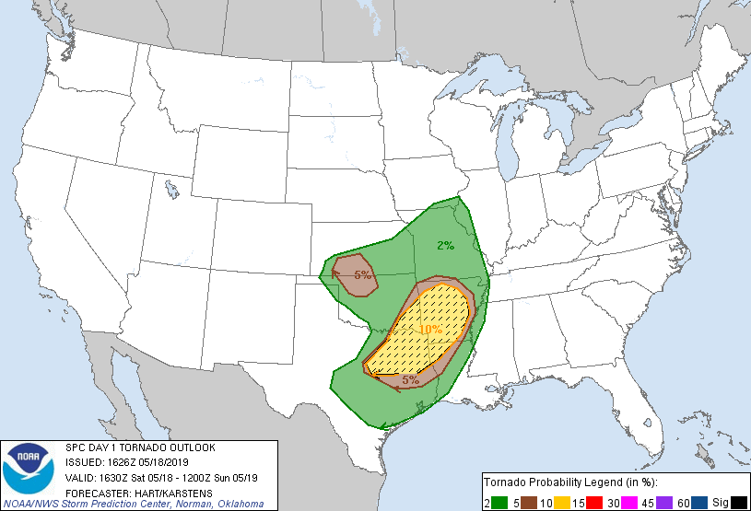
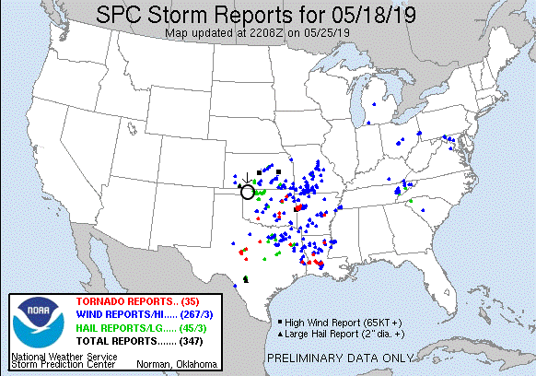
Day 6: May 19th, 2019
Off day spent hanging around the hotel and outlet malls in Oklahoma City, OK.
Miles for the day were 14.8 for a trip total of 1895.1
Day 7: May 20th, 2019
A high-risk day for the eastern Texas Panhandle and western Oklahoma! Forecast conditions for this day: dew points in the 70’s, CAPE in the 3000-5000 J/kg range, and strong shear had tornadoes written all over it, at least as long as the storms could remain isolated. That was the main concern as the day also came with a weak capping inversion, meaning the storms might not remain isolated for long. The forecast and target area also suggested that the chaser hordes would be out in force. Our plan was to head southwest out of Oklahoma City and play with the initial storms in the warm sector first before they congealed into a line, then head further southwest to the dry line where we expected the biggest, meanest storms to be later on. The hope was also that most of the hordes would stick with the warm front storms as they put OKC under the gun toward evening. It was an ominous forecast: Some schools in the OKC area were closed in anticipation of a major severe weather event.
We departed OKC and headed southwest to Lawton, then west through Altus, heading for our target Childress, TX where we would stop and adjust accordingly. At Altus AFB, they were getting ready, with all the big military planes on the taxi line revved up and ready to get out of harm’s way. Arriving in Childress, the chaser hordes were already there, and we hung out for some time at a Pilot in town with dozens of other chasers waiting for the warm sector to initiate.
After waiting almost two hours in Childress, storms began firing and soon our attention was drawn to a storm heading up from the southwest towards Paducah, so we headed south on Rt. 62 to intercept. But, as we got close to town just minutes ahead of the rotating area of the storm, we ran into construction and were stopped in our tracks waiting for a lead car to return and take us into town. Seeing that we were not go going to beat the storm into town and get to our east option to stay with the storm because of the construction, we headed east on FTM 314 through the mud then south on FTM 301 trying to get back to pavement.
As we got to the junction of the paved FTM 2876, we could observe the wall cloud of our storm just to the west, and soon, tornado! The storm produced a slender elephant trunk tornado hanging off the back of the wall cloud, fully condensed to the ground. The tornado lasted about 7 minutes before roping out into a long-arced needle funnel.
We headed northeast on FTM 2876 and FTM 104 to stay with the storm, which looked to by cycling to our west. After some maneuvering through Kirkland about 30 minutes later, we head briefly west on Rt. 287 and pulled off in the mud near some railroad tracks as the old occluded mesocyclone passed by, and waiting for the new meso to catch back up to us. Once the precipitation core cleared and the mesocyclone passed it was clear the storm had turn HP, but still had a rock-solid updraft as it passed us by.
As the storm passed just to our west, we were faced with a decision: Follow the storm northeast and cross the river back into Oklahoma and thus give up the dry line play, or let the storm go and head back west to set up for the dry line storms that were already firing. We chose the latter and later found out that our storm had produced a strong tornado near Mangum, OK a bit later. Apparently however the chase had been hindered by an enormous line of chase vehicle traffic, so it is unclear if we could have actually gotten to it. We headed back into Childress and stopped back at the same Pilot gas station and waited again, passing through flash-flooded roads caused by the front-flank precipitation core of our previous target storm as it passed through.
After a fairly short pause in Childress, we had a number of cells to choose from as the dryline was now firing, but unfortunately the worst-case scenario was developing: With no cap, too many storms were initiating and they were all interfering with each other and starting to line out. Examining the storms coming towards us we elected to target a storm showing rotation and still somewhat isolated to our northwest heading for Estelline. We headed through Estelline and west out of town a few miles on Rt. 86, but the storm was a big HP mess, burping out a big shelf cloud as it approached from our west.
At this point, things were looking grim for our chase as the storms were becoming more or less a solid line. Close to giving up, we targeted an HP supercell that was embedded in the line coming up from the south. We passed through Childress again, then Paducah on Rt. 83, and headed west on FM 193 to get towards the inflow notch and area of rotation. Passing through Dumont, we continued a few miles further before determining that the storm was right turning and threatening to cut us off. We blasted back east then south towards Guthrie, passing the area of rotation to our west just north of town. Parked along Rt. 83, it was clear there was a tornado embedded in the big core to our west as the sirens went off in town, but there was no way we were ever going to see it so we had to continue south to get out of the way. We made it as far south as FM 448, waiting for the last storm in the line to meet us, but by the time it got to us it had weakened greatly. After waiting and throwing the football around for a while, we gave up and headed east on Rt. 82 and Rt. 277 to our hotel in Wichita Falls, TX for the evening.
The excitement wasn’t <quite> over yet though since as we settled into our rooms there were not one but two tornadic supercells heading almost directly for the hotel about 2 hours away. But after keeping an eye on them for a while it became clear that they would pass north of town and it was off to bed to get ready for the next day. Somewhat of a High risk bust, though there were tornadic storms chugging away through the night keeping just about the whole state of Oklahoma on alert.
Miles for the day were 558.7 for a trip total of 2453.8

Day 7: 1630Z Convective Outlook, Tornado Probability, and Storm Report:
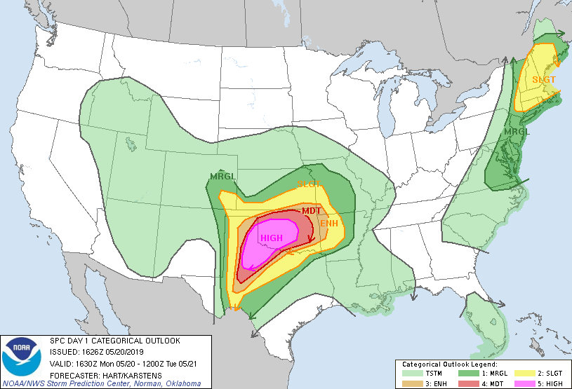
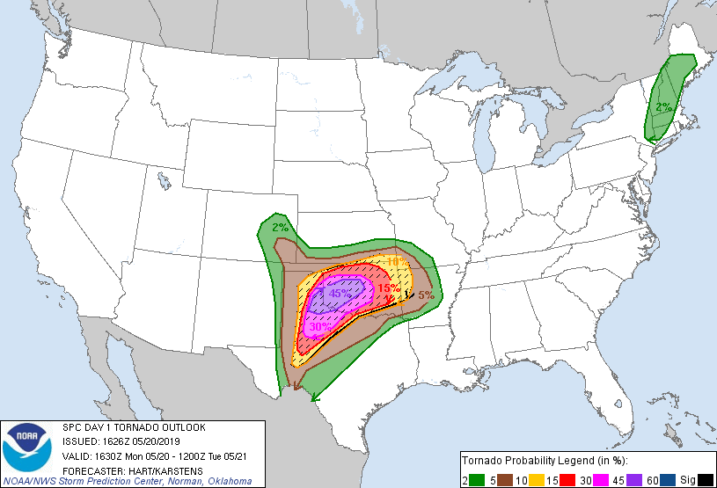
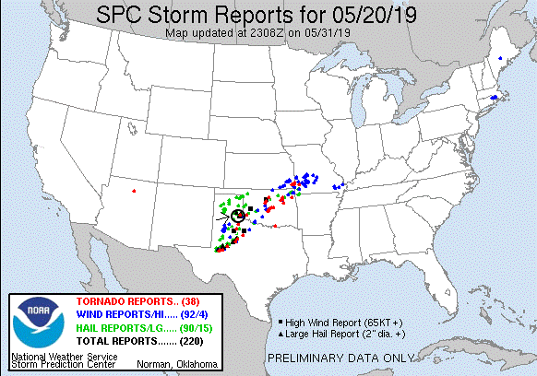
Day 8: May 21st, 2019
A long and somewhat frustrating chase day. The play this day was cold-core, low-topped supercells forming in the residual instability behind the line of storms still churning eastward from the previous day and night’s storms. We headed for central Kansas looking to position ourselves to the northeast of the low moving northeasterly through Kansas towards Nebraska where the winds would be more backed, and secondarily the boundary out in front of it.
We headed north up I-44 through Oklahoma City and then North on I-35 into Kansas, stopping in Park City for lunch. Storms were already forming northeast of the low but we waited for a bit to see if the boundary to our west, where we expected better shear and thus better storms, to form. Finally, we had the storms north of us on the northeast side of the low and storms firing on the boundary to our northwest so we blasted north on I-135. We immediately realized we might have waited too long and that the storm to our northeast might already be out of play. Passing through Newton we were already at a decision point: try to catch the storm blasting off to the northeast of us that looked to be in better conditions, or head to the boundary storms to our west that looked almost as good and were easier to intercept. These storms were not your typical supercell but instead were of the low-topped variety: cloud tops in the 30,000-foot range and little or no anvils. Also worth noting was the amazing amount of flooding in this part of Kansas: The spillways in Wichita, which I’ve always seen bone dry, were completely full, and the fields to the sides of the interstate were fully inundated with water, with exits closed and standing water across the ramps.
As we reached McPherson, the storm to our east looked the best as was soon tornado warned. But, as it was moving more than 40 miles per hour away from us, it would have been almost impossible to catch. Not surprisingly based on how the storm looked, it was soon tornado warned and went on to produce several tornadoes to our northeast. Also, at this time the boundary storm to our west was cycling up considerably, and with additional storms along the boundary strengthening and coming our way we targeted the storm straight to our west and exited the highway at Bridgeport, heading southwest, then west on Rt. 4 through Lindsborg. As we cleared Bridgeport, we got a better view of our target storm: it had nice low-topped structure and a distinct lowering under the base, with scud rising and attaching to the lowering. Again, all of the fields were under water, so we knew that county roads were going to be out of play. Proceeding west through Lindsborg, we had a clear view of the updraft and the storm had a large, scuddy wall cloud, but it was not showing any signs of rotation at all. We continued west as the storm headed north and pulsed down. With that storm weakening we stopped west of Marquette and waited for the next storm along the boundary to come north to us.
We remained at our stop for about 30 minutes, watching one storm pass well west of us. As the storm we were waiting for moved up from the north, it didn’t look terribly impressive and was very high based. Meanwhile the storms to our northeast had produced 2-3 tornadoes. We decided to get back to the interstate and head north to keep the boundary storms in play as they strengthened, and to give ourselves some chance of catching the storms to the northeast if we had to make a mad dash for them.
About 20 minutes later we were blasting up I-135 towards Salina. At this point the storms to the northeast were clearly the best and still producing tornadoes so we decided to head east and north and see if we could catch them. First though we had to pass through the hail swath of a storm just to our north, and got to it just as we turned east on I-70. There were copious amounts of small hail on the highway, making the going very slippery, and we observed a pickup truck that had gone off the shoulder and ended up down in an inundated field just a moment earlier. Cruising east the fields just to our south looked like a lake, complete with wave action from the outflow winds of the storms.
We continued east and then got off the highway at Junction City, heading north on Rt. 77 through Milford and toward Bala, then east on Rt. 24 through Riley and north on Rt. 77 towards Randolph. However, the storms were moving more than 40 miles per hour away from us and heading northeast, forcing us to stairstep and struggle to make up ground.
Eventually it was obvious that we could not catch the storms as they blasted to the north and northeast so we called it a night, turned around, and headed for dinner and the hotel in Salina, KS. A frustrating chase day but still interesting to see some different storm types for a change.
Miles for the day were 618.4 for a trip total of 3072.2

Day 8: 1630Z Convective Outlook, Tornado Probability, and Storm Report:
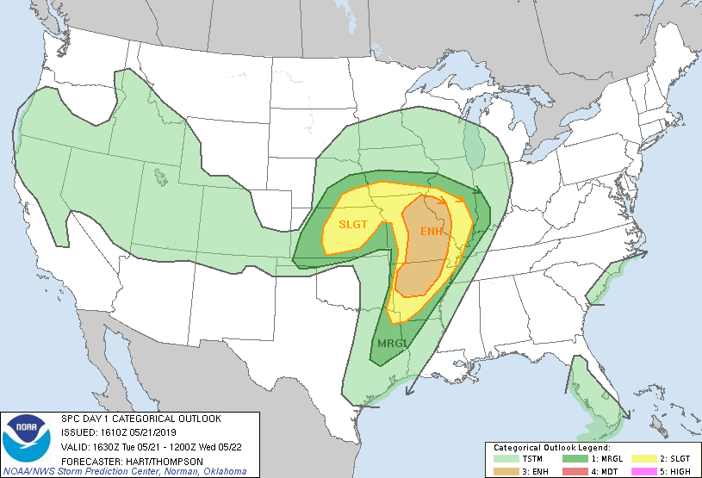
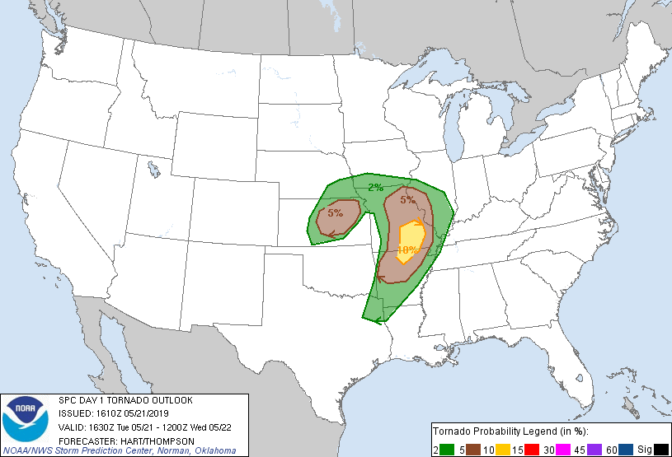
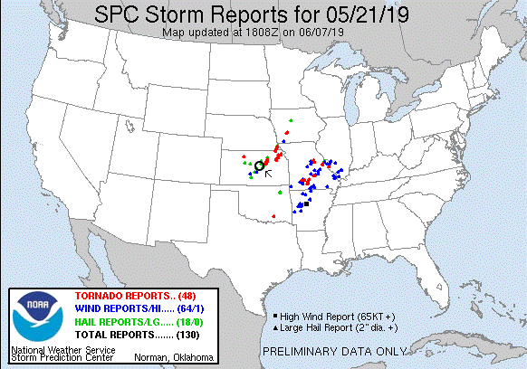
Day 9: May 22nd, 2019
Yet another day with big possibilities as moisture poured into Oklahoma with 70-degree dewpoints along a frontal boundary stretching from about Wichita Falls, TX to Joplin, MO and beyond. The models put the best sheer profiles in the area of Tulsa, OK so we started making our way down there from Salina, KS, intending to stop in Bartlesville, OK.
We proceeded down south of Wichita on I-135, stopping for a rest break just north of the Oklahoma border. Once there, analyzing the road flooding situation on the Oklahoma DPW website, we realized we had a problem: there was no way to get to Bartlesville from where we were as all of the roads were flooded out! Because of that we adjusted our target to Tulsa and continued south, and then east on Rt. 412 all the way to Tulsa where we stopped for lunch and waited for storms to initiate.
We stayed in Tulsa for about an hour and a half as storms began to initiate to our south and grow in intensity. Soon there were multiple severe storms to our south showing signs of rotation and we headed south to intercept. We headed south on Rt. 75 intending to get to Beggs and wait for our target storm to come to us, but as we closed in the storm went tornado warned and there were tornado sightings so we sped down to Okmulgee with a west option that would allow us to drive right up to the updraft. We made it through Okmulgee and headed west on Rt. 56 into the woods around Okmulgee Lake in heavy rain as we skirted the front-flank core. As we blasted west past Nuyaka and got around the precipitation core, the big, beefy updraft became visible and it was clear we were going to meet it right on the road to our west. After the road made a dogleg south, we turned west again and were driving right towards the ground scraping wall cloud just to our west. As we closed further, in the distance through the woods a dark mass crossed the road about 2 miles west of us. Tornado! We drove right up to where it had crossed the road and there it was in the woods just north of us, a multi-vortex tornado slowly meandering away to the north, shifting from multi-vortex with tendrils skipping along the ground to a brief cone with more complete condensation. We observed the tornado for about 5 minutes and then decided we needed to get east and north to keep up. We blasted east then north up Dentonville Rd. towards Nuyaka, with the wall cloud to our northwest. But we were running out of road and not closing the distance much, when it became clear that the next storm to our south behind this one was interfering with our target storm and also taking over the show. We broke off and turned back south to Rt. 56.
When we got to Rt. 56 and turned east, it became clear that we had to get east to Okmulgee in a hurry because the meso-cyclone of our new, tornado-warned target was going to get there at just about the same time we were! I did some quick calculations as the lead van had lost radar and decided we would make it with just a few minutes to spare. We flew east in the rain and when we got to the outskirts of Okmulgee, we navigated around the perimeter of town by heading south on S. Madison Avenue, then East on E0970 road and finally turning south on Rt. 62. Almost immediately upon making the turn south, the road went up a hill providing a good vantage point, and off to our west was a large cone tornado traveling through the woods. Tornado #2! about 30 minutes after the first one on the previous storm. This one had formed on the occluded meso of our new target storm and as we watched it to our northwest, the new meso to our southwest looked like it might tornado at any time as well, and soon produced a big funnel as the cone tornado faded off into the rain to our north.
We had to get back north to prevent ourselves getting cut off by the storm so we turned around again, going north, then east out of Okmulgee on Rt. 62 towards Morris with the meso coming right up behind us. Just west of Morris we pulled over and observed as the rapidly rotating wall cloud crossed the road only a mile or so behind us. As it crossed the road several brief suction vortices appeared skirting across the ground towards cloud base, tornado #3! After this brief tornado lifted, we headed into Morris and then north on Rt. 52 and drove right up to the mesocyclone as it headed north-northeast right in front of is. It had clearly lost some focus though and a new tornado was not yet imminent so we followed north, then turned east briefly on E0940 Road to get a view, but saw that he wall cloud was disorganized, so we got back on Rt. 52 north then turned east on Rt.16 as we continued stair-stepping.
The storm was moving rapidly away from us to the northeast as we reached the junction of Rt. 16 and Rt. 64 and off to the northeast we saw a white elephant trunk tornado in the distance. Tornado #4 of the day! This one was pretty far distant though and moving away. We continued east into Muskogee and north on Rt. 69 but it was clear we weren’t going to catch the storm.
Being behind the storms without much opportunity to catch up and having had our fill, we called off the chase and turned south back to I-40, keeping an eye on storms to the south of OKC in case they should become worth chasing. They never did, though a severe storm did hover about an hour west of our hotel most of the night. We eventually ended the chase and headed to OKC to spend the night.
Miles for the day were 555.1 for a trip total of 3627.3

Day 9: 1630Z Convective Outlook, Tornado Probability, and Storm Report:
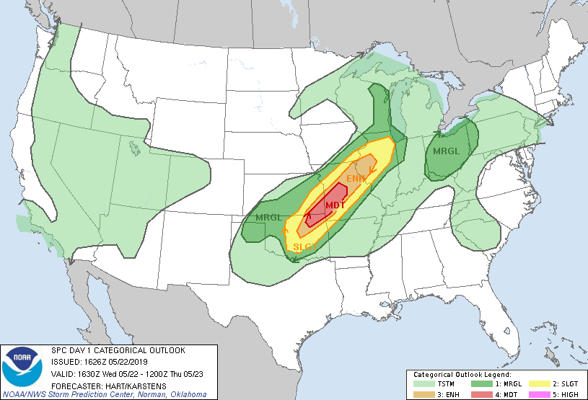
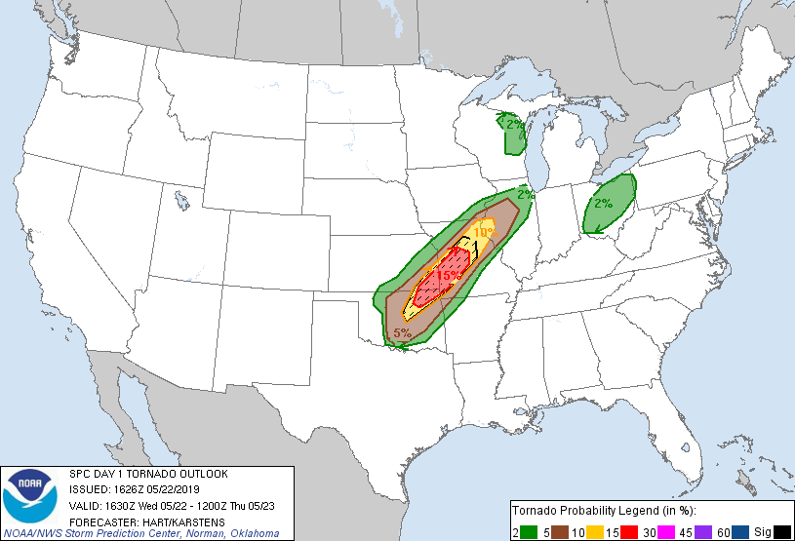
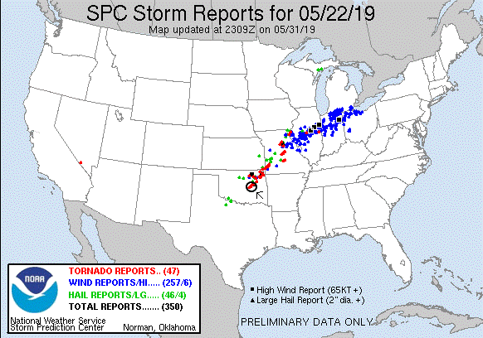
Day 10: May 23rd, 2019
Another somewhat frustrating day trying to catch up to storms and getting to the right places but at the wrong times while the storms cycled. It was also another day with big potential resulting in a Moderate threat over the Texas Panhandle and northwest Oklahoma as a sharp frontal boundary passed through the region and eventually stalled, resulting in a forecast for warm sector storms first, and later more beefy supercells down the dry line near Lubbock, TX.
We departed Oklahoma City and headed for Amarillo in cold, foggy conditions which persisted well into Texas as we headed west on I-40 and were still in the soup when we stopped for a break at the big rest area near Alan Reed. Proceeding into Amarillo we crossed the front and found ourselves suddenly in 80+ degree F temperatures. The problem was that the front which was supposed to have stalled, had not, and was still racing eastward. Waiting to see where and if it finally slowed, we paused for lunch. Fortunately, it did stall shortly thereafter, the frontal boundary ranging from about 20 miles east of us northeast towards Woodward, OK. Soon storms were forming along the boundary and traveling along the edge, and we elected to target one coming through Claude just to our east, while keeping an eye to our South for stronger storms forming on the dry line.
We headed northeast from Amarillo through Panhandle then north out of Pampa on Rt. 70. Storms were now firing along the dryline west of us and we shifted our focus to those, and soon there was a tornado-warned storm coming up towards us from Skellytown. We crossed the Canadian River and headed west on the dirt North River Road for several miles, getting right to the edge of the precipitation core to where the mesocyclone was going to pass just to our west. It was hard to see cloud features in the murk: the storms unfortunately were interfering with each other and already we had a line of cells to deal with rather than isolated storms. We waited for about 20 minutes for the updraft to get to us, and when it did there was a well-defined lowering rotating hard, but it was unable to focus and soon got disorganized. As that storm blew by, another tornado-warned storm with at least one reported tornado sighting was heading towards us but threatening to cut us off if we didn’t get back to the road to the east, so we blasted east hard, pausing only for a group of cows that was crossing the road in the open cattle land, and headed north again on Rt. 70. When we reached Rt. 281. We had a choice to make: turn west and try to get into the notch of the storm we’d just left, or head east and get ready for the next storm, also tornado warned, on the way up towards Canadian. As we reached the crossroads there was a huge line of chaser traffic coming from the west. Wanting no part of that mess, we headed east. But unfortunately, we were soon treated to Twitter pictures of a tornado bring produced by the storm, which was the one we’d left father south a while earlier. We headed east until the road hit Rt. 83 and stopped, waiting for the next storm coming up. The stopping point looked familiar: in 2015, we’d stopped at the same location when chasing the storm that would produce the Canadian tornado a little farther down the road.
We waited for some time while the storm approached, but it didn’t look great on radar. Meanwhile, the worst-case scenario developed. Our original storm was now producing a wedge tornado not far to our northwest, shrouded from us by the rain wrapping around the back side of the hook. We waited for a bit then blasted north on Rt. 60 to Glazier, then up Rt. 305 towards Lipscomb, but it was no use as there was no way we’d be able to get into a position to look down the inflow notch to see the tornado in the midst of the HP supercell. Frustrated, we finally gave up, turned around, and started making our way south then east back to home base in Oklahoma City to end the tour.
Miles for the day were 681.6 for a trip total of 4308.9
Day 10: 1630Z Convective Outlook, Tornado Probability, and Storm Report:
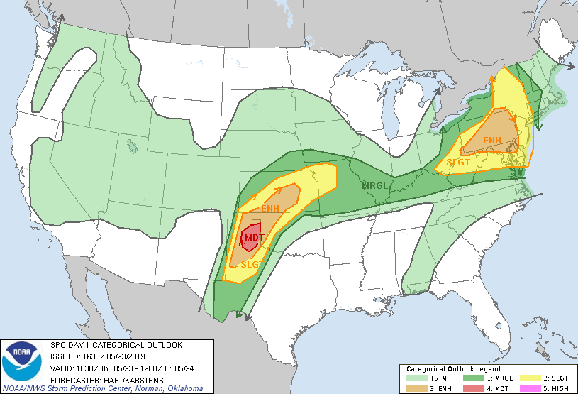
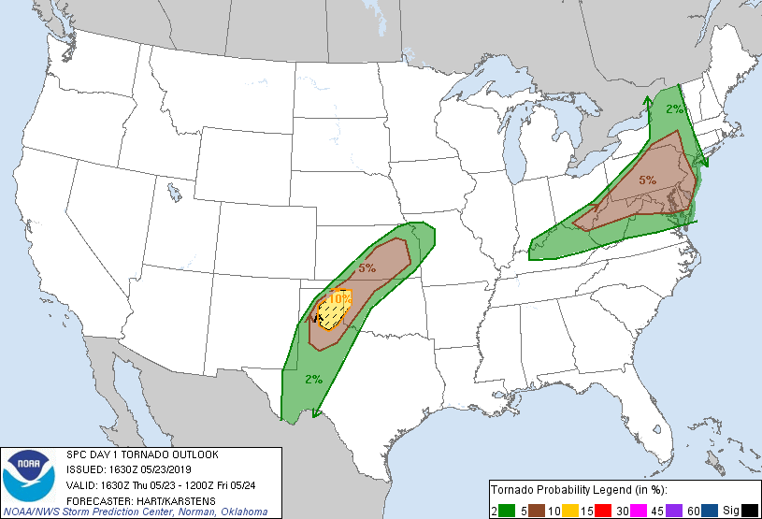
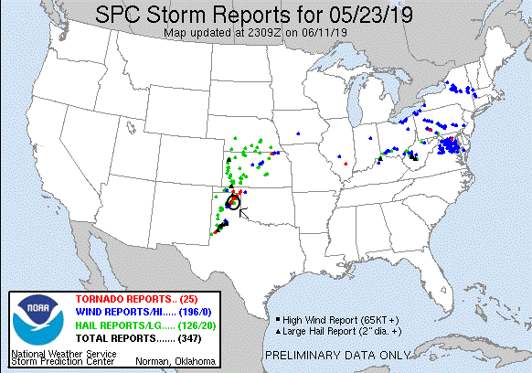

A really strange pattern for the tour: We had 3 completely down days with nowhere to go, but also 3 tornado days, that, with some luck, it could have been 5. We still saw 7 tornadoes in 3 states: Nebraska, Texas, and Oklahoma and got to chase in a couple of areas I hadn’t been to in a while. All in all, my most successful trip since 2016.

