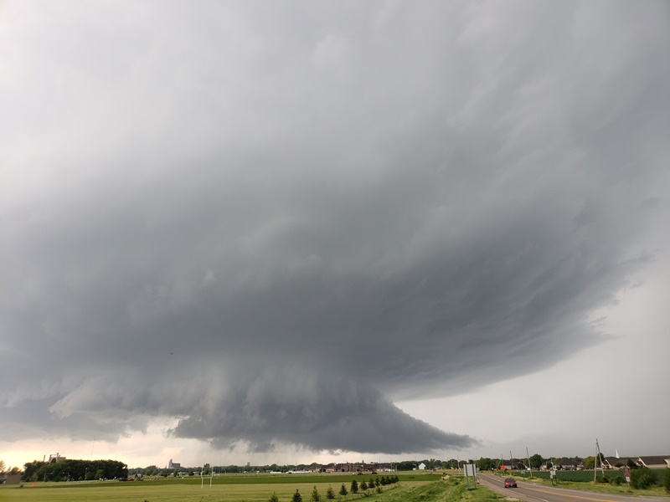

2018
Daily Chase Log

Pre-Day 1: June 4th, 2018
Positioning day, arrived at Minneapolis airport and drove to Fargo, ND to set up.
Mileage for the day 281 miles.
Pre-Day 2: June 5th, 2018
This day went from looking impressive in models to slowly deteriorating into very little as the cap remained strong and the moisture return was slower than expected. Models anticipated a late show as a cold front dropped down from the north. Storms were projected to form behind the front then rapidly catch up, then intensify as they interacted with the boundary. After a slow morning we drifted over to Jamestown and waited for several hours, having lunch, going to the Buffalo Museum, and then hanging around in McElroy Park. Not much seemed to be developing as 0Z passed, but there were some signs of development to our northwest, so we finally headed up to Carrington, then west towards Sykeston, pausing on a county road in between to observe for 30 minutes or so. Where we stopped, the front had passed us and the wind was cool and out of the north. The secondary line was very slow to develop and cold-air clouds we evident just to our north, with almost a roll cloud linear feature defining the secondary boundary. With not much going on and development going on towards the interstate, we headed south and stopped out in the grasslands about 10 miles north of Medina to observe. There was some slight development to our northwest and a few bolts of lightning, but soon the front caught back up and it was clear that not much was going to happen so we started heading for the hotel. On the long trip down to Brookings, SD, we had lightning popping in the distance from storms in every direction, including an isolated cell in front of us near Lamoure, ND. Eventually the system evolved into a big squall line, which we beat to the hotel by about 20 minutes, then had some fun watching as the highly electrified shelf cloud approached and the gust front came in followed by torrential rain and more wind, but no hail. It was now 3 AM and time to hit the bed.
Total miles for the day 494, trip total 775 miles

Pre-Day 2: 1630Z Convective Outlook, Tornado Probability, and Storm Report:
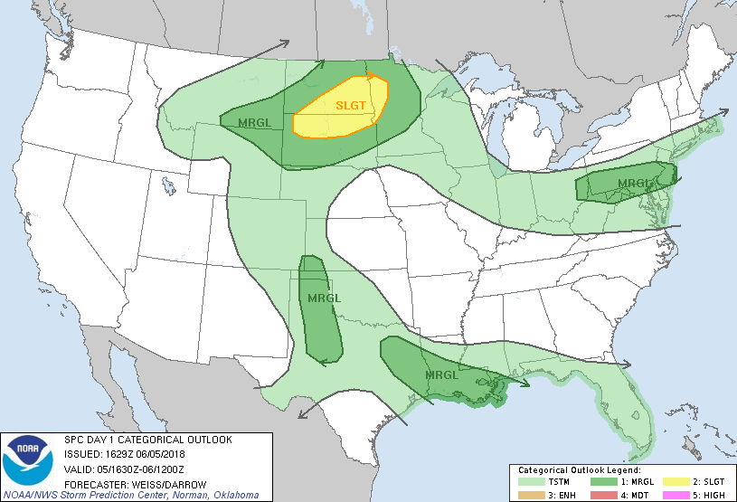
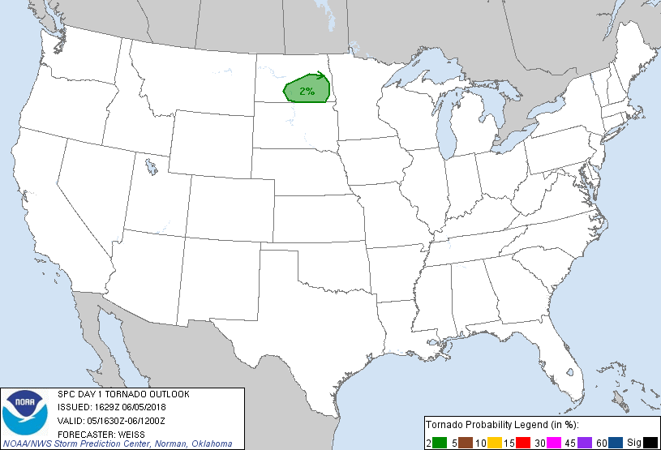
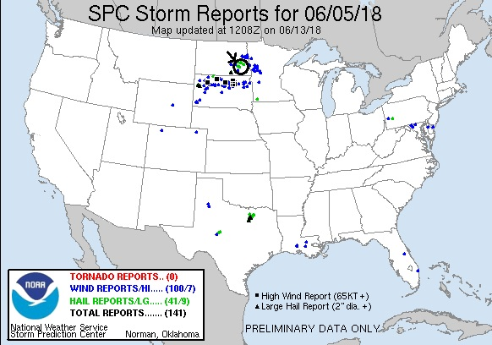
Pre-Day 3: June 6th, 2018
Starting in Brookings, SD, our target was the intersection of the outflow boundary from the previous day’s convection and the triple point, somewhere west of Des Moines, IA. There was practically no shear, so the tornado threat was nil. Models showed that the storms would, at best, remain isolated for only a short period before the whole system lined out and charged south into Missouri. There was plenty of moisture though and the mid-level lapse rates were very high, so the storms that did form were going to go up quickly and generate plenty of hail. We headed down to Sioux City where we decided that rather than head all the way down to I-80, we would head east to Denison and watch things develop. The haze we saw proved that the moisture was definitely there, and satellite imagery showed a pinch point right over the new target area. At Denison, we decided to get a little south and headed to Harlan, then east on Rt. 44, towards Guthrie Center. As we headed east though, storms were developing and we decided to target the most isolated one to our northeast. We headed back north through Coon Rapids, then east to Perry and north on 169 to Ogden, and finally east to intercept near Jordan. As we got to the storm it was a solid hail storm, barely moving and without much in the way of structure. We observed for a bit then decided to get out of the rain and went west towards Boone. As we proceeded, a cluster of two cells was intensifying quickly, so we decided to intercept those, blasting west on Rt. 30. As we did, another cell opened right over us and dumped rock-hard nickel-sized hail on us near Beaver. We intercepted our new storm on the farm roads south of Churdan. The cluster had broken into two cells, with the westernmost storm the more dominant. Soon the storm belched out a massive precipitation core that looked like a possible microburst.
We waited for the storm to get close and then stepped south with the storm starting to surge towards us. We proceeded down J Ave. and eventually over to Rt. 4 and down to Rt. 141 west of Jamaica, stopping to observe the surging storm which now had a well-defined greenish glow and shelf cloud. By now, the storms were starting to line out and move more quickly. We raced east to get in front of the beefiest part of the line, trying to beat it to Dawson. We got there just before the storms did, then headed south on Road P-46, again moving south to get in front of the line and stopping to watch. We eventually made it down to Rt. 44, near Linden and stopped again. By now the line was moving towards Des Moines, but a single isolated storm was to our northwest, so we headed west towards Guthrie Center to intercept.
By the time we made it to Guthrie Center, the storm was pulsing up and down and we decided we’d had enough. We headed east on Rt. 44, then north on Rt. 169, plowing through cores all the way until we cleared the line near Ogden. Then we headed east to I-35, and on to Minneapolis. A fun chase day given the so-so overall setup.
Miles for the day were 765 for a 3-day total of 1540.
Pre-Day 3: 1630Z Convective Outlook, Tornado Probability, and Storm Report:
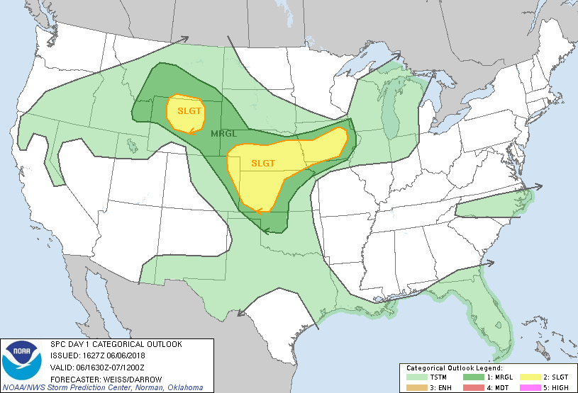
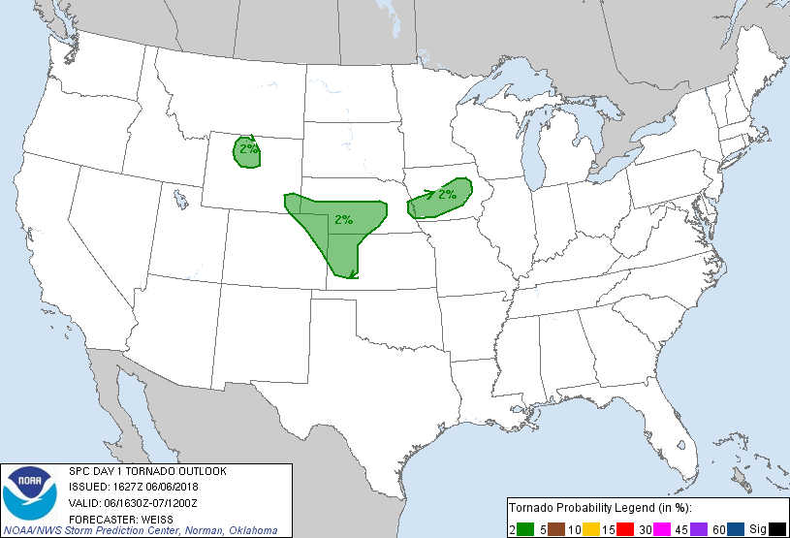
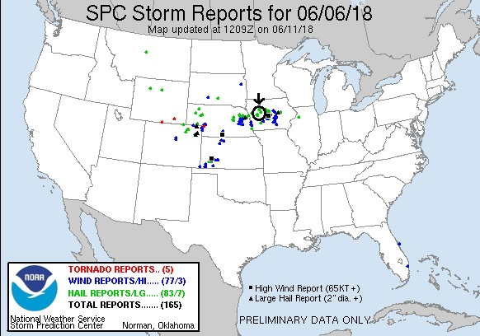

Day 1: June 10th, 2018
A good chase day to start the tour! We left Denver with the intent to play the triple point intersection of the dryline, warm front, and crashing cold front somewhere in western South Dakota. We knew that once the cold front arrived, all the storms would be undercut and line out, so there would only be a couple of hours where we could get isolated storms before that happened. We proceeded north into Wyoming on I-25 to Orin then over to Lusk, then north to Four Corners and Sundance before stopping for lunch in Spearfish, SD. By the time lunch was over, there were agitated cumulus fields to the north, so we headed that way through Belle Fourche and onward toward Buffalo.
As we proceeded north on Rt. 85, we could see development occurring right at the triple point very clearly so we stopped and waited near the intersection with Rt. 168. We didn’t have long to wait as soon towers were exploding right over our head with convection clearly visible to the naked eye. Meanwhile we also observed two sheer funnels along the line of convective towers so we knew there was a lot of vorticity available for the storms. We waited for another 20 minutes to see which updraft was going to take over, and once one did we were on the chase. Our target storm was slowly moving northeast, and we were roughly paralleling it as we went up Rt. 79 towards Hoover. We stopped and saw that the storm had 2 nice inflow bands feeling in, the stacked plates look, and clear rotation just to our west. We watched for some time as the storm looked like it had a chance to tornado and went tornado warned, but soon we had to get out ahead of the storm before we got cut off by the hail core. Waiting until the last second, we soon had to beat-feet towards Reva to avoid getting slammed by the core. One we got clear of the hail, we headed south on the dirt Sorum Road to get out in front of the hook echo region of the storm. We were able to find a good point and stop and wait for the storm to come to us, but even though it was still tornado warned it wasn’t looking as organized. The storm was now beginning to line out and surge forward and soon we were running again on 9 miles of dirt road, getting caught by the rain core. Luckily the South Dakota dirt roads were in great shape and we finally made it back to Rt. 20. We headed east towards Bison to get in front of the hail and south before town on Bixby Rd, which to our surprise was paved.
We again watched as the storm surged toward us and had another distinct lowering. It once again failed to tornado however and rather than track north to stay with the part of the storm we were with, we decided to go south for the tail end part of the cell, or possibly drop down to another storm that was severe near Rapid City. We headed south until we hit Rt. 212, then east for a pitstop in Faith. After a LONG stop, the line of storms was catching back up to us and had a beautiful shelf cloud and was highly electrified, so we found a side road and watched as the shelf came towards us. We then headed east and had pretty much called it a night when they reissued the tornado warning, so we stopped again to watch right at dusk. Visually, it didn't look anywhere close to producing a tornado, but the view was spectacular: As the Sun set blood red, the colors it lit up the shelf cloud with were amazing! We let it catch us again and enjoyed the colors and the lightning before finally heading to our hotel in Pierre, SD for the night.
A fun chase with some great structure. Mileage for the day was: 752 miles.

Day 1: 1630Z Convective Outlook, Tornado Probability, and Storm Report:
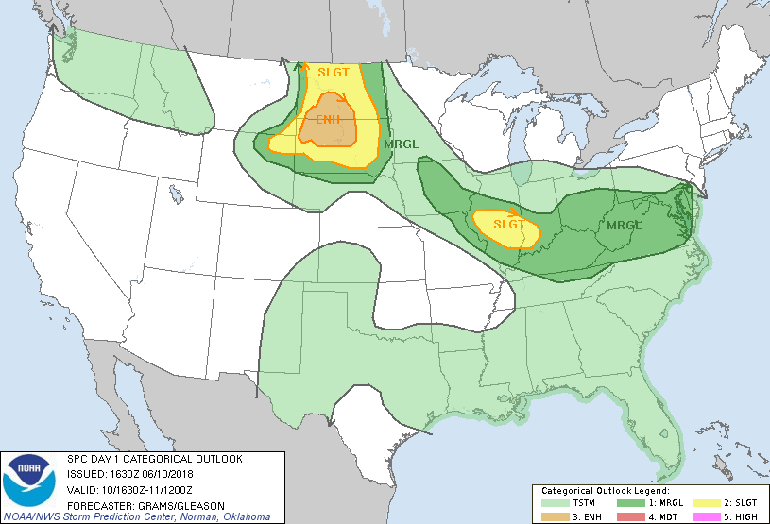
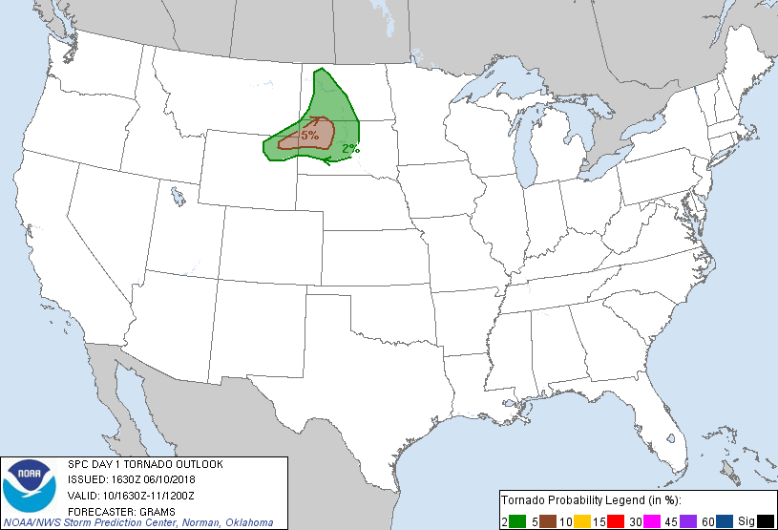
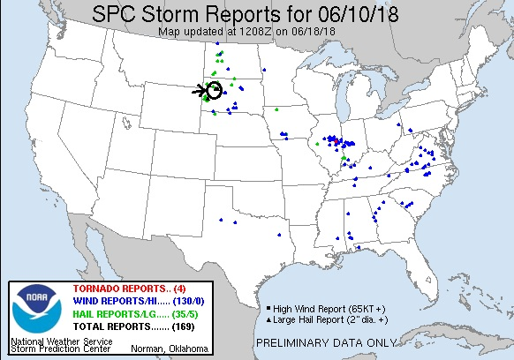
Day 2: June 11th, 2018
Another long day of driving and chasing. We started the day in Pierre, SD with the plan to play cells firing along the north or south edge of a bubble high projected to form in the wake of the MCS that had formed off the previous day’s convection, somewhere in southeastern Nebraska or southwest Iowa. The day would be somewhat of a repeat of the previous day: Lots of moisture and CAPE but not much wind support at the 500 MB level. The key would again be to get on storms as early as possible to hope they could do something in the window where they were isolated before merging into a large squall line. We headed out and made it to Sioux City, IA for lunch, and then were delayed a bit by a mechanical issue with one of the vans.
Once the technical difficulties were resolved, we headed south on I-29, but towers were already forming to our west and southwest so we got off the highway in Missouri Valley, IA and took Rt. 30 west across the Nebraska state line into Blair. By the time we got into town, there were already 3 storms to our west, and another to the southwest, west of Omaha. We targeted the southernmost of the 3 to our west which already had a broad, rain-free base, and turned north at Nickerson and northwest on Rt. 275 towards Hooper, stopping short of town to observe, parked in the rain as a precipitation core from another cell passed over us. The storm had a distinct lowering, with scud rising into the updraft, but the storm cycled down as it was interfered with from a cell that had blown up on the flanking line farther south. This one was the real deal, and we charged back south on Rt. 275, getting off in Fremont as the storm generated a well organized and rotating wall cloud. We watched as the fantastically structured storm tried to wrap up and got very close to producing, but then lost its organization and the wall cloud deteriorated. There was a spotter report from near our location of a confirmed touchdown, but we did not see even a funnel from our vantage point so we couldn’t confirm.
Our storm was never able to cycle as it was now being seeded with rain-cooled air from the southernmost storm down near Greenwood, NE which was not only tornado warned but had produced a confirmed tornado. With our storm merging with others near it and lining out, we decided to try and get to the southern storm, but the problem was we had to not only close the distance, we had to maneuver all the around it, which would take time. We headed southeast on 275 to Rt. 6, utilizing some local knowledge from one of our guests who lived in the area, and crossed into Iowa and back onto I-29 south, skirting the northern side of our new storm’s precipitation core.
As we headed south, our new target looked to be lining out as well, and we considered blowing it off and targeting a cluster of cells that were still away from the line near Oakland, IA, but then thought better of it and continued after our southern storm after the tornado warning was renewed. We got off I-29 at Pacific Junction and headed for the crossing over the Missouri River at Plattsmouth, but then realized that by the time we got south on the west side of the river, we’d be cut off by the tornadic rotation and stuck on that side, while the storm crossed over the river and went east. So, we turned around and headed south to Nebraska City, NE about 20 miles south. Proceeding down the highway we could eventually see lowerings at 2 different sections of the line that were tornado warned but didn’t see anything to indicate a tornado was in progress.
Once we got to Nebraska City, the whole system had become a huge line, and after heading west out of town briefly we decided to divert to the tail end cell, which was taking over as the dominant part of the line. We turned around and went back south on Rt. 75 to Auburn, briefly committing west before again changing our minds, as now the line was surging east and was almost on us with baseball sized hail. We continued down towards Dawson then turned west on Rt. 4 to Humboldt, where were pulled off and observed as the shelf cloud came towards us. We watched as a portion of the line near us that was tornado warned spun hard, but again, no tornado. Soon, the first raindrops started to fall around us and the gust front hit, throwing flying dirt in the air all around us so we bolted south to get out of the way.
We dropped down to Rt. 8 and back east to Rt. 75 again, stopping along the way a couple of times to take some photos, but eventually called it a day and headed to the hotel in Topeka, KS about an hour ahead of the line and hunkered down as it passed over us.
Another long driving day of 665 miles, for a two-day total of 1417 miles.

Day 2: 1630Z Convective Outlook, Tornado Probability, and Storm Report:
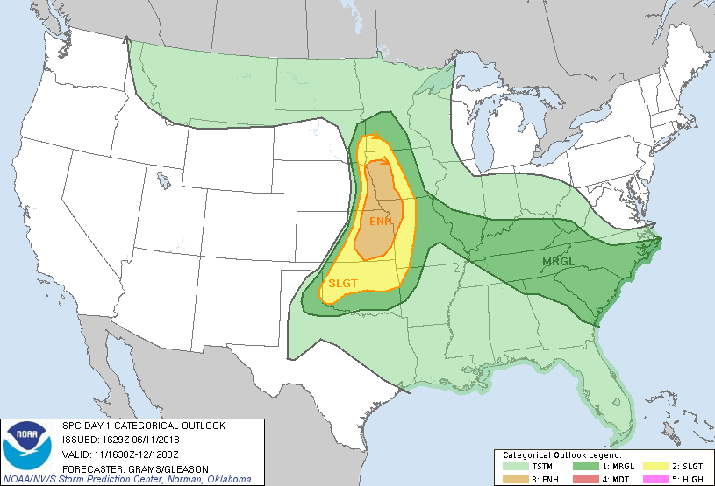
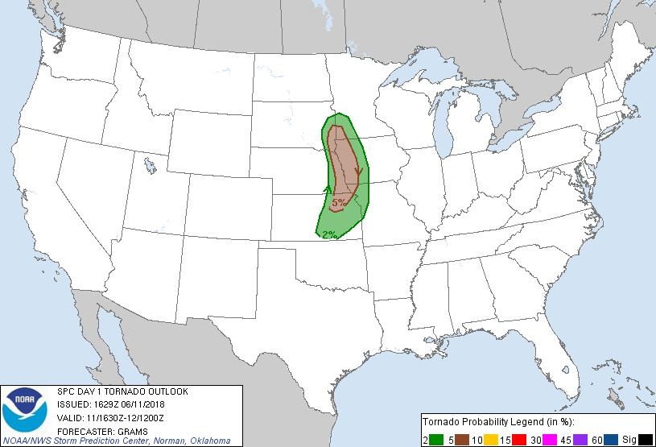
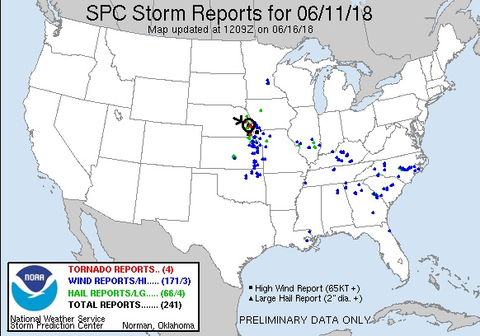
Day 3: June 12th, 2018
For the 3rd day in a row, we were able to watch a storm from initiation all the way through it’s life cycle to final collapse. We weren’t expecting much this day, and with strong instability but minimal shear it looked like pulse storms were the best we could do. With two potential targets: one just southwest of Wichita and the other on the Oklahoma panhandle near Guymon, we left Topeka and headed for Wichita, stopping there for lunch, and by that time the panhandle option looked more likely to verify so we headed west on Rt. 400 out of Wichita.
After making the obligatory pass through Greensburg and a stop at the metal sculptures in Mullinsville, we were forced to divert south at Bucklin on word that there was an ethanol fire in Minneola and that roads were blocked and people were being evacuated. We got down to Sitka and up Rt. 283 but stopped before making the turn towards Meade to consider options as an updraft with a broad flat base had gone up to our southeast and was already creating and anvil. From where we stopped, we could see the smoke plume from the fire in Minneola. Given the proximity of the updraft and the fact that the storm was in about as good conditions as we were going to find, we went for it, intercepting the storm at Protection. There were actually 2 updrafts, each with hefty precipitation cores. The two updrafts were separating and the southern one was becoming dominant, so we headed east then south on Kansas Rt 1., passing though the core of the north storm (all rain) then crossing the state line and stopping near Lookout, OK to observe the storm which now had a big core with hail and decent structure. We continued to circle the barely moving storm, stopping on Rt. 64 north of Selman, OK, then again a few miles farther down the road for a better look at the updraft, and noted that the storm was developing a wall cloud, so we continued west to get a better look at the hook echo area.
After an emergency fuel stop in Buffalo, OK we headed west out of town and were able to get in perfect position to watch the developing wall cloud ingest scud into the base. Another stop and we found a great vantage on E0130 road and watched as the storm developed a big, almost vertical tail cloud (it was not rotating and was not a funnel, though it was reported as one), and soon the storm was a beautifully striated stack-of-plates with a big inflow band and green hail glow in the vault. Around this time the storm became very highly electrified, dropping bolts all over the place and starting a big grass fire to our north, while sucking in copious amounts of inflow from directly behind us, giving the vans a nice dirt bath. We continued along Rt. 64, stopping for a look every few miles as the storm continued to be almost anchored in place. At Rosstown we turned south towards Laverne after another pause to watch the rotating storm to our north, then stopped and watched the storm as it lost supercellular characteristics, though it continued to spark like crazy. Once the bolts started hitting behind us, it was time to go.
At that point, we decided to head for the hotel, but had to maneuver west to clear the still strong cores to the north. Twice along the way the storm produced wall clouds and we diverted north, once towards Gate and once toward Mocane to take a look. Near Mocane we were getting hammered by outflow as we got very close to the wall cloud, but while it looked good for a few moments, it quickly fell apart once we got there. We ended up hitting a hail core north of Beaver, OK in violent outflow winds, and then passed through two more cores before getting clear of the storms north of Liberal, KS and finishing the trip to Garden City, KS where we stopped for the night.
A fun day that far exceeded our limited expectations!
Miles for the day were 605 for a trip total of 2022 already!
Day 3: 1630Z Convective Outlook, Tornado Probability, and Storm Report:
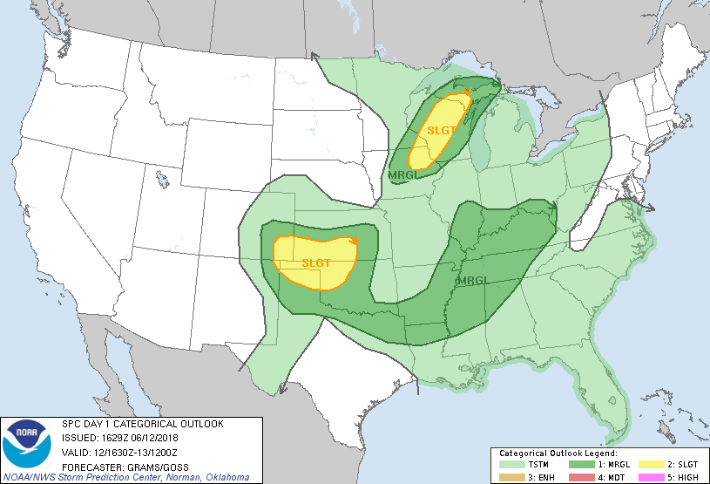
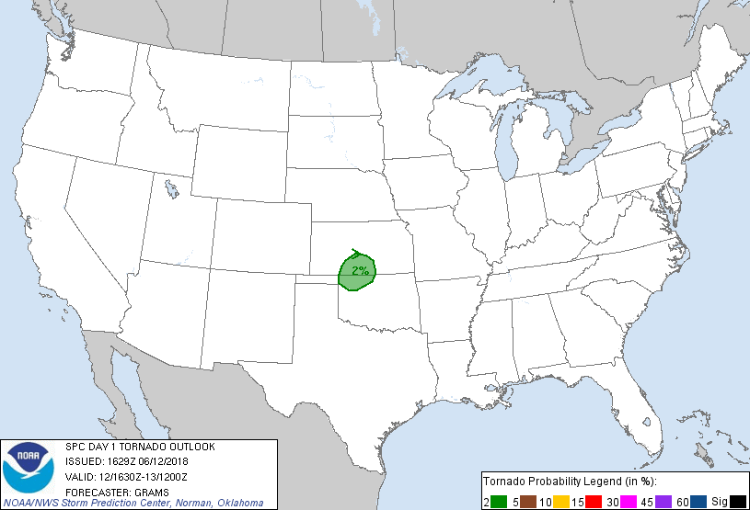
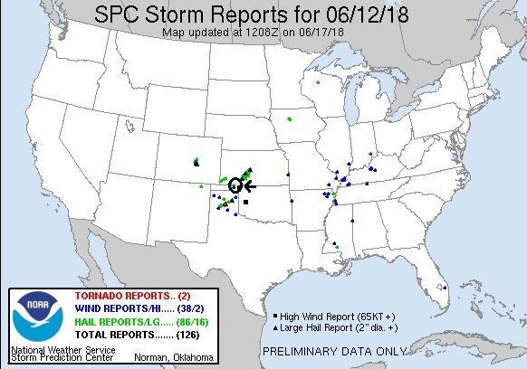

Day 4: June 13th, 2018
Travel day. We started in Garden City, KS and travelled to Bennett, CO, then up to Gillette, WY to set up for a northern play the next day.
680 miles for a trip total of 2702.
Day 5: June 14th, 2018
A moderate risk, 10% hatched tornado threat bust! We started the day in Gillette, WY, with the expectation that we would probably be chasing in Canada on the warm front, but with a secondary target of the triple point in western or southwestern North Dakota. We left Gillette and headed north through Montana then northeast all the way to Williston, ND before stopping for lunch and waiting. By the time we’d reached Williston we knew the Canada play was out: The warm front had already become a mess of storms with a stratus deck crossing the border into the US. As we waited, there was a single storm right along the border tempting us with a 60+ dbz core and signs of rotations, but it was clear that it was elevated. The HRRR model was showing that storm and that it would become surface based, but we were skeptical and the storm was traveling nearly 50 mph along the border so we’d never have caught it regardless. The model also developed supercells along to the southwest of Williston, but there was little sign of that happening. To kill time and be in a better position to make a desperate attempt to catch the storm on the border if we needed to, we went east, making a picture stop and the going to Stanley and waiting. Finally, not only did two cells form to our south, but the outflow boundary to the west initiated as well and one updraft in particular caught our attention. Initially the southern storms looked better, so we dropped south on Rt. 8, but we quickly decided the better play was the western storm as it reached 50,000-foot tops, while the southern storms looked to be pulsing down so we went back to Stanley and headed west.
We pulled down a side road on Rt. 2, and watched the storm, which had a nice broad base but not much of a lowering, for a few minutes until the rain got to us and we moved east. At our next stop on 75th Ave. W, the storm was now severe and had a bit of a wall cloud and produced a quick funnel, but then lost focus. The storm continued to strengthen and soon we had to run north back to Rt. 2 when the hail core caught up to us and we got a bit of small hail before getting to the road.
We continued east to get space ahead of the hail core and turned south at Berthold onto Rt. 10 to get southeast of the storm as it right-turned. At Lonetree, we stopped again and observed that the updraft was now a tight corkscrew spinning hard at upper levels and sparking quite a bit, but with no low-level rotation. It also had a big inflow band feeding into it. Soon we had to move again to stay ahead of the storm, but within a few scans the storm fell apart and we decided to head towards our hotel in Bismarck, and also to observe a storm that was coming up towards us from the South Dakota border. We preceded down Rt. 83 and crossed Lake Audubon. Meanwhile, the storm coming up from the south was now over Golden Valley and looked like a solid supercell with 55,000 ft. tops, a maxed out VIL profile, and signs of rotation, so we decided to divert and try and intercept it around Hazen. We took Rt. 200 through Riverdale and Pick City, then turned south towards the storm, which was showing a decent amount of lightning but was pulsing down. As we proceeded down Rt. 200, the storm looked like it was falling apart so we pulled off on 5th St. SW to let the guests take a few pictures as the storm died. We stayed for a few minutes, but then gave up and headed for the hotel. While doing so, we were at least treated to a decent lightning show heading to the hotel. Quite a bust of a Moderate Threat! There was only one tornado report in the threat area, a “Sherrifnado” near dusk far in the eastern part of the threat area.
Miles for the day were 656 for a trip total of 3358.
Day 5: 1630Z Convective Outlook, Tornado Probability, and Storm Report:
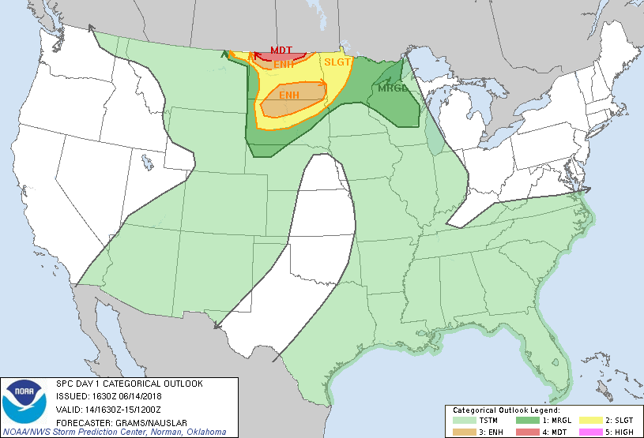
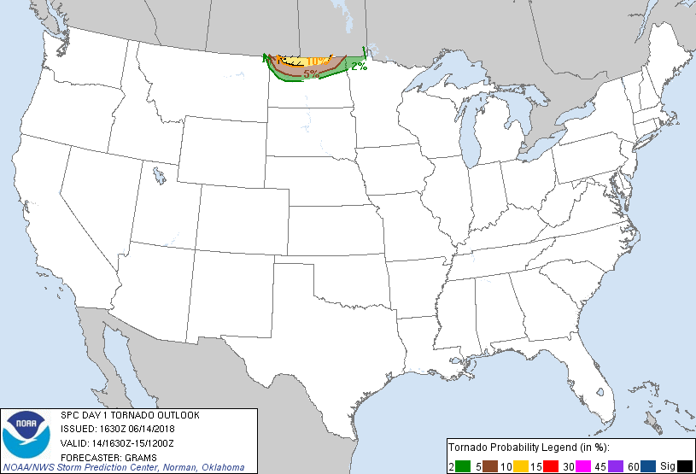
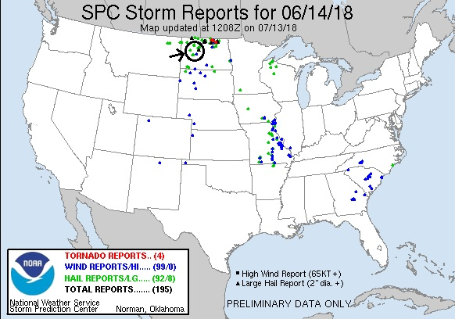
Day 6: June 15th, 2018
This day was mostly a travel day with a bit of chasing thrown in. We started in Bismarck, ND for the long trek back to Denver, turning south at Dickerson then tracing our steps from Day 1 all the way to Lusk, WY, where instead of turning for the interstate we headed south on Rt. 85 to intercept the only storm that looked like a viable target, which was anchored southwest of Hawk Springs. As we got there however, the storm was falling apart, and we started heading for Cheyenne, then paused when a new updraft with rock-hard convection blew up over Chugwater. We retraced our steps north on Rt. 85 then turned west on Rt. 313, eventually stopping to watch the storm, which had a broad base but no distinct lowering, spit out lightning bolts for about ½ an hour amidst a great background of a butte. One interesting feature the storm had was a big scud tag that just seemed to hang there the whole time, neither shrinking nor getting sucked into the updraft. We moved farther west and up onto the high ground and got some shots from a different angle including down into the canyon before giving up and heading to Chugwater, then down I-25 into Colorado and on to Denver. On the way down there were a few small cells coming out of the mountains that occasionally spewed some cloud-to-ground lightning.

Miles for the day were 770, for a final tour total of 4,128, almost the all-time 6-day tour record!

Day 6: 1630Z Convective Outlook, Tornado Probability, and Storm Report:
