Silver Lining Tours Prime Time Tour, 2013, Tour Log
Prime Time Tour, Pre-Arrival Day, May 19th 2013
May 19th was a unique experience in storm chasing for me. Awakening in Boston, MA, I got on my 9:50 AM flight to OKC through Dallas. Looking at the models while on the plane, it was obvious that I needed to chase, but would I get there on time with a scheduled 3:20 landing, and would the storms form far enough south to make chasing realistic, since Oklahoma City was at the extreme southern end of the target area? Sitting on the right side of the plane as we came up from Dallas, it looked like things hadn’t gotten started yet as there was nothing but a high-based line of cumulus clouds to my east. But, as the plane circled to land from the north, I suddenly found myself looking straight up at a mammatus field and off to the immediate northwest was well developed supercell! My plane’s wheels hit the ground at exactly 3:16 PM and I scooted to get by bag while Boris Konon arrived to pick me up for the chase.
Finally, after about ½ an hour waiting for my luggage, we hit the streets, driving directly to Edmond to intercept the storm I’d seen from the plane. Just as we got there, voila, a white cone tornado dropped about a mile right in front of us as if by order! The time? 4:28 PM, exactly one hour and 12 minutes after I landed. We watched the tornado for several minutes from atop an overpass on I-44, then as it dissipated we paralleled the storm east-northeast along I-44, fighting the endless trees to try and get a glimpse of what was being reported as a big multi-vortex tornado in progress (that did significant damage in Carney as it turned out). Along the way I made a big navigational error: as we got toward Carney, I planned to navigate to route 177 to get out in front of the tornado…. But there is no exit off the turnpike at route 177!! Crushed, we were forced to travel another 10 miles to the next exit until we were way out in front of the storm.
We eventually got off at route 18 and headed north towards Agra, and as the storm finally approached we observed a strong cone tornado again visible in and out of the trees a few miles to our west. Once that tornado ended, the wall cloud became obscured with rain and the storm looked to be going HP, so we decided to jump south to intercept another storm that had just gotten tornado warned near Norman, OK. We continued south on Rt. 18 past one storm to head for the tail end storm, passing through Meeker, then took I-40 west to Dale and south on Rt. 102, trying, through the trees again, to keep an eye on what was being reported as a mile wide tornado crossing Thunderbird Lake (we feel this was an exaggeration. The tornado was repeatedly reported as a mile wide, and while it was certainly ¼ mile or bigger at times, I don’t think it was ever nearly that big).
Near Shawnee Reservoir we knew the tornado was close, but again, the trees were killing us and we headed down a dirt road to the east side of the lake, figuring we’d get a good view there. Wrong! The tornado was clearly getting close now but we could only get fleeting glimpses of the multi-vortex tornado approaching. The area we drove through was the location on the east side of the reservoir where all the homes were destroyed when the tornado passed through. We eventually crossed Rt. 102 and went east into Bethel Acres and finally found a high spot to watch the tornado approaching. While the base was again obscured by trees, the motion was incredible and the roar of the tornado was clearly audible as it passed by to our north. We headed east for another few miles, and about 15 minutes later we finally found a nice clear area with a good pull off and watched for about the next 10-15 minutes as a large cone tornado crossed to our north and became a wedge tornado as it headed off to the east. Even after that tornado wrapped up in rain (and went on to damage northern Shawnee and cross the highway, destroying several tractor trailers and cars and closing I-40 for hours), we held our position as another mesocyclone formed and looked like it was going to drop another tornado right in front of us.
The second wall cloud did not produce however, and we proceeded into Shawnee, then north to I-40, heading east to Okemah where we stopped and watched the storm pass to our north with Rocky Rascovich and William Hark. The storm produced a fairly robust white funnel just to the north of the highway, but it soon dissipated and we continued east to Henryetta before finally stopping and returning to OKC (getting stuck in the I-40 mess which was still going on at 10 PM).
A great arrival day chase and 3 tornadoes intercepted, though it’s always sad to see the wide areas of destruction caused in Shawnee and Carney. My thoughts go out to the folks who lost property or were hurt during those storms. Ultimately we drove about 300 miles on the day.
For the full NWS report on the Edmond and Shawnee tornadoes including tornado tracks, radar images, damage reports, etc., go to Norman, OK NWS office page on the event at the following link:
http://www.weather.gov/oun/events-20130519
Pre-Arrival Day 1630Z Convective Outlook and Storm Report:
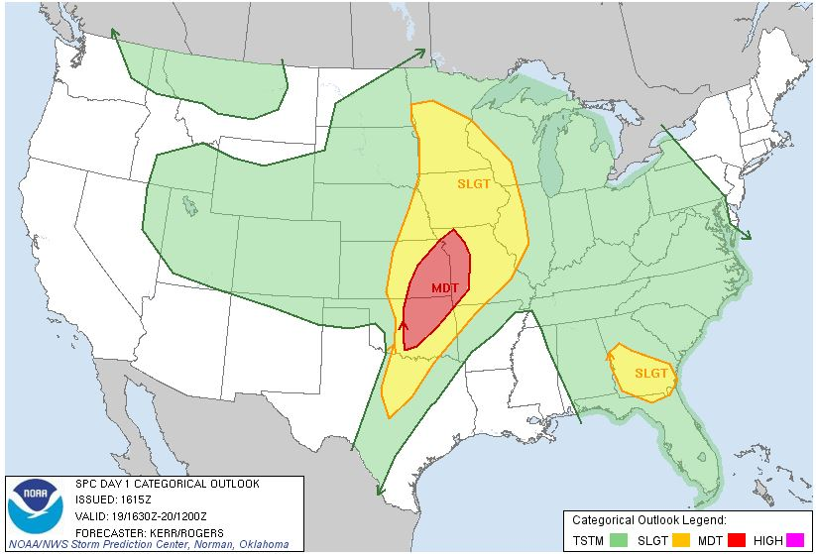
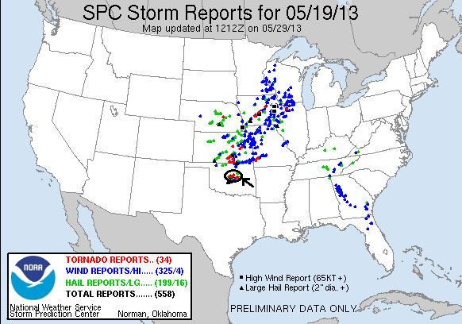
Prime Time Tour, Arrival Day, May 20th 2013
Nothing in the following paragraphs is as important as the devastating tornado that occurred in Moore, OK, on this day, but nonetheless here is the write up:
We dubbed this day “Tour 3.5” since we gathered whatever guests had arrived early for the Prime Time Tour and any who wanted to stay an extra day from the previous tour to chase. We started the day in OKC under another moderate threat, targeting the area around Duncan, OK. As we headed south, numerous updrafts were showing explosive convective development already, including one we passed just to the east of that would over the next two hours develop into the supercell that dropped the Moore tornado. As we got about 20 miles south, we were fully aware that the storm looked ready to tornado, but decided we wanted nothing to do with chasing in a city again after our experiences in Joplin 2 years earlier so we elected to target the next storm south in line.
By the time we got to Chickasha, we realized that we already needed to get southeast, and headed down Rt. 19 towards Lindsay, then south on Rt. 76. By this time we were targeting an approaching tornado warned storm and had to race west to get to a south road so that we could get into position before we got crushed by big hail. We made it and got a view of the mesocyclone through the rain to the west of Bray. That was the recurring theme in our chase: because of the very high humidity, it was a very murky chase: it seemed like we were perpetually getting cored or running from hail. With limited road options, we could only find a spot and stop and wait for the storm to arrive, and we were eventually rewarded with a rain-wrapped cone tornado that lasted for about 5 minutes but was never very easy to see in the rain. We watched until the tornado roped out and then headed between the southern flank of our storm and the northern flank of a cell merging with it.
When that storm died out, we targeted a monster HP supercell that was next in line, but by the time we got to Fox (where the sports teams for the school are creatively known as the Foxes), we had a good view of the giant whale’s mouth of the storm and then the hook area and saw that it was an outflow dominant ice-machine, so we decided to blow it off and target the much better looking tail-end supercell that was tornado warned and running right along the red river. We passed through Healdton, then crossed the Red River into Texas and blasted west into Nocona just as the storm developed a monster hook echo and the tornado sirens began to blare. We pressed west to see the storm and found the hook was completely rain wrapped and soon were running east from the big hail in the storm. We stayed with that storm until Muenster but by now it had become a big HP linear system, so eventually we gave up and, after stopping for dinner, headed north on I-35 towards OKC. Once we got close, we detoured west to avoid the damage in Moore and eventually crossed the damage path at the Canadian River Bridge on I-44. The rail bridge over the Canadian was mangled, with whole trees stuck in the bridge’s metal superstructure where tornado had crossed when it had first touched down. It was an eerie flashback to Joplin for me as we drove back towards the city listening to the radio with the continuous news of the damage in Moore. Finally, we got back to the hotel, ending the chase for the day.
Though we didn’t chase the Moore storm, for the full NWS report on the Moore tornado including tornado tracks, radar images, damage reports, etc., go to Norman, OK NWS office page on the event at the following link:
http://www.weather.gov/oun/events-20130520
Arrival Day 1630Z Convective Outlook and Storm Report:
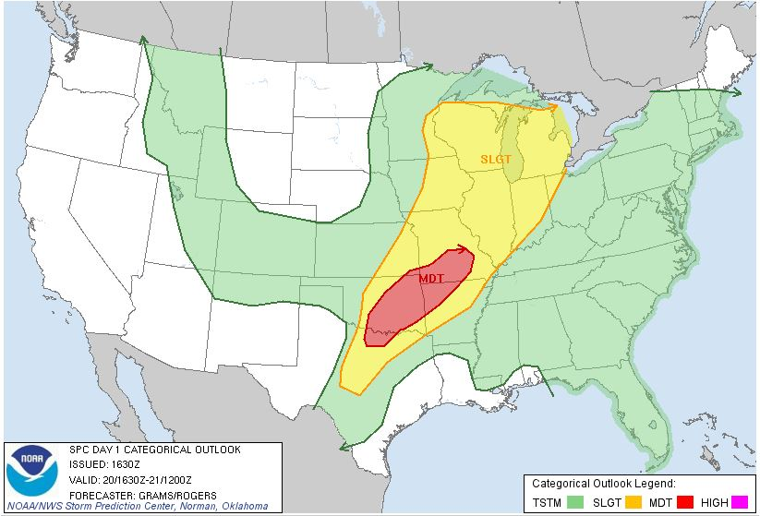

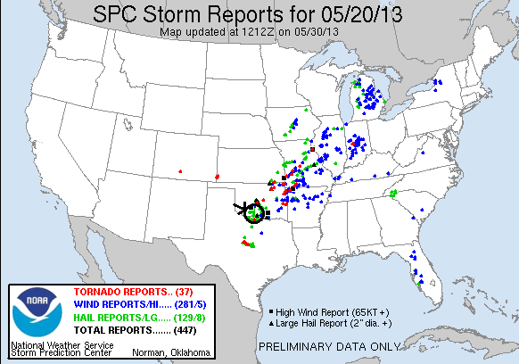
Prime Time Tour, Day 1, May 21st 2013
We left OKC and headed south on I-35 with the plan being to get out in front of a squall line that was sweeping south from Oklahoma and either play any storms that developed in front of the line, or hope that discrete cells developed on the tail end. To head in that direction, we first had to pass through Moore on I-35 directly to the damage path, and so we saw firsthand the tremendous damage caused by the storm. It’s amazing how “discrete” tornado damage is: we passed though the path north to south, and went from no signs of damage briefly to nothing damaged but debris scattered on roofs and in yards, to everything totally destroyed, and back again in no time. I’d say the damage path was a few hundred yards wide where we crossed it, and was also only a mile or so south of the path of the 2003 tornado that also did a lot of damage in Moore.
We headed south trying to decide whether to get out in front of the squall line or head for the tail end, stopping in Gainsville, TX for lunch. At that point, we decided the northern target ahead of the squall line was our best bet, and headed through the Dallas-Ft. Worth Metroplex and then east over the Rockwall Reservoir. As we continued east, it was getting clear that nothing interesting was going to happen in front of the line, and in fact the line was expanding rapidly and catching up to us quickly, so we gave up and let it run us over in Sulphur Springs, TX, where we experienced winds gusting into the 50 MPH range and torrential rain for about ½ an hour. We then went back to the hotel in Greenville, TX (where the lobby had been completely flooded by the storm, seemed like a poor design) for the evening.
So, kind of a bust chase day, though I guess the story of the day was the Moore damage. We travelled 365 miles for the day.
Day 1 1630Z Convective Outlook and Storm Report:
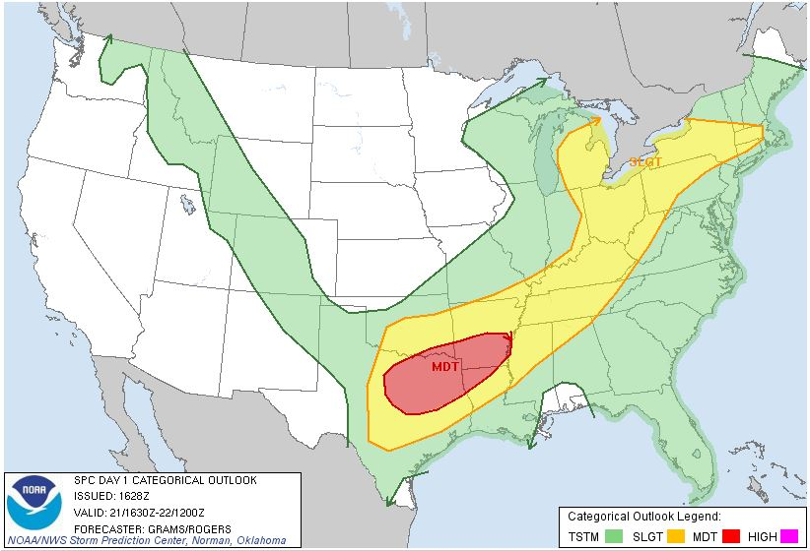
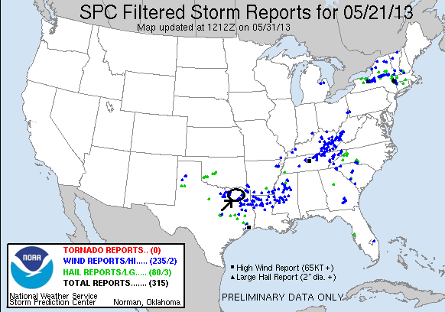
Prime Time Tour, Day 2, May 22nd 2013
This was a transit day from Greenville, TX to Amarillo, TX. The only points of interest were a pretty strong dust devil somewhere around Estelline, TX and of course, a stop at the Big Texan during the evening. Mileage for the day was 393 for a 2 day total of 758.
Prime Time Tour, Day 3, May 23rd 2013
A really fun chase day! We started the day buying into what the HRRR model was selling regarding a two part play, with the action starting along a boundary running between Lubbock, TX and Childress early, then a second wave of supercells later in the day in the better wind and moisture near Amarillo,TX, where we started the day. Since we were near the target area, we were able to start the day late, with a “Weather 101” class in the morning followed by lunch, and then we headed south. Our general target was the Matador area, and the plan was to proceed to Tulia and then decide whether to head east toward Turkey or further south and then east towards Matador.
Before we made Tulia however, the first storm of the day fired north of Floydada and appeared firmly anchored to the boundary, barely moving, and quickly we received a report of a possible landspout tornado. With the storm not moving there was no point in going east, so we proceeded south to Plainville, then on to Floydada. The storm was a dirty mess! There was dirt flying around all over the place and we saw several gustnadoes as we passed south of the hook echo of the storm and stopped in perfect position to see any tornado that developed. This was one of those situations that you could look at the radar image of a storm then look up and really see all of the features laid out in front of you. The hook region of the storm was outstanding! Just to our north the inflow was streaming into the storm right to left, but just west of us where the hook wrapped around the meso was spinning left to right. The storm looked like it would tighten up and produce just to our northwest several times, but could never get it done. I wish I had captured a still of the radar image of the storm in the early period where you could clearly see the boundary “kinked” right into the hook of the storm before it proceeded on to the east.
Soon the front flank core was getting close, and with the storm showing large hail on radar it was time to run south and get in position for the next attempt. We headed south past Dougherty on farm roads, watching the storm cycling while pushing a huge plume of dirt out in front of it to our west, eventually stopping near Crosbyton. The storm by now had broken away from the boundary and was heading south, and after one last try to produce a wall cloud, became a dirty, outflow dominant mess. We stopped in Ralls for a break, and then headed north to get ready for round two up near Amarillo.
By the time we’d reached Floydada again the show was already beginning north and we bee-lined it to I-27 to head back to Amarillo, all the while getting buffeted by outflow winds from our original storm to our east. The storms to the north developed quickly and we could see a big overshoot over the updraft of our target storm. The storm merged with another cell as it developed, which bought us some time, then split, which bought us even more, and soon we were close enough to chase it. The atmosphere had become pretty mixed by that time though, and the storms didn’t recover from the split as expected. In fact, the right split died almost immediately! We chased the left split, which was now traveling to the northeast north of Amarillo, for a bit, but that storm also collapsed quickly and we called it a night, conveniently within ½ an hour of the hotel.
Overall it was a fun chase day with a great supercell that almost produced a tornado. We traveled only 338 miles for a tour total of 1096 miles over the 3 days, way below average!

Day 3 1630Z Convective Outlook and Storm Report:
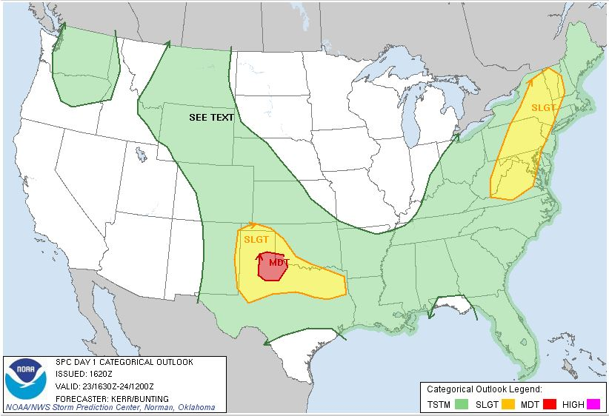
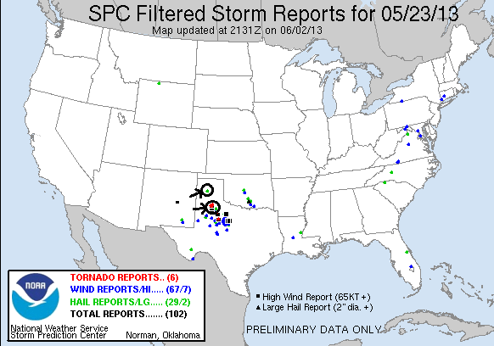
Prime Time Tour, Day 4, May 24th 2013
A long, challenging, chase day. We started off in Amarillo, TX with 3 distinct target opportunities: northeast Colorado / southwest Nebraska, a “Campo”-style play near Lamar, Colorado, and a lesser play up on the Nebraska Panhandle near Sydney. As we headed north we were faced with a puzzle as the models were in total disagreement regarding where the best storms were going to be: While most pointed toward the area between Wray, CO, and Imperial, NE, the HRRR broke out a huge supercell down near Lamar and had virtually nothing in northeast Colorado. We decided to hedge our bets but lean towards the north because the conditions all pointed that way, and as we lunched in Burlington, CO the winds there were veered and the dew points dropping rapidly as the dry line approached, so we decided to head north to Wray. The transit through southeastern Colorado was amazing: I’ve never seen it so dry down there and as a result it seemed that there was blowing dirt from horizon to horizon throughout the whole region. Sheridan Lake was completely dried up, with the lakebed itself adding to the blowing dirt.
In Wray we were posed with the same problem as earlier: Storms were underway and looking decent to our south, but up north where our target area was, the towers that were forming kept withering and dying. Still, our attention was drawn by the Holyoke, CO surface observation that suggested dewpoints in the low 60’s streaming into the area. Finally after a long wait, two updrafts finally managed to get established and we raced up north in between the two of them. Once we got to Holyoke we were right in between the two cells, but they weren’t looking great, with the left split being a tiny little LP Supercell spinning away but very high based, while the right split kept pulsing up and down. Meanwhile, there were solid cells to the north and south that alternately looked good then lousy from scan to scan on radar. We decided to head east on Route 6 as that would allow us to keep contact with the western cell but also be in position to move to any of the others near us, as one thing that did work in our favor was that all of the storms were moving very slowly.
Crossing into Nebraska, we stopped near Lamar (Nebraska, not Colorado) and observed the Western storm as it seemed to be getting better organized. This was a continuous theme for the next 6 hours: every time we tried to leave the storm, it showed us just a little something that made us stick with it, despite different cells around us pulsing up and down and enticing us towards them. Near Lamar the storm showed a nice rain-free updraft and was popping cloud to ground lightning bolts continuously. We also saw several shear funnels on the storm, one of which persisted for at least 3 or 4 minutes before it fizzled out. As the storm didn’t appear to be intensifying while others around it did, we headed east, then north, bypassing Imperial. As we headed into Grant we got pounded by golfball hail from the front flank core of our storm, then as we popped out north of the core near Grant we were gifted with a tremendous mammatus display on the backshear of the anvil from the cell to our north, a cell which was showing rotation on radar. But again, as we drove away from our cell it pulsed back up and showed rotation of its own. At this point it had the classic “backwards C” looking updraft and clear rotation. After numerous brief stops to watch our storm, we headed east as it started to get dark and as the low-level jet kicked up the storm really took off. Just at dusk the storm gave us a fantastic lightning show near Elsie, and then as we continued east the storm was tornado warned and showed strong rotation on radar. We noted a lowering under the mesocyclone in the distance, but could never see anything touch down. We proceeded south of Wallace to get out of the rain and parked and watched as the area of rotation came right to us. The inflow winds were pouring into the storm past us, and as they blew through the wires overhead it created a spooky howling sound that added to the atmosphere. After about 20 minutes the hook echo was almost right on top of us and we had to run to the southeast to get out of the way. We found a place to watch it pass and observed a large blocky wall cloud through the rain on the back side of the hook as it passed by in the night, but again no tornado.
Finally, the rotating area was well past us and there were no roads that would allow us to keep up, so we headed north behind the rear flank of the storm with a great cloud to cloud lightning display just to our east and all kinds of tree debris from hail on the road. We thought we’d see some big hailstones as we headed through the tree debris and hail fog, but never spotted any. Not long after that the storm collided with a left-mover to its south and collapsed so we called it a night and made the easy 40 mile trip to our hotel in North Platte, though that did mean driving through the northern part of the collapsing core which was a bit of a challenge.
A very fun, LONG chase! The longest chase both timewise and mileage-wise of the tour so far in fact, 589 miles for a 4 day total of 1685 miles.
Day 4 1630Z Convective Outlook and Storm Report:
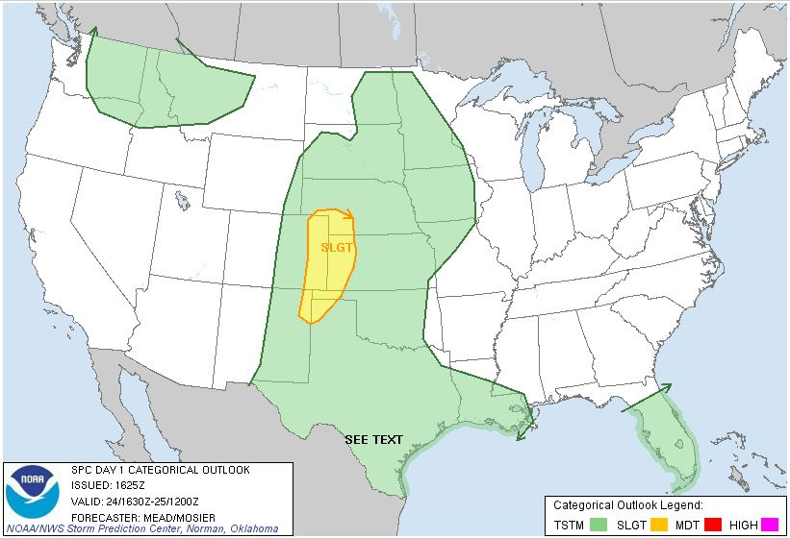
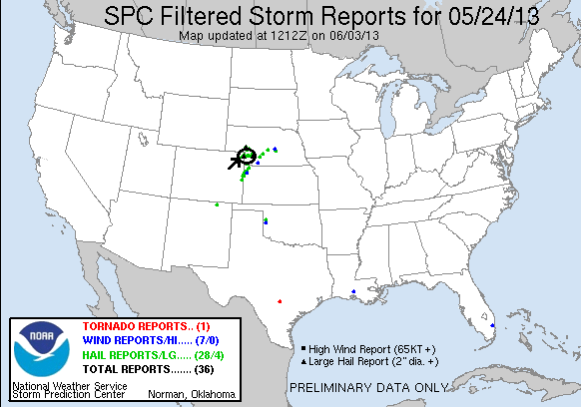
Prime Time Tour, Day 5, May 25th 2013
The best non-tornadic storms I’ve seen to date! Structure was the name of the game today as we left North Platte, NE with our target being northeast of Rapid City, SD. We headed up through Valentine and then into South Dakota. By the time we reached I-90, storms were already firing off the Black Hills, and we made the decision to head north, then west to get to our target storm. We stopped in Philip, SD for fuel and then the chase was on! At Howe’s we turned west as our storm, which was between Belle Fourche and Spearfish, had barely moved in the hour we’d approached, and then it began to right turn hard over Bear Butte.
One thing about chasing in South Dakota is that the terrain is spectacular even without a storm over it, which makes for some very photogenic shots. As we drove west about half way between Union Center and Sturgis on Rt. 34 we stopped and watched the storm about 20 miles from us, framed over Bear Butte with a farm and a river in the foreground, and a long inflow band wrapping around over us into the storm. After about 15 minutes we headed west towards Sturgis, then dropped south onto dirt roads and drove right up to the hook area of the storm as it belched a big hail core right over the Butte. The storm still barely moved and we were able to maneuver to just about any position we wanted for a good view, and at every stop we weren’t disappointed at the structure of the storm. Behind us, the inflow winds were howling into the storms for hours.
After the first cell started to cycle down after a weak attempt to spin up, the western updraft of the storm took over and again, we drove right into the notch and watched the incredibly structured supercell spinning away with a big, broad meso as it came right to us, which dirt entrained in the inflow blasting by us towards the updraft. Luckily the dirt roads were in good shape and we didn’t have much trouble getting around in the road hole. As the second cell got very close to us it dropped a HUGE hail core just to our northwest where you could almost watch the individual streams of hail falling. Again, there was solid rotation on radar but still, not even a decent attempt at a funnel.
After the big hail core bombed out, the new western updraft took over and we did the same thing all over again as the new storm took on the classic “mothership” look with a big disk of a base and striated layers on top. We had to run east towards Elm Springs to beat the big hail, then headed south with the storm obediently following along. The structure somehow was even better than the previous two updrafts!
Finally we decided to get out ahead of the storm for a distant view of the structure, getting on I-90 again and heading a little east to a rest area near Wasta. As the Sun set behind the storm, the storm got even MORE photogenic! As it crossed the highway, a decent funnel formed (finally) but then the storm cycled down. We found another great vantage point and watched the storm, which was now becoming a skinny LP storm, twisting and turning with the Sun setting behind it and numerous cloud to ground and cloud to cloud bolts coming out of the vault area. We finally called it quits and headed to the hotel in Spearfish for the night. A great chase day! Once again, the mileage was not that bad, 562 for the day for a tour total of 2247 miles.
Day 5 1630Z Convective Outlook and Storm Report:
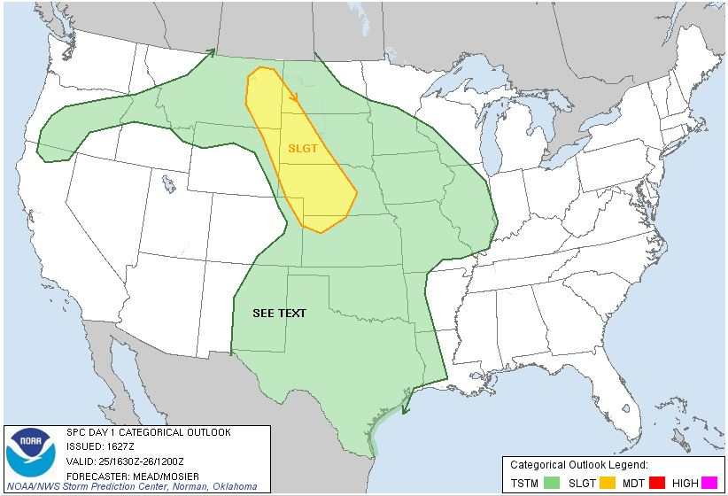
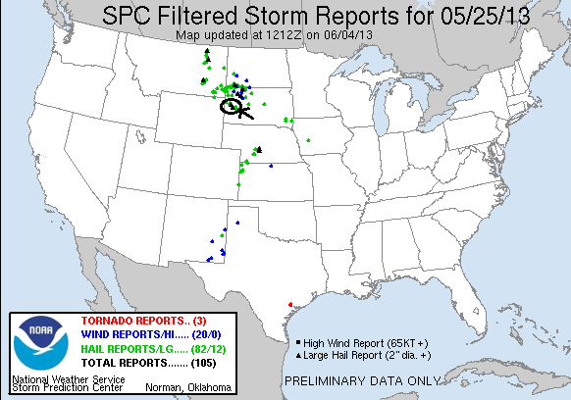
Prime Time Tour, Day 6, May 26th 2013
A day with multiple levels of frustration followed by great reward: We awoke in Spearfish, SD with the intention of chasing in Montana but a look at the morning models quickly changed our focus to a more southern target in central Nebraska. Both target areas had issues: The Montana target had better shear, but looked to lack the necessary instability to support anything other than high-based storms, even in the higher terrain up there. In Nebraska, the instability and moisture was there to support strong tornadic storms, but the question was whether the shear profile would get it done. The models thought it would, and we needed to be in Kansas the following day regardless, so we adjusted our target to Thedford, NE, but left very late as we’d expected only a 2 hour drive to our target and not the 4-5 hours it would take to get to Thedford.
As we headed east on I-90 in the soup north of the warm front, it seemed like we’d never get south before initiation as there was already a developing cumulus field in west Cherry County and a mesoscale discussion was issued for that area. However, as we headed south begging for the cap to hold on until we got down there, the cumulus field more or less died and as we emerged into the Sun south of Valentine, NE when we crossed the frontal boundary, the whole area looked capped to the point where we wondered whether initiation would happen at all. We reached Thedford at about 5:30 with no sign of anything happening and waited for over an hour before finally towers exploded to our north and east and we were off and running. Between Dunning and Anselmo on Rt. 2 we were faced with a tough decision: The updraft we were targeting to our east was the oldest, but despite the strong convection and broad updraft, it didn’t seem to be doing much, while a younger updraft to the north quickly generated an overshooting top and cloud heights above 50 thousand feet. We continued past Broken Bow trying to decide whether to break off and head north up Rt. 183 to intercept the northern storm, but as we got near Westerville and up along the side of the updraft the structure on our storm was incredible! We could not possibly bail on the storm regardless of what was going on up north with this tank of an updraft just to our south, so we headed east through the north edge of the hail core and stopped to film the big barrel base with laminar striations on the bottom and a crisp spiraling updraft above. In fact, the structure was so good that we didn’t hesitate getting out in order to video the storm despite the golfball sized hailstones that were falling all around us!
Soon the updraft was literally right on top of us and anvil lightning began striking behind us, so it was time to get out of Dodge and back in front to continue to watch the storm develop. We passed through Arcadia and stopped again with a more distant view of the magnificently structured supercell, then again moved on towards Ord, still keeping our options open for heading towards the north storm. Since initiation had been so late however, we decided that even if we did break off and head north we’d never get to the northern storm before dark. When our storm became tornado warned, we decided to focus on it and headed west on dirt roads trying to get a closer look at the base. The road network killed us though, passing through wooded areas and down into valleys that frustrated us over and over, so we popped back out on Rt. 70 and headed west back towards Arcadia, then stopped and watched the unbelievably structured storm, backlit against the setting Sun and throwing cloud to cloud and cloud to ground lightning prolifically. The storm by now had a rear inflow band that seemed to extend southwest all the way to the horizon and was just a textbook-diagram looking storm.
After spending 30 minutes or so filming the awesome lightning display, we again headed towards Ord to possibly get a look into the notch of our storm, or possibly take a look at the now massive HP storm the northern cell had become. Our cell died though, and as we got to Ord we gave up and headed for our hotel in North Platte. On the way back we were treated to an excellent lightning show from the northern cell that was rapidly plunging south and back building. I ended up taking a lot of video with the dash cam of the lightning that was illuminating the nice mammatus field just to our north.
What a great storm from a day that looked like it was going to be a failure several times! We finally made it to the hotel at about midnight after a 580 mile trek, for a 6 day total of 2827 miles.

Day 6 1630Z Convective Outlook and Storm Report:
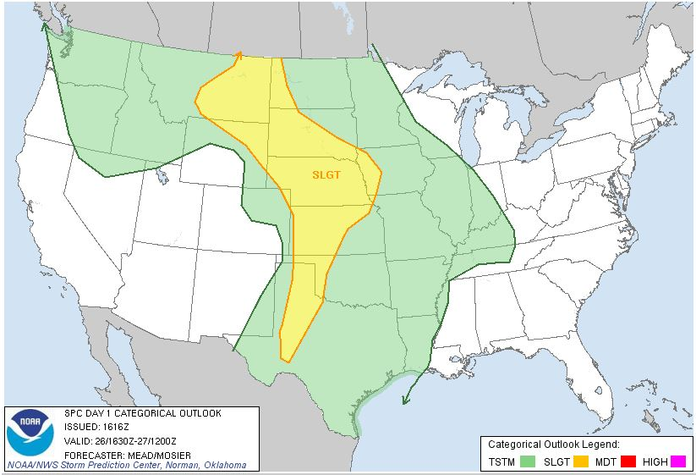
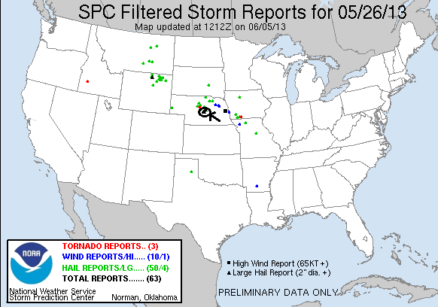
Prime Time Tour, Day 7, May 27th 2013
This was a promising chase day with an extremely easy forecast: surface low in western Kansas, sagging cold front along the Kansas / Nebraska border, and a dry line equaled triple point play in north-central Kansas! Because the forecast was so easy though, it meant that ALL the chasers would be there, and this turned out to be true. We left North Platte then headed east on I-80 then south down Rt. 183, crossing into Kansas then stopping for lunch in Stockton, KS. Since the atmosphere was not yet ready for initiation, we found a nice park and hung out there for an hour or two waiting for things to get going. There were storms happening in eastern Colorado, and some suggestion that the only place the cap was going to break was on the dry line near Hutchison, but we still felt that the area we were in could be the “sweet spot” for the day. We considered heading down to I-70 to make it easier to play all 3 options but then storms started firing to our north after finally breaking the cap.
While the storm to our north was strengthening rapidly, it was already moving north towards the frontal boundary, and we knew that if the cell crossed into the cold air it wouldn’t last long. Luckily, additional cells were firing down the flank of the first storm towards the south, so all we needed was for one of the tail end storms to turn right and stay south of the front rather than crossing it. We got our wish north of Phillipsburg, and soon were off onto the dirt roads to the east of Rt. 183.
The southern-most storm on our line immediately took over the show and turned straight east right towards us, showing rotation on radar and soon developing a big hook echo. The hook echo was clearly visible, with low level stratus being ingested into the storm and the long hook extending from our right to the northeast all the way around and coming back towards us from the southwest. The storm looked like it was getting ready to tornado but it was also still expanding south, and soon, rain and hail was falling around us and threatened to swamp us on the roads if they became muddy, so we bolted east then south on dirt roads north of Kensington to get away while still keeping in contact with the hook echo region of the storm. We kept proceeding east and south on dirt roads just ahead of the hook, trying to keep out of the rain and stopping every time the storm tried to spin up. At one point, north of Smith Center, there was a notable dust swirl that persisted for a minute or two that was reported as a tornado, but we weren’t sure that it was so we didn’t count it. Heading towards Esbon the storm looked ready to tornado several times and at one point generated what looked to be a “scud stovepipe” that might have tricked some people, but it wasn’t rotating. Unfortunately, just to the east of that location the storm WAS generating what looked to be a truncated cone tornado based on pictures another chaser showed us, but that area was obscured from our vision by trees. At Esbon we hit pavement and, because we had 2-wheel drive 12 passenger vans, we had to head south to get off the dirt before we got stuck. Those with 4-wheel drive who headed north into the notch ended up seeing a wedge tornado buried in there! Ugh, but what can you do, you can’t put the guests at risk.
With the storm looking more and more HP and additional cells firing to the south, we broke off the northern storm and headed down the line, practically retracing our steps of May 29th, 2008 when we caught the Glen Elder / Beloit tornado. This time, however, the results were not as good as, even though the severe indices for the environment we were going into were off the charts, the storms died one after another as we passed one core near Beloit, another near Lincoln, and then finally the last two near I-70 and Ellsworth. By the time we’d finished a gas break in Ellsworth the show was completely over and we headed to Salina for the evening. It ended up being another relatively easy driving day, 405 miles for a total of 3232 miles on the tour.

Day 7 1630Z Convective Outlook and Storm Report:
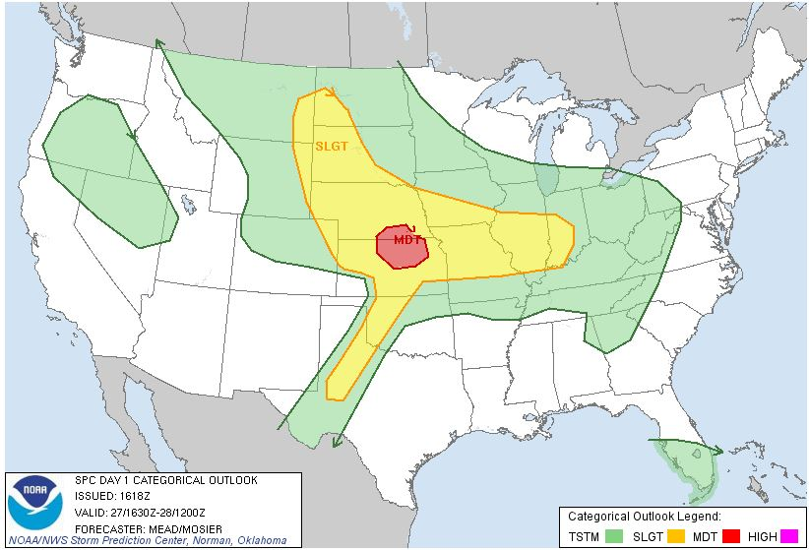
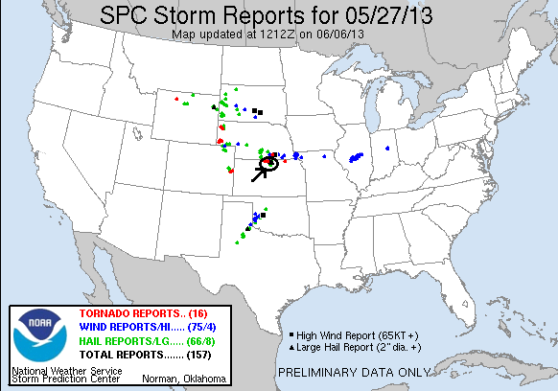
Prime Time Tour, Day 8, May 28th 2013
A great chase day and the shortest I’ve ever driven for a chase! The toughest part of this day was figuring out our target. We started the day in Salina, KS sleeping in a little and waking to discover that we had 3 distinct targets to consider: Northeast Kansas just east of where we were along the boundary with a good combination of shear and moisture, a nice high plains setup in Northeast Colorado, or the southwest part of the boundary near Dodge City, KS. We agonized for a bit and told the guests we’d meet an hour later, then decided that at least we would not take the Cheyenne Ridge bait and hedge more about where on the boundary to play, so we waited, then went to lunch, hung out at Walmart, then parked at the Petro on the north side of town and waited some more, as by now we’d decided to play the northeast target. Problem was, it looked like we’d waited too long with a cell already dropping a tornado in the Manhattan, KS area, 100 miles east of us and out of range! We calmed down and reasoned however that if we could get a cell to develop and right turn into the same environment the Manhattan storm developed in, it might do the same thing.
We continued to wait as towers bubbled all around us and more and more chasers parked at the same gas station with us, until finally an updraft just to our west took off and we headed out north on old Highway 81 after it. The storm was not moving fast at all, and we were easily able to get east of it, parking just off Rt. 18 west of Bennington. As we watched, the storm, which was really a group of updrafts, began to congeal into one supercell and showed immediate signs of rotation, much as the Manhattan storm had. We kept our fingers crossed as a cell to the south merged with it, and storm survived and was soon a rotating monster! The rotation under the mesocyclone continued to increase until, 35 minutes after we initially parked, a long elephant trunk funnel formed, making it 2/3 of the way to the ground (there were some reports of a brief touchdown but we were not in a position where we could see it) before dissipating a minute or two later with a neat ropeout. By now, the wall cloud was spinning like crazy and it was only a matter of time before it tornadoed, and 15 minutes later the storm dropped a big cone about 3 miles west of us and slowly coming directly at us. We then watched as the huge cone lasted for almost an hour, barely moving at all. As it got closer you could get a good feel for the motion of the tornado, and soon Bennington was sounding their tornado sirens. As the tornado closed on us, it spawned a brief satellite tornado to its south and then occasionally got wrapped in rain, peaking in and out as the rain curtains wrapped around. Soon the tornado turned into a monster half-mile wide wedge, sort of reminding me of the Quinter tornado of 2008. What a moose! The structure and motion of the storm was incredible, with a striated updraft and inflow bands streaming in from all directions and wrapping around the updraft.
As we sat still in our original spot now for the 2nd hour, something I’d never seen before happened: The storm began to retrograde and soon the storm and the tornado were moving west away from us! At this point the whole tornado was rain-wrapped from our vantage point, but the motion of the cloudbase and inflow told us it was still in there. Finally it seemed to wind down and the storm went into obvious HP mode, dumping well over 6 inches of water on the same area where the tornado had been grinding away. Worried about the flash flood warning, we finally left the area about 2.5 hours later, having never moved once after we stopped!
A fantastic chase day virtually right on top of us! In fact, I measured and from the Petro parking lot to where we watched the storm unfold was only 10.4 miles! Incredible! We headed to Logan’s Roadhouse for a nice steak dinner, then to the hotel in Wichita for a total distance of 130 miles on the day for an 8 day total of 3362 miles.
The NWS Topeka Office has a writeup of this storm featuring tornado track, radar, and damage pictures at:
http://www.crh.noaa.gov/news/display_cmsstory.php?wfo=top&storyid=94990&source=2
The Washington Post also had a very good description of the meteorology that caused the storm to just “sit and spin”:
http://www.washingtonpost.com/blogs/capital-weather-gang/wp/2013/05/30/how-a-violent-tornado-stood-still-bennington-kansas/
Day 8 1630Z Convective Outlook and Storm Report:
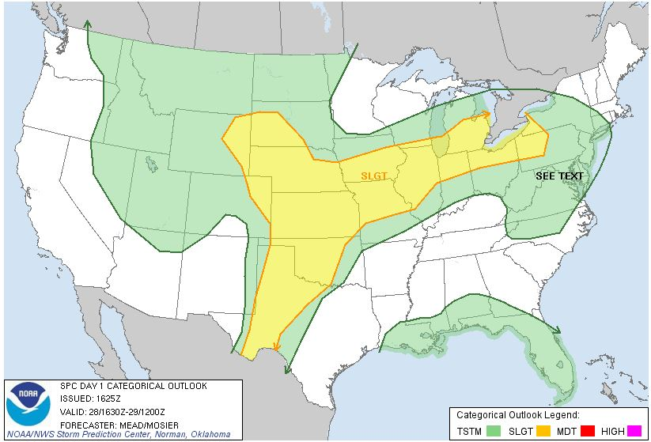
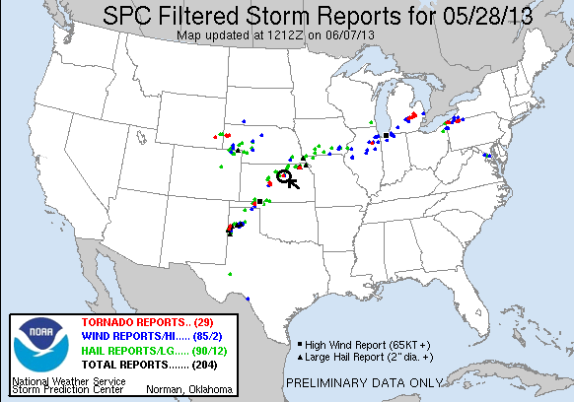
Prime Time Tour, Day 9, May 29th 2013
Another moderate threat day: this time on the eastern Texas / Oklahoma Panhandle. The forecast was for early day convection out ahead of the boundary on the extreme end of the Panhandle to give way to 3 or 4 violent supercells relatively early in the day that had a chance to be tornadic for the first couple of hours before the storms went linear. Well, that’s not how it played out, but ultimately we still had a decent chase day.
Knowing it was going to be an early show and starting in Wichita, the plan was to go west as fast as possible into the target area before heading south towards out target which was Perryton, TX. We left the hotel and headed west on Rt. 54/400, stopping in Pratt to grab lunch, then continued to Minneola and headed south. It was only 1 PM or so by this time, but already storms were firing on the boundary. Soon the focus of the mesoscale analysis shifted from the Panhandle to central Kansas and we became concerned that we’d missed the boat on the target.
We took Rt. 283 down to Shattuck, OK and waited for a while to decide what to do. There were storms everywhere: Just north of the Kansas border, a linear system near Amarillo, and what was left of the elevated storms from earlier in the day to our east that occasionally showed signed of intensifying.
As the 80 mile-long line segment south of Amarillo intensified, different segments of the line were tornado warned and the rest was severe warned so we decided to target the southern end and hope that the line would break up into discrete storms. We headed down Rt. 283 all the way to Sayre, then west on I-40 and south again out of Erick on Rt 30. As we got south of town, we could clearly see the big shelf cloud from the storms approaching from the west, but the line weakened rapidly as it got to us. We stopped for a while and then tried to go meet the tail end storm out on paved county roads near Lake Hall that extended right to the Texas border.
By now, the low-level jet kicked in, and to our surprise the storms quickly re-intensified and we went back after the southern cell, stopping on Rt. 30 about halfway between Lake Hall and Erick. As we waited there the storm suddenly started to exhibit rotation and got stronger quickly and fairly large hail started to fall around us, so we retreated to the south, then turned around to nudge along the storm and work our way to the interstate. Suddenly, big hail started crashing down around us and a tennis ball sized stone broke the window of the lead van! So, we retreated south again, and as we stopped at the same location we’d waited at before for a third time, I jumped out of the van and just to our east there was a big spin up occurring on the ground, with clear rotation overhead! We watched for a few moments as the spin up persisted and tore off to the east up a ridge and over, the circulation above it all the while. After looking at it, I’m convinced it was a developing weak tornado.
To continue chasing the intensifying storm, we needed to get out in front, which meant getting on the interstate. Once the hail core passed, we blasted north into Erick then took a wild ride east, splitting the cores of our storm and another just north of it through heavy wind, rain, and quarter sized hail, popping out in front near Sayre. We got off the highway and headed east on Rt. 152 as the now tornado warned storm approached from the southwest. Though it had its moments, it never got too close to producing another tornado and eventually went high-precipitation as the Sun set. We went as far east as New Cordell before calling it a chase and heading north to Clinton for dinner, where we were cored again while sitting in the restaurant. We still weren’t quite done yet though as on the way to the hotel we passed just north of the core yet again, with a rapid-fire lightning display occurring over and south of us as we passed through near Weatherford. Finally, we punched through and went to the hotel in OKC.
So, a frustrating chase day that turned around into a solid 3 hour chase at the end, though it certainly didn’t live up to the moderate severe threat category. We drove 554 miles for the day, for a total of 3916 miles.

Day 9 1630Z Convective Outlook and Storm Report:
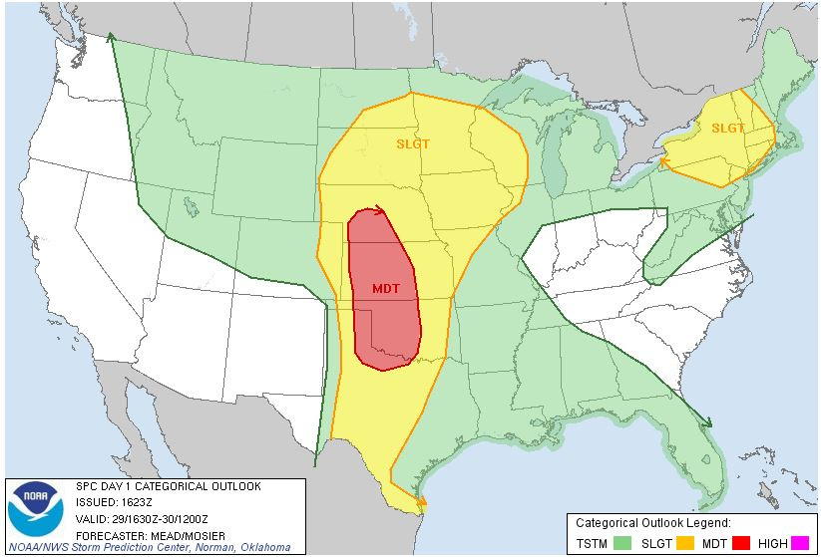
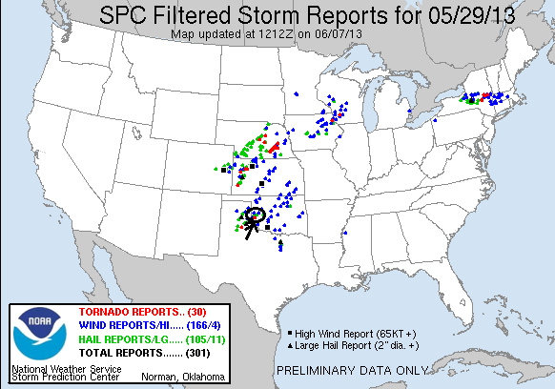
Prime Time Tour, Day 10, May 30th 2013
Another moderate risk day, and since it was Day 10 and we were already at the host hotel we were able to leave our stuff at the hotel and just bring our chase gear with us. Being in our target area already, were able to loiter around Oklahoma City for a lot of the morning and early afternoon as we knew the storms would initiate relatively close to the city, starting to the north near Enid and then building south roughly along I-44 towards Lawton. After lunch and more waiting, the first storms fired and we headed southwest on I-44. Immediately we were posed with a choice between a more northern storm up near El Reno that looked better on radar, and a younger storm to the south coming up towards Chickasha that was in what appeared to be in the area with the better shear profile. The issue with the northern storms, we feared, was that they would become linear pretty early, merging with an MCS that was already active in Kansas. This did turn out to be true, though the tail end storm hung together longer than we expected, and much later that evening produced a tornado far to the east in Broken Arrow near Tulsa. We stopped at the rest area near Chickasha for a while trying to decide, and then, with the Chickasha storm clearly visible with a broad base and long inflow band to our south, we decided to go after that one, quickly getting through Chickasha and towards Anadarko on Rt. 62. Almost immediately the storm generated a solid wall cloud with rotation as we watched it move by to our northwest, but it never seemed to generate enough focus at the lower-levels, a common theme for the day.
We followed the storm northeast on Rt. 277 towards Blanchard, and it looked like it was ready to tornado at one more point as we stopped for a while east of Dibble (while the locals got ready to head into their storm shelters), but it again never quite got the focused rotation needed to tornado, and we were soon drawn south on Rt. 59 through Lindsay towards the next storm, as there were now a number of isolated supercells to our southwest in a line all the way down to the Red River. After dropping south on Rt. 76, we were soon retracing our route from the Moore tornado day and heading west through Bray to just east of Marlow, where we intercepted another storm with huge hail and rapid rotation that was turning hard right and coming right towards us! We stopped several times, staying just ahead of the core, and eventually ran south on the exact same road we’d seen the brief tornado on east of Bray on the Moore day. We stayed out in front of this storm, which had morphed into a high-precipitation hail storm with baseball-sized hail reported, all the way down to Tatums, where we again stopped and watched the big, teal glowing core pass us to the north, all the while looking to two more supercells, that were alternately being tornado warned, down towards the Red River to the south. Another theme of the day was constantly being torn between storms: From each radar scan to the next we’d be drawn towards a different storm, and every time we left one, it would seem to briefly cycle back up and tempt us to turn right back around.
Again the pattern repeated and after heading south through Fox then east on Rt. 53, we jumped on I-35 and headed south towards Marietta near the Texas border to intercept the last two storms in the line that were right along the Red River. Heading west out of Marietta, we stopped near Falconhead Country Club near Burneyville, OK and watched a textbook LP supercell just to our north, with almost perfect LP storm structure. It was clearly shriveling up not long after we arrived though, and we decided to head back north towards the hotel to intercept another big storm up there along I-35 on the way. First, however, as we headed east, the last supercell in line came across the river, and even though it looked to be dying, it was still tornado warned so we turned around and headed through the core just west of Falconhead, getting heavy rain and wind but only the smallest amount of hail. We turned around and headed back to I-35 to a pretty funny sight: what was left of that storm by the time we got on the highway was just the littlest poof of an updraft attached to what could be barely described as a tiny little anvil on top.
Heading back north, we were faced with a huge HP supercell coming across the highway. The structure as we neared the storm at dusk was amazing, mostly because it was just so incredibly big! The base of the storm seemed to stretch on for miles, with a giant rear flank inflow band to the left and a huge cow-killer shelf cloud in front. With structure that good, we had to stop briefly south of Davis, then were able to split between two big cores as we crossed under the storm near Paul’s Valley. Finally, after a dinner stop in Purcell (Braum’s!) we headed back to the hotel, completing the tour.
Lots of storms on this day, but the low-level shear just didn’t get it done. I don’t think I’ve ever chased so many tornado warned storms on the same day without any of them even managing so much as a decent funnel cloud! There were virtually no tornadoes in the moderate threat area for the day, while far to the north where nobody would have expected and nobody was chasing there were a number of them up in Nebraska. Mileage for the final day was 395 miles for a tour total of 4311 miles.
Day 10 1630Z Convective Outlook and Storm Report:
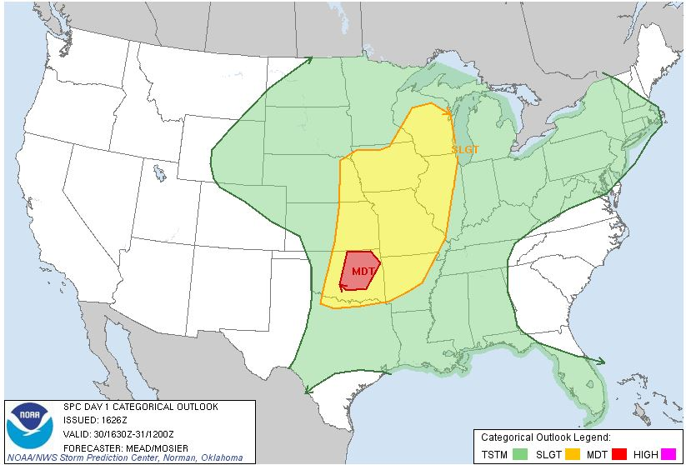
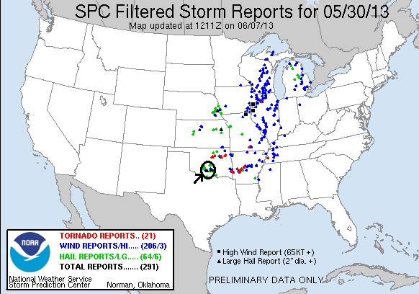

A really fun tour (and pre-tour)! For the tour, 3 tornadoes and a ton of great structure on storms through Oklahoma, Texas, Colorado, Nebraska, South Dakota, and Kansas, plus 4 more tornadoes for me on my arrival day and the tour’s arrival day. On the tour, we chased 9 out of the 10 days with only one of them being an overall bust (Day 1 east of Dallas), and the other off day was a positioning day, so there was really no downtime at all. This was by far the least mileage I’ve covered on a 10 day tour at 4311 as they are almost always over 5000 miles. Overall, of the 12 days I chased, 7 were moderate threat days, a very active period in what was supposedly one of the least active years of all time!

