The following is the tour summary for Silver Lining Tours Tour 3, 2010. The SPC Storm Reports for each of our chase days with our chase area outlined were compiled by Boris Konon, and the daily GPS logs were recorded by Cathy Murphy. Thanks Boris and Cathy!
Tour 3 Day 1, May 18th 2010
WOW!!!! What a chase day! We started in OKC with an initial target of Dalhart, TX. Though our eyes were occasionally drawn to the great conditions up in Colorado, we stayed with our target area and waited in Dalhart. Finally, around 5 o'clock, the old Panhandle Magic kicked in full bore. A blip on radar developed just southwest of town, and we quickly decided to go after it. In a very short period of time, the storm went severe and started dropping big hail. We got to it just west of Hartley, TX, where the storm quickly produced a low hanging wall cloud just to our west. After watching for a while, we nosed back north, getting banged around by golf-ball hail and driving past fields loaded with recently fallen hail. Meanwhile a second cell had formed and we found ourselves needing to blow through the gap between the two despite the hail. As we made is about 1/2 way through, it appeared the southern cell was going to drop a big wedge tornado just south of our position! We managed to get through the cores and ended up in a chaser's dream scenario. The two cells merged into a monster supercell that more or less traveled on and easterly course just north of our east-west road for the next several hours.
We stayed ahead of the storm, stopping every few minutes and watching until the hail core caught up with us. Meanwhile, the storm had developed FANTANSTIC structure and cycled wall cloud after wall cloud. In between Hartley and Dumas, after forming several funnels, the storm finally dropped a very brief elephant trunk tornado. As we continued to stop and go to the east, the inflow became awesome, howling towards the storm at 50-60 MPH at times and remaining active for just about the rest of the chase. Meanwhile, the storm had a massive vault area and the hail roar was plainly audible and the core glowed green with hail.
After we moved east of Dumas, the storm produced a second, this time cone shaped, tornado partially wrapped in rain, and then simultaneously produced a second elephant trunk to the north (which I sadly did not see). The cone lasted for a minute or two before it dissipated. In the next cycle, the storm formed a big block wall cloud just across the field from us and looked ready to drop a big tube right in front of us, but somehow did not.
Finally it looked like our chase was coming to an end as we were nearing Stinnett, TX and with Lake Meredith to the town’s east it looked like we were out of roads. We decided we'd head to the north side of town to watch the still amazing structure as it went by us and off into the river valley, when the town’s tornado sirens started blaring. Then, as we came over a rise and got a clear view, the storm dropped a big stove pipe / cone tornado right on the front of the storm's mesocyclone! We then proceeded to drive up and down the north road into little notches between big cores and the storm continued to produce funnel after funnel almost right on top of us. When the largest core went by it was an awesome sight with a massive hail shaft moving slowly across the field just east of us, and the tail end mesocyclone spitting out funnel after funnel to our west.
Eventually, with darkness falling we decided to call it a day and head to the hotel which conveniently was less than 60 miles away.
What a day! The storm surpassed the entire Tour 3 2009 in about the first 2 hours! And this was supposed to be the warm up for the big day on Day 2 in Oklahoma!
Mileage for Day 1 was 513 miles.

Day 1 Route and Storm Report:

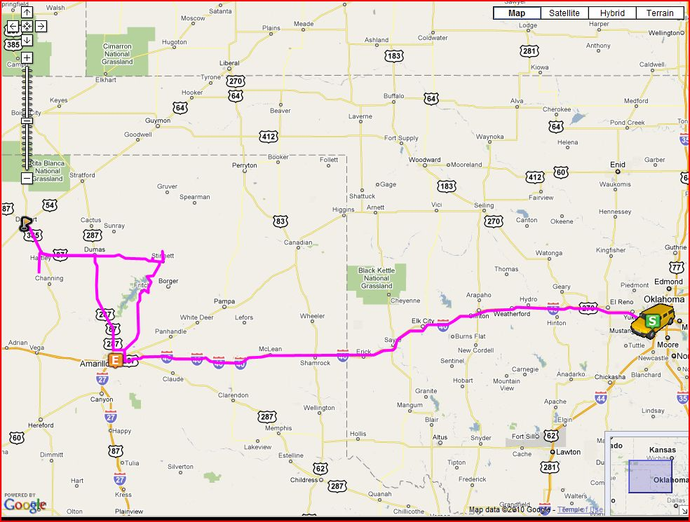

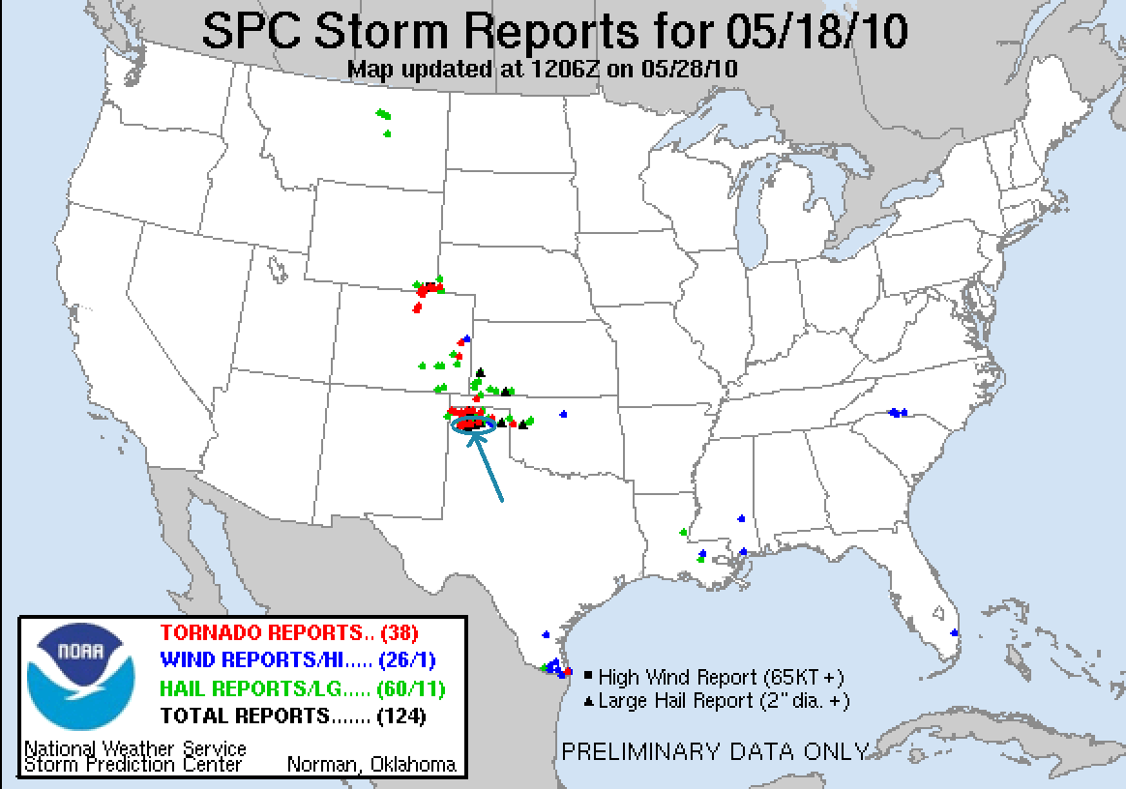
Tour 3 Day 2, May 19th 2010
A crazy, crazy, high excitement, high stress chase day! We started in Amarillo, TX and headed east to Clinton, OK, targeting the junction of the outflow boundary left over from the previous night's storms and the dry line coming in from Texas. Watching spotter network as we headed for our target, it was apparent that every chaser within 500 miles also had similar ideas.
Storm initiation was early, and by 2:30 we had a supercell exploding to our north, just past the Canadian River. We head north towards Taloga. About halfway there we decided to proceed west towards Leedey to get a closer look because of road network issues and were surprised as we came rolling over a hill to see a large cone tornado way off in the distance! It was difficult to tell if it was on the ground from where we were, but Vortex 2 teams and other chasers confirmed it.
We then turned around and went east and north to get right up to the notch. At this point, the storm was riding along the boundary instead of crossing it and seemed to be losing organization, and we started considering whether we should target a different storm. We could see another monster storm off to the east near Enid, and soon that one was dropping tornadoes, but there was no way we could catch it. So, we decided to stair-step south and east towards Watonga and keep an eye on our storm and others nearby. By this time, the chaser convergence was already becoming ridiculous. There were literally hundreds of vehicles sharing the 2-3 roads that were in the vicinity of the storm.
As we passed through Watonga, the storm rapidly re-intensified into a monster with a distinct hook on radar. We needed to get north and east fast, and with the traffic, this is where things got VERY interesting… We were now hopelessly mingled into a convoy of hundreds of cars weaving through Watonga. Our goal was to beat the hook to Hitchcock, but we didn’t have much time. At a stop light in town, we decided to cut the corner through a gas station parking lot to beat the traffic at the light. Vans 1 and 2 beat the gaggle. My van and Stu Robinson’s, who was with us, did not… We found ourselves several cars behind vans 1 and 2, and in particular stuck behind the “Hummer Chase Vehicle” which was rumbling along at 30 MPH. By the time we finally got by that, vans 1 and 2 were far ahead. Then, as we passed through Hitchcock, a state policeman came flying up and passed us, then stopped a short way up the road. As we were near the hook, I thought he might be going to block the road, but as we slowly went by him, he neither stopped us nor signaled in any way, so we moved on, and then he pulled out behind us, blew by us again, and again pulled over. He did this a 3rd time, costing us more precious time. As I think about it now, I wonder if he figured, well, we were chasers and probably knew what we were doing, so it was OK to follow us? Finally, we got out ahead of him and started to punch the hook. While the rain and wind were heavy, apparently the updraft was strong enough to keep the hail aloft. As we punched through the west side of the hook, the wind blasted us intensely from the north, and then slowed, so I knew we were inside the "bear cave". Suddenly, the wind picked up violently to our south and Stu started screaming over the radio “tornado!” as the top of a tree just off to our right VAPORIZED as we went by and we got blasted by flying debris, dirt, rocks, leaves, you name it! As I looked in my rearview mirror, the suction vortex shot across the road just behind us and out into the field to our 8 o’clock! Stu had slammed on his breaks as the vortex passed right between us! Luckily, it was a relatively weak rotation so I was able to keep the van on the road when we got slammed and get us east. With the developing tornado behind us, I pulled to the side of the road a little to take a look, but the guests on the right side of my van starting yelling that there was another funnel coming up from behind us, and I couldn’t see from my driver’s position, so I blew east and out of the hook to get us to safety, with Stu following close behind. As we exited the hook, a fire department truck turned and blocked the road and was very slow in deciding to let us out, all while we had a developing tornado coming up behind us!! Finally, he moved and we rejoined van 1 and 2. No time to stop and chat though as a new tornado, a much more robust cone, formed in the rain not far from us. We headed east, and then had to race south towards Dover, OK to get past the rotation… behind the Discovery Channel team and the TIV, who for some unknown reason decided to go about 10 mph down the road. Then, they stopped abruptly and the whole crew, including the TIV that is supposedly trying to intercept tornadoes, pulled a u-turn in the road with no regard whatsoever to the pile of traffic wedged in behind them! We were now hopelessly stuck with the rain wrapped meso-cyclone just to our east, and moments later watched as a dark rain-wrapped cone tornado swept across the road no more than half a mile in front of us and off into the fields to our east, changing into a slender stovepipe as it drifted off into the rain.
We finally cleared the hook of the storm to the south and found, if it was possible, even worse chaser congestion. As we stair stepped east towards Guthrie, the storm had become an HP monster and was no longer really chaseable. We passed through Guthrie slowly, stopping here and there to get a view of the on rushing monster storm as the Guthrie tornado sirens blared, then headed south near Meridian to clear the core. Unfortunately, the road we had taken became an unpaved, muddy bog. With two cars in front of us, we inched forward knowing that we had about 10 miles of mud road to navigate. As we got clipped by the southern end of the core, we got into torrential rain and parts of the road appeared to wash out completely, and at different times we had the vans practically sliding sideways trying to stay out of the ditches. Suddenly, one of the two vehicles in front of us slipped off the shoulder into the ditch, hopelessly trapped, and his buddy stopped in the middle of the road! I figured once we stopped, we were toast, but finally we got moving again and after a long, sloppy struggle, finally hit pavement.
After a brief bathroom stop in Chandler (I think), we were back into chase mode again, heading down towards Shawnee towards a tornado warned storm. As we approached the incredibly wrapped up meso from the west, the storm had an eerie pink aura to it in the fading sunlight and the storm became highly electrified. Pretty cool looking. Finally it became apparent that we were not going to be able to get into position to see any tornado that was going on before well after dark and so we finally called it quits, returning to the host hotel in OKC, which was only 35 miles away.
This had to have been the most trying day of driving in my 8 years as an SLT guide. The chaser convergence down in Oklahoma is almost making it not fun to chase down there. Too much time having to watch traffic and not enough time to watch the storms. I looked forward to the following days when we’d be heading up north for promising setups that would hopefully be away from the majority of the masses.
Amazingly, with all that happened I got very little in terms of pictures as my hands were firmly cemented to the steering wheel all day, but I’ve got a few images in my head, especially the tree disintegrating right alongside us, that I’m not going to forget anytime soon!
Mileage for the day was 487 miles for a tour total so far of exactly 1000 miles, and 6 tornadoes in the first 2 days for me, even more for some of the guests!

Day 2 Route and Storm Report:

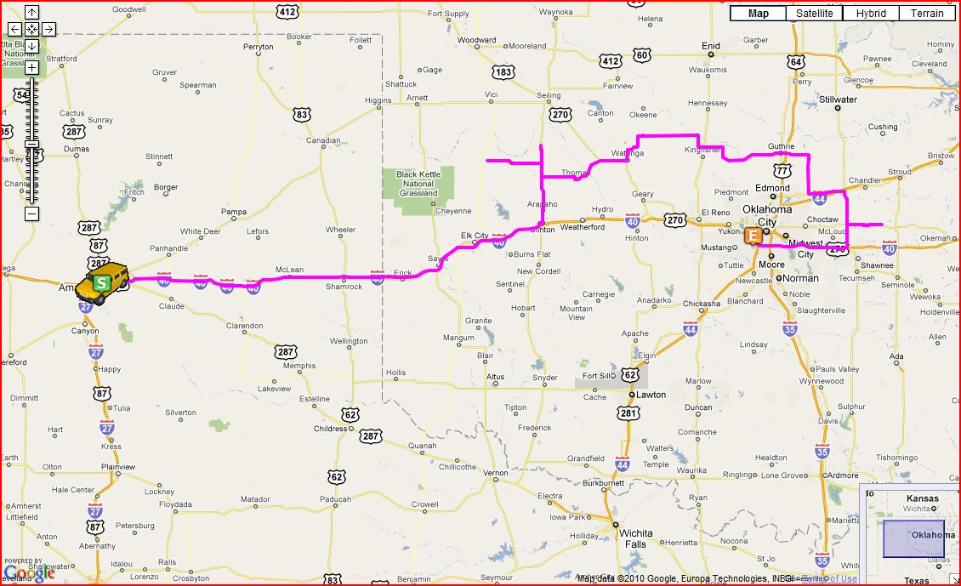
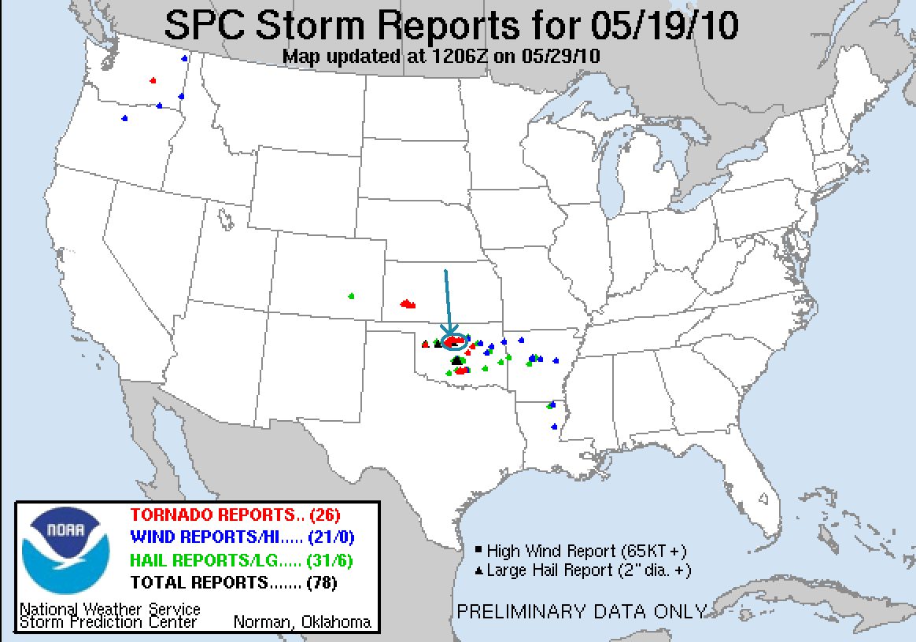

Tour 3 Day 3, May 20th 2010:
Travel day to Colby, KS to set up for what promised to be an active rest of the tour. We chose not to head down into Texas or Missouri because we'd never have been able to make it north for the next few days. Getting to Colby early allowed us to go to dinner at, where else, Twister’s.
Day 3 mileage 460, tour total 1460. We were running below average!
Day 3 Route:

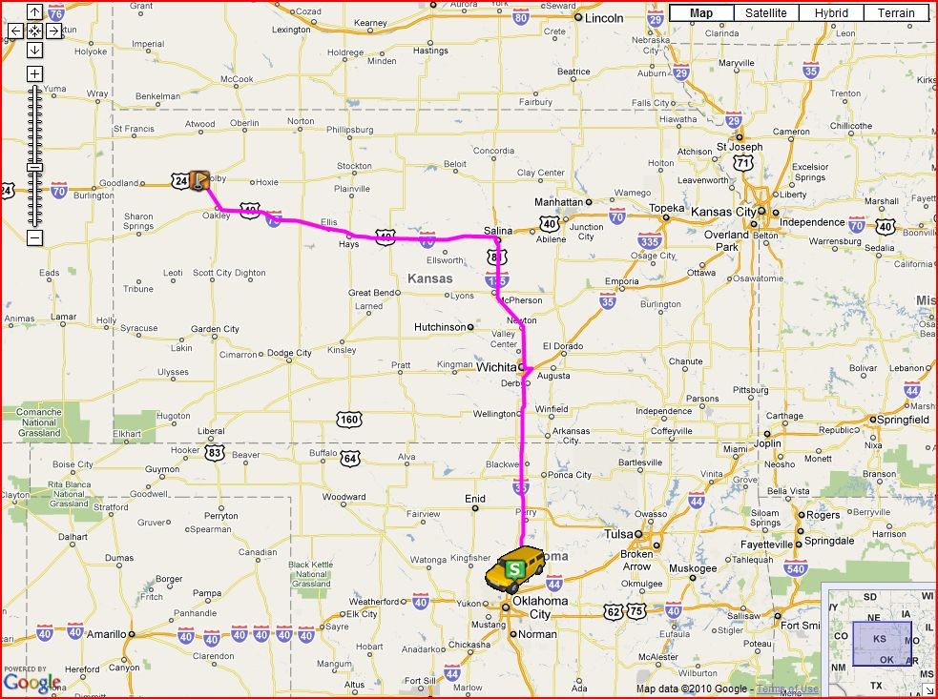
Tour 3 Day 4, May 21st 2010:
We started the day in Colby with the initial idea of heading up to Sydney, NE then over to Kimball to play storms forming on the Cheyenne Ridge. As we headed into Colorado, however, the conditions began looking better and better in the northern part of that state, so we decided to divert to Sterling, CO, which would give us more options in terms of roads letting us get to different targets. After stopping for lunch, it seemed like the atmosphere in CO was capped, and the moisture plowing into the Cheyenne Ridge made it look better and better, so we decided to head north for Kimball, NE, and by the time we got there storms were firing in the Laramie Mountains, so we proceeded west to Cheyenne, WY and then north.
Though the initial storms were all dying as they came off the mountains, one finally took hold up near Wheatland and we charged north on I-25 towards Chugwater. A little after we passed that town, off in the distance we observed a long, ropey funnel from the still high cloud base, which was later confirmed by several people as a tornado, number 7 of the tour for me and my first Wyoming tornado, albeit not a very exciting one. The mesocylone then occluded and we had some time to get right up to the storm, exiting the highway and heading east towards Guernsey. Right about this time, the storm had split, as is classic supercell behavior, and surprisingly the left split managed to survive for quite some time and visibly looked better than the right split for a while, though the right storm had the better radar signature and we stayed with that one.
This is where the road network began to take its toll. While the storm cycled, we paralleled it, driving east, but the road drifted to the southeast as we headed into Fort Laramie. We then headed north right to the updraft up the one paved road in the area that took us to Lusk. As we got to the updraft a new RFD clear slot was eroding, right ahead of us, but there was no well defined wall cloud. At this point, we ran out of road. Our only option was to blow north behind the storm to Lusk, then go east all the way to Crawford, NE, then south again, a distance of over 60 miles. As we headed north, we cut through the core of the north split and got some small hail, and after we turned east got into another significant hail field, which while there was a lot of it, was only of maybe quarter size at the largest. We were far enough behind the updraft of our storm that we were able to see two stacked plates of the rotating updraft and a nice double rainbow.
By the time we got east, the storm absolutely collapsed and fell apart into a stringy linear system. We got out in front of it and watched south of Crawford, but the show was more or less over and other than a couple of stops to see if there would be any good lightning opportunities, we gave up and headed for our hotel in Valentine, NE.
Luckily the storm never produced another tornado after we lost it because of the roads. It never seemed to be able to lower its cloud base enough to really go crazy. Perhaps the moisture, which was somewhat limited in the first place, was also surface based and not very deep.
A long driving day, 735 miles, for a tour total of 2195.

Day 4 Route and Storm Report:

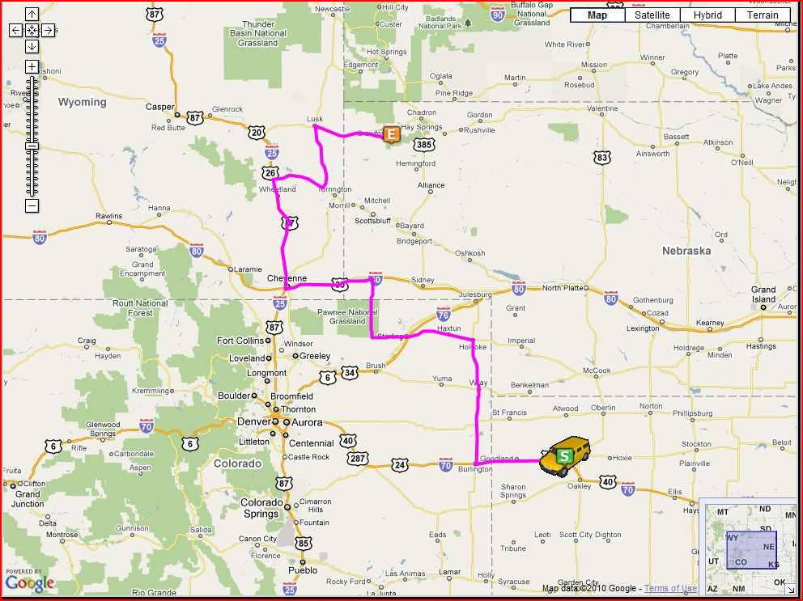
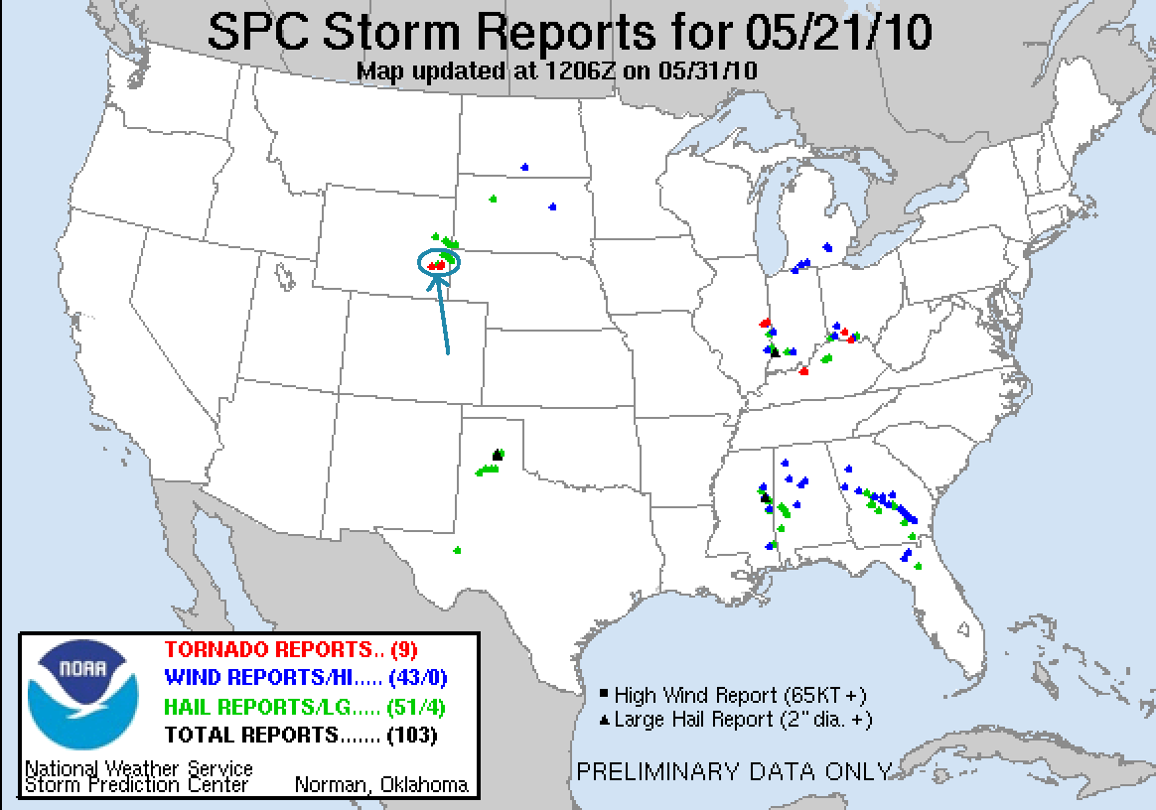

Tour 3 Day 5, May 22nd 2010:
If day 2 was “WOW”, there are no words to describe day 5. It was simply a once in a lifetime chase day. We started in Valentine, NE with an initial target of Pierre, SD. This was a high risk / high reward day. All of the ingredients were there, but so was a very strong cap that might prevent storms from firing at all. Our plan was to find the triple point and wait, hoping that the additional convergence there would allow an updraft to break the cap and get a storm going.
After lunch in Pierre, we decided that we needed to get north, and eventually stopped in Gettysburg, SD. It was clear that the triple point was almost directly over us: To our north, a line of cumulus towers being sheered over to the right, to our southwest, another line being sheered over to the left. We watched and waited as tower after tower went up, looking good at first but then sheering over and dying as the cap continued to win. Finally though, the cap broke and the show began. We headed north with our storm, which started showing supercell characteristics almost immediately. We stopped along route 83 north of Gettysburg and the storm developed a lowering and showed clear signs of rotation. As the storm moved over the road, we were forced onto a dirt road east through Lowry. As we got north of the town, it was obvious that the storm was going to tornado any second. Back on pavement we pulled to the side of the road as the storm produced a strong cone tornado coming almost directly at us! We watched for a minute or two, and as the tornado approached from the southwest moving northeast, we headed north to stay ahead of it. At the next road, we turned east towards Bowdle, while the tornado had temporarily dissipated. As the rotation crossed the north road where we had been it touched down again and I saw a suction vortex just miss a chaser who had just driven right up to it for some idiotic reason. As we raced east, the new tornado then became a massive stovepipe tornado with a big debris fan, just in the field behind us. I could only catch little glimpses as it was over my right shoulder as I drove, but as we got into Bowdle, I saw it crossing the road a ways behind us. Reports are that it took down the power poles and blocked a lot of the chasers, which would make sense because there were very few with us for the next stage.
Heading north out of town, the tornado was now a big wedge. We got as far north as we thought safe and watched it roll towards us. A big ¼-½ mile wide monster only about ½ a mile away from us! We could not have been in a better position: Right on top of it, but in little or no danger from the huge tornado! We were able to actually set up tripods and film as it closed in. We decided to move about a mile back south to stay clear of the RFD we knew was coming, but other than that we just watched and enjoyed. The best tornado of my chasing career!! As we sat and watched, a pickup truck raced over to us: The family that owned a farm just north of us that was directly in the tornado’s path. I have no idea whether it was hit or not but I certainly hope it was spared. (note: per the damage report below, sadly it was not)
Finally, we were forced to run south as the RFD got to us, blasting us as we headed back in to Bowdle. We bolted east towards Roscoe to stay with the right moving storm that was now moving almost due east. Getting out of Roscoe, our old tornado had died, but as we got to Ipswich, a new, nicely contrasted elephant trunk appeared almost right over Roscoe with a big debris fan. We again stopped and watch the elephant truck do its thing. After that tornado dissipated we headed north a few miles out of Ipswich and saw three more brief tornadoes, including two on the ground at the same time!
By this time, the storm was becoming an HP moose, with an angry green hail core coming right at us. Abandon ship! As we loaded up, the core right to our west totally collapsed in a clearly visible wet microburst, very interesting to see. We blasted south to get out of the way, and I watched several cars of locals heading north, apparently unaware that they were about to be pummeled with hail. I tried honking and pointing the other way to a couple of them, but nobody paid attention.
We decided it was time to bail from that storm and head south for the new tail end storm, which was also tornado warned. We were in perfect position to sit and wait for it, and as it came towards us we watched as three different times it tried to tornado but never did. The structure however was incredible: 4 layers of stacked plates, beautiful mammatus clouds, and a monster beaver tail. We watched for awhile and then decided to head for the hotel since we had a long way to go to get to Winner, SD, our stop for the night.
We headed south as the whole set of storms became a huge line segment running from Nebraska to Minnesota, in our path almost the whole way! We stopped in Miller, SD to gas up, and then decided to head west to blast through the cores, and then go south in clean air. Fortune was with us as there was kind of a hole in the line when we headed west, and we got through without much of an issue at all. We were then treated to a fantastic lightning show along the rear flank of the squall line, all the way for the 140 miles to our hotel.
The Bowdle Tornado was eventually rated EF-4. Here is the full damage assessment from the Aberdeen, SD NWS office:
http://forecast.weather.gov/product.php?site=MEG&product=PNS&issuedby=ABR
PUBLIC INFORMATION STATEMENT
NATIONAL WEATHER SERVICE ABERDEEN SD
230 PM CDT THU MAY 27 2010

...FINAL DAMAGE SURVEY RESULTS FROM THE 22 MAY 2010 TORNADO EVENT...

RESULTS FROM NWS STORM SURVEY DAMAGE TEAM ALONG WITH EYEWITNESS AND
MEDIA REPORTS INDICATE THAT A TOTAL OF SIX TORNADO TOUCHDOWNS
OCCURRED ON 22 MAY 2010.

...SOUTH CENTRAL WALWORTH COUNTY...

MAX RATING: EF-0
MAX WIDTH: UNKNOWN
PATH LENGTH: 0.1 MILES /ESTIMATED/
BEGIN POINT: 3 S OF AKASKA
END POINT: 3 S OF AKASKA

THE FIRST CONFIRMED TOUCHDOWN APPEARS TO HAVE BEEN ROUGHLY 3
MILES SOUTH OF AKASKA. THIS WAS A BRIEF TOUCHDOWN AND NO DAMAGE
WAS REPORTED. THIS IS CONSISTENT WITH AN EF0 TORNADO RATING WITH
WIND SPEEDS FROM 65 TO 85 MPH.

...EASTERN WALWORTH COUNTY...

MAX RATING: EF-1
MAX WIDTH: UNKNOWN
PATH LENGTH: 0.1 MILE
BEGIN POINT: 7 SW OF BOWDLE
END POINT: 7 SW OF BOWDLE

THE NEXT TOUCHDOWN TOOK PLACE ROUGHLY 2 MILES SOUTH OF HIGHWAY 12 ON
STATE HIGHWAY 47...WHERE 6 WOODEN POWER POLES WERE KNOCKED DOWN. THE
TORNADO THEN LIFTED SHORTLY THEREAFTER. THIS IS CONSISTENT WITH AN
EF1 TORNADO RATING WITH WIND SPEEDS FROM 86 TO 110 MPH.

...EXTREME EASTERN WALWORTH COUNTY THROUGH WESTERN EDMUNDS COUNTY...

MAX RATING: EF-4
MAX WIDTH: 3/4 MILE /ESTIMATED/
PATH LENGTH: 11 MILES
BEGIN POINT: 4 W OF BOWDLE
END POINT: 1.5 N OF BOWDLE

THE TORNADO RE-FORMED ABOUT 4 MILES WEST OF BOWDLE ON HIGHWAY 12.
THE TORNADO CAME DOWN ON A FARMSTEAD ON THE NORTHSIDE OF THE
ROAD...OR FORMED IMMEDIATELY TO THE SOUTH OF THE FARMSTEAD AND
TRACKED THROUGH THE YARD. SEVERAL OUTBUILDINGS WERE DAMAGED...WITH
THE RESIDENCE SUSTAINING SIDING AND ROOF DAMAGE. A STOCK
TRAILER WAS THROWN ABOUT 75 YARDS FROM ITS INITIAL POINT. TREE
DAMAGE WAS SUSTAINED ON THE WEST SIDE OF THE PROPERTY...WITH FALLEN
TREES LEANING TO THE WEST. ON THE EAST SIDE OF THE PROPERTY DEBRIS
WAS SCATTERED TO THE NORTHEAST. THE TORNADO CONTINUED MOVING
NORTHEAST CROSSING INTO EDMUNDS COUNTY AT THE INTERSECTION OF 133RD
STREET AND 323RD AVE. THE DAMAGE SUSTAINED AT THE FARMSTEAD IS
CONSISTENT WITH AN EF2 TORNADO RATING WITH WIND SPEEDS FROM 111 TO
135 MPH.

THE TORNADO CONTINUED TO TRACK NORTHEAST THROUGH WESTERN EDMUNDS
COUNTY...STRIKING A FARMSTEAD NEAR THE INTERSECTION OF 132ND STREET
AND 323RD AVE. SEVERAL LARGE COTTONWOOD TREES WERE UPROOTED ALONG
WITH DAMAGE TO SEVERAL TRAILERS. 3 GRAIN BINS WERE DESTROYED WITH
DEBRIS LOCATED SEVERAL HUNDRED YARDS TO THE NORTHEAST. THE RESIDENCE
SUFFERED SOME SHINGLE DAMAGE AND ANTENNA DAMAGE. THE MAIN TORNADO
TRACK WAS SOUTH OF THIS LOCATION...AND DAMAGE AT THIS LOCATION IS
CONSISTENT WITH AN EF1 TORNADO RATING WITH WIND SPEEDS FROM 86 TO
110 MPH.

THE TORNADO TRACKED TO A LOCATION ABOUT 1.5 MILES NORTHWEST OF
BOWDLE. THE RESIDENCE IS LOCATED JUST SOUTH OF THE INTERSECTION
OF 132ND STREET AND 325TH AVENUE. SEVERAL OUTBUILDINGS AT THIS
LOCATION WERE DAMAGED OR DESTROYED...WITH WIDESPREAD TREE DAMAGE
ON THE PROPERTY. THE MAIN HOUSE AT THIS LOCATION SUFFERED NO
DAMAGE. SEVERAL GRAIN CARS WERE ROLLED ABOUT 100 YARDS INTO THE
TREES BEHIND THE HOUSE. DAMAGE AT THIS LOCATION IS CONSISTENT WITH
AN EF3 TORNADO RATING WITH WIND SPEEDS FROM 136 TO 165 MPH.

THE TORNADO CONTINUED TO TRACK NORTHEAST TO A LOCATION ABOUT 1.5
MILES NORTH OF BOWDLE ON 132ND STREET. THE MAIN LIVING RESIDENCE
SUFFERED MAJOR DAMAGE TO WALLS WITH PART OF THE ROOF STRUCTURE
REMOVED. WIDESPREAD TREE DAMAGE WAS SUSTAINED...WITH MANY OF THE
TREES COMPLETELY DEBARKED WITH ONLY STUMPS OF THE LARGEST BRANCHES
REMAINING. TWO LARGE GARAGES WERE COMPLETELY DESTROYED WITH THE
CONCRETE SLAB WIPED CLEAN. THE VEHICLES IN ONE GARAGE WERE
ROLLED/TOSSED FROM 25 TO 100 YARDS AWAY. IT IS ESTIMATED THAT ONE
VEHICLE FLEW THROUGH THE AIR 75 TO 100 YARDS RESTING IN THE TREE
SHELTER BELT TO THE NORTH OF THE RESIDENCE. SEVERAL OTHER
OUTBUILDINGS WERE COMPLETELY DESTROYED. THE DAMAGE AT THIS LOCATION
IS CONSISTENT WITH AN EF4 TORNADO RATING WITH WIND SPEEDS FROM 166
TO 200 MPH.

LOCATED JUST NORTH OF THIS RESIDENCE...SEVERAL METAL POWER
TRANSMISSION TOWERS WERE TOPPLED. ONE TOWER WAS SHEARED OFF FROM
THE CONCRETE FOOTINGS AND TRAVELED AN ESTIMATED 400 YARDS AWAY.
THERE WERE 6 TO 8 OF THESE TOWERS TOPPLED. GROUND SCOURING WAS
VISIBLE ALONG THE PATH OF THESE TOWERS. THE DAMAGE TO THE TOWERS
IS CONSISTENT WITH AN EF4 TORNADO RATING WITH WIND SPEEDS FROM
166 TO 200 MPH.

THE TORNADO CONTINUED TO TRACK IN AN EASTERLY
DIRECTION...CROSSING OVER STATE HIGHWAY 47 JUST NORTH OF THE
INTERSECTION WITH 132ND STREET. A STATE RADIO TOWER WAS TOPPLED
AT THIS LOCATION...AND IS CONSISTENT WITH AN EF2 TORNADO RATING
WITH WIND SPEEDS FROM 111 TO 135 MPH. THE TORNADO LIFTED SHORTLY
THEREAFTER.

...CENTRAL EDMUNDS COUNTY...

MAX RATING: EF-0
MAX WIDTH: UNKNOWN
PATH LENGTH: 0.2 MILES /ESTIMATED/
BEGIN POINT: 6 WNW OF ROSCOE
END POINT: 6 WNW OF ROSCOE

ANOTHER BRIEF TORNADO TOUCHDOWN OCCURRED 6 MILES WNW OF ROSCOE,
OR ONE-HALF MILE NORTH OF THE INTERSECTION OF HIGHWAY 12 AND
STATE HIGHWAY 253. THERE WAS NO DAMAGE REPORTED WITH THIS BRIEF
TOUCHDOWN...AND IS CONSISTENT WITH AN EF0 TORNADO RATING WITH WIND
SPEEDS FROM 65 TO 85 MPH.

...NORTHEASTERN EDMUNDS INTO SOUTHEASTERN MCPHERSON COUNTY...

MAX RATING: EF-2
MAX WIDTH: 200 YARDS
PATH LENGTH: APPROX 17.0 MILES
BEGIN POINT: 8 NNW OF IPSWICH
END POINT: 2 NE OF WETONKA

THE INITIAL TORNADO TOUCHDOWN OCCURRED IN NORTHEASTERN EDMUNDS
COUNTY NEAR THE INTERSECTION OF COUNTY ROADS 128TH STREET AND
360TH AVE WHERE SECTIONS OF ROOF WERE REMOVED FROM A BARN. THE
TORNADO THEN TRACKED NORTHEASTWARD THROUGH PRIMARILY CROPLAND AND
PASTURE LAND TO NEAR DEERFIELD COLONY. SPORADIC TREE DAMAGE WAS
OBSERVED ALONG THE TORNADO PATH AND SEVERAL WOODEN POWER POLES WERE
COMPLETELY SHEARED OFF. A FARMSTEAD WAS STRUCK ALONG STATE HIGHWAY
45 JUST OVER THE MCPHERSON COUNTY LINE WHERE A CALVING SHED WAS
COMPLETELY DESTROYED WITH LARGE SECTIONS OF THE ROOF BLOWN OVER 100
YARDS. DAMAGE ALONG THIS STRETCH OF THE TORNADO TRACK IS CONSISTENT
WITH AN EF2 TORNADO RATING WITH WIND SPEEDS FROM 111 TO 120 MPH.

THE TORNADO CONTINUED MOVING THROUGH SOUTHEASTERN MCPHERSON COUNTY
NEAR THE INTERSECTION OF COUNTY ROADS 122ND STREET AND 366TH AVE. A
BARN SUSTAINED A MODERATE DAMAGE WITH ONE WALL COLLAPSED. MULTIPLE
SOFTWOOD AND HARDWOOD TREES WERE UPROOTED AND SEVERAL POWER POLES
WERE COMPLETELY SNAPPED NEAR THE BASE. THE TORNADO CONTINUED
EAST/NORTHEASTWARD THROUGH SOUTHEASTERN MCPHERSON COUNTY TEARING A
ROOF OFF A TURKEY BARN AT LONG LAKE COLONY AND CAUSING SPORADIC TREE
AND POWER POLE DAMAGE. DAMAGE HERE WAS CONSISTENT WITH WIND SPEEDS
FROM 111 TO 120 MPH. THE TORNADO CONTINUED NORTHEAST INTO WETONKA
WHERE SEVERAL SINGLE FAMILY HOMES SUSTAINED MINOR ROOF DAMAGE.
SEVERAL UPROOTED TREES WERE ALSO NOTED. THE TORNADO APPEARED TO
DISSIPATE ABOUT 5 MILES TO THE NORTHEAST OF WETONKA IN FAR WESTERN
BROWN COUNTY.

IN EARLIER STATEMENTS THIS TORNADO WAS SEPARATED INTO TWO SEGMENTS.
AFTER FURTHER ANALYSIS IT WAS DEEMED THAT THIS TORNADO WAS
CONTINUOUS ALONG A MAJORITY OF THE PATH. HOWEVER DUE TO THE
SPARSENESS OF DAMAGE INDICATORS...SHORT LIVED OR INTERMITTENT BREAKS
IN THE TORNADO PATH WERE POSSIBLE.

...NORTHERN BROWN COUNTY...

MAX RATING: EF-2
MAX WIDTH: 100 YARDS
PATH LENGTH: APPROX 1.0 MILE
BEGIN POINT: 8 WSW OF HECLA
END POINT: 7 WSW OF HECLA

EYEWITNESS ACCOUNTS INDICATE THAT A TORNADO TOUCHED DOWN
APPROXIMATELY 8 MILES WEST AND 1 MILE SOUTH OF HECLA NEAR THE
INTERSECTION OF 105TH STREET AND 396TH AVE. THIS TORNADO PRODUCED
DAMAGE TO ONE FARMSTEAD INCLUDING TEARING A ROOF OFF AN OUTBUILDING
AND THROWING GRAIN BINS 100 YARDS OR MORE. WIDESPREAD TREE DAMAGE
WAS ALSO NOTED. THE TORNADO CONTINUED NORTHEAST FOR ABOUT 1 MILE
DAMAGING ANOTHER OUTBUILDING AND DESTROYING A EMPTY GRAIN BIN BEFORE
LIFTING. MAXIMUM WIND SPEEDS ARE CONSISTENT AN EF2 TORNADO RATING
WITH WIND SPEEDS FROM 112 TO 120 MPH.
What an awesome day! It lacked nothing and I can’t think of a single thing that I would have changed!
Total for the day: 503 miles. Tour total: 2698

Day 5 Route and Storm Report:

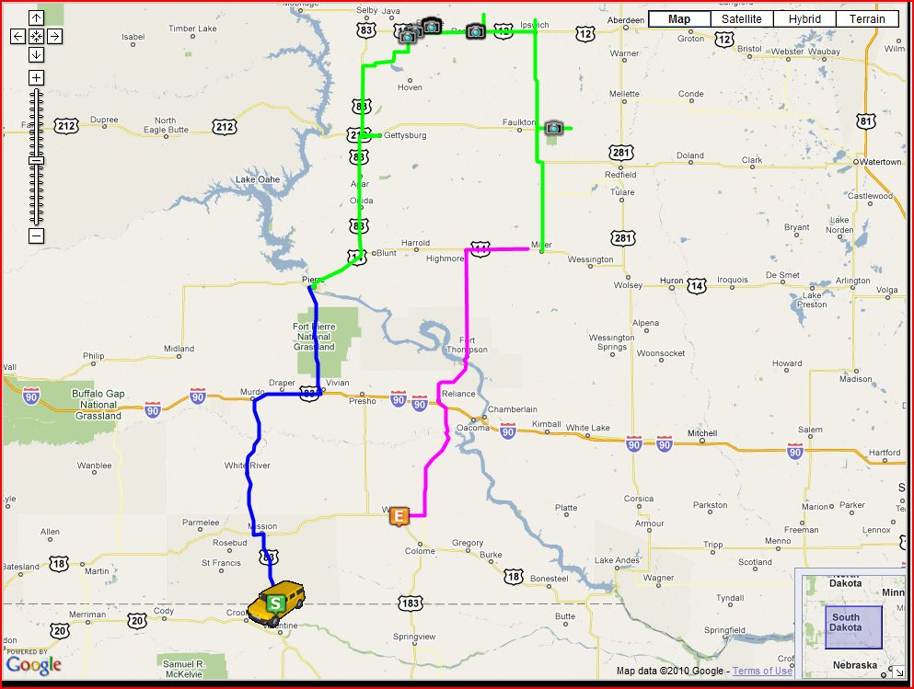
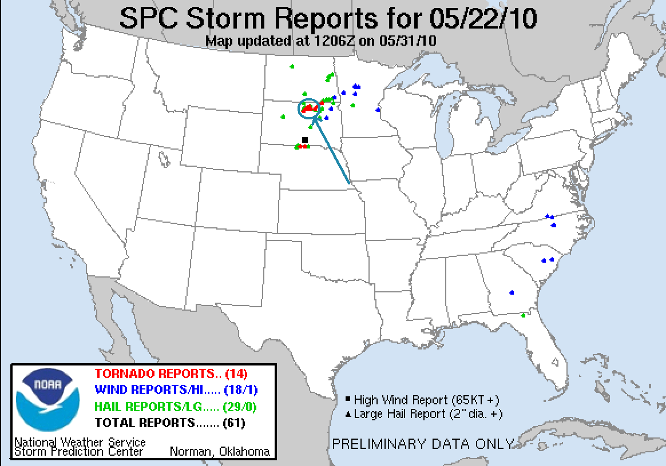
Tour 3 Day 6, May 23rd 2010:
Starting in Valentine, NE, this day’s target was the warm front / pseudo dry line intersection, which we expected to be somewhere in western Kansas. Visibly as we came south through Nebraska, it looked like a severe clear day: under the cap there was literally not a cloud anywhere in the sky.
By the time we got to Oakley, KS, the warm front was clearly visible on the horizon to our south and east, as was a storm far to the southeast near Wichita, and a few other cells due south of us near Dodge City that were forming on the pinch point where the front and dry line met. On radar though, they looked pretty horrible, and we could see that they had very high bases.
The storms started to strengthen a little as they came north (storm motion for the day was north-northeast). As they came up, we chose a cell to target and headed east on I-70 to get around them. We got off the highway near Park, and watched the storms come up towards us, but they looked disorganized. By now, there were several cells in the line and most seemed to be choking on cold air to their north.
One of the cells got tornado warned as it came up the line, so we elected to target that one, passing through some small cores as we headed west out of Oakley in the direction of Sharon Springs. As we drove past Winona, we saw the stick probes Vortex 2 deploys trying to get one hit by a tornado every 2-3 miles. A couple of the cells had decent structure but we didn’t see anything of great interest and when we arrived in Sharon Springs we found ourselves without a clear target and only an hour or so of daylight left. Our choices were to either wait for the cells that were tornado warned way down in Lamar, CO to come towards us or to chase a storm we’d blown off already that was north of us, but looked a little better on radar than it had in some time. As it also was heading in the general direction of our hotel for the evening, we decided to chase that one and headed north on the road to Goodland.
As we got closer to the storm, it had developed a long, dragging wall cloud in the twilight and soon was tornado warned. Nearing the town, we saw numerous funnels trying to get to the ground, but one after another they would lose focus and dissipate. Finally, just south of town, one managed to focus long enough to produce a brief elephant trunk tornado for about 30 seconds, another tornado day!! Then, as we entered town, the storm was looking more and more organized and another cell to our east began to get our attention. The storm was highly electrified and as darkness finally fell, we watched glimpses of lowerings in the cloud base just to our north illuminated by the frequent lightning. We were just south of the hook, and crept north out of town just outside of it, watching carefully to make sure nothing developed directly to our west that would put us in danger. Not far from town, another needle tornado formed, Number 2!! Then as we got a little further from the town, a big stovepipe formed clearly to our northeast as the lightning flashed away, lasting a couple of minutes, an eerie, ominous site not far from us!
We finally got to our east road option and decided we’d have to punch the bottom of the hook echo region to get east. As we came through, the wind suddenly picked up violently from the north, almost blowing the vans off the road: the rear flank downdraft. Then, it very suddenly shifted violently from the south and the vans were blown in the other direction! Kind of strange in that the amount of time between wind shifts was very short, like 10-15 seconds. We looked above us to see if there was any evidence of a funnel or a lowering, but nothing obvious was there. Who knows what we had just passed under..
The storm eventually moved off to our north with the tornado threat diminishing, so we stopped west of Atwood and filmed lightning for a few minutes as the storm was sparking like crazy, to the point where I was able to get a couple of lightning shots with my still camera without even setting a long shutter speed, just be clicking a few shots and hoping to catch a flash. The structure of the storm was lit like it was daylight by the amount of lightning.
With the show finally over, we headed back up to North Platte, NE for the night.
3 more tornadoes so that’s 16 in 5 chase days, in 5 different states. What a tour!
675 miles yesterday for a total of 3373.
Day 6 Route and Storm Report:

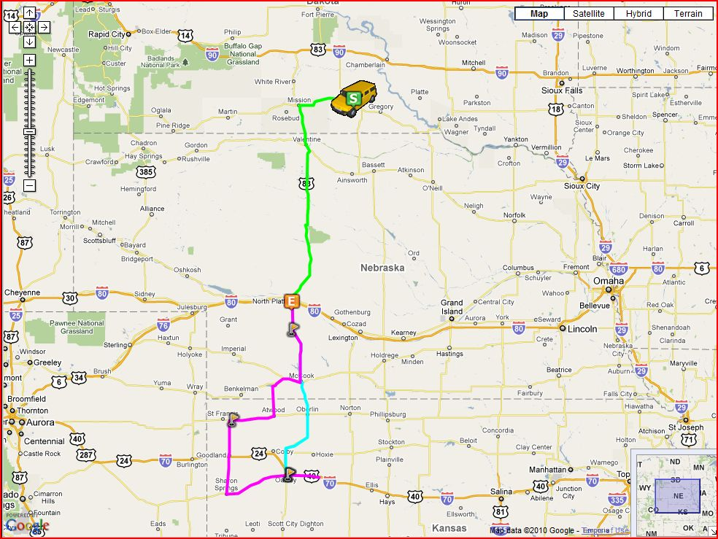

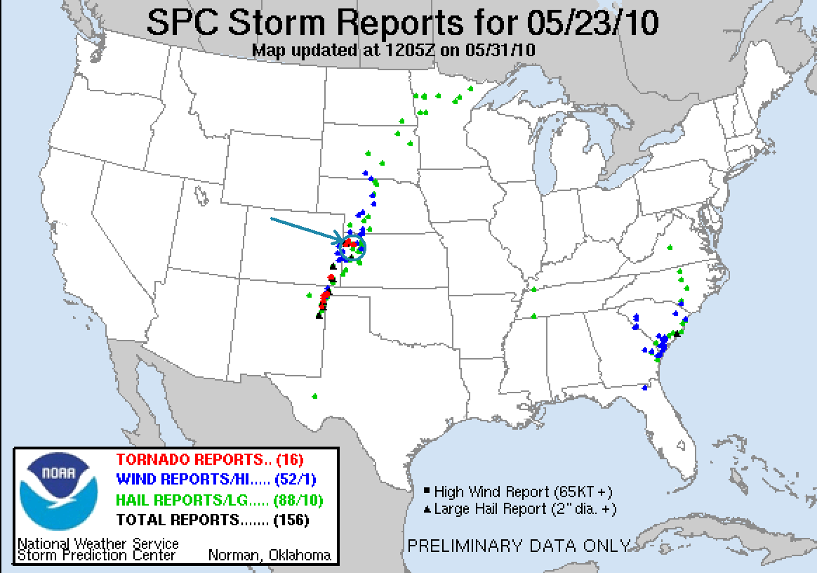
Tour 3 Day 7, May 24th 2010:
A tough chase day for us, but I guess we were due for a little disappointment.
Starting in North Platte, NE, our target was somewhere in the area west of Pierre. We knew it would be a tough chase day: very unstable with little capping, unidirectional flow which meant that the storms would line out pretty quickly, and supersonic storm motion in the range of 50-70 mph. The only way to catch a tornado today would be to place ourselves well in front of where we thought storms would initiate, and hope that they would mature and drop a tornado as they screamed by, since we'd never be able to catch up once they passed. Well, it turned out to be even earlier than we expected and by the time we got to Murdo, SD on I-90 storms were already blowing up on the warm front in our target area and along the dry line to our west. Since the warm front storms were out of reach, we bolted west towards the line of storms coming up towards Rapid City, SD, but as we got past Wall the storms had already lined out.
Meanwhile, one of the storms well to our north dropped a big tornado, but we had no way to catch it. We were about 100 miles south of the storm and it looked spectacular from a distance, but there was nothing we could do. With the warm front out of reach and the storms to our west forming a massive squall line that later would stretch all the way to Texas, we blasted back east to try and intercept a line of storms coming up from Central Nebraska. The surface winds were AMAZING, regularly gusting into to 40 mph or more and making the drive on the Interstate a white-knuckle affair.
Eventually we got off the highway at Vivian and let one of the cells from the south come to us. It looked pretty interesting as it closed on our position, but then lost focus and appeared to be losing intensity as it rocketed by at 71 mph! It seemed I turned around to talk to someone for a minute, then turned around again, and the updraft was gone to the horizon!
At this point, there were cells everywhere as the uncapped environment along with 3000+ j/kg CAPE turned every updraft into a storm. Eventually, with a squall line coming from the west, another linear system to our east, and popcorn storms to our south, we gave up and decided to head for our hotel for the night in Valentine, NE, expecting to let the squall line run us over for some fun on the way. As we drove down Rte. 83 towards Valentine, a storm got its act together for a few minutes and generated a nice wall cloud, but as we paralleled it to the east it eventually weakened and regardless we could never have kept up with it.
We finally got nailed by the squall line which had weakened considerably as we approached Mission, SD. Still we got blasted by high winds (one spotter report indicated an 87 mph gust near our position) and as we rolled through Mission saw a tree down in the road. As we continued south, we were now on the back of the squall line which appeared on radar to have re-intensified somewhat and started bowing out, and we once again got into heavy wins as the rear-inflow jet of the line cranked up.
Arriving in Valentine, NE, we headed to the Bunk House for dinner, of course. Entering town, we saw a massive tree that the wind had taken down. We ended the day getting a very, very nice surprise, the best mammatus cloud display I've seen in my 10 years of chasing.
All in all, an unsuccessful chase day, but the mammatus were a very nice consolation prize.
Miles for the day: 505. Tour total: 3878.
Day 7 Route and Storm Report:

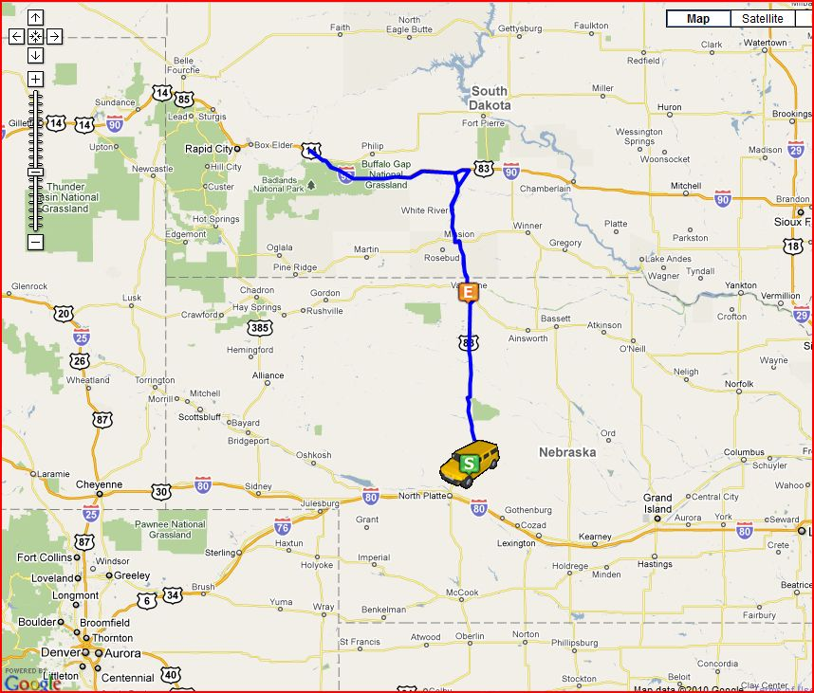
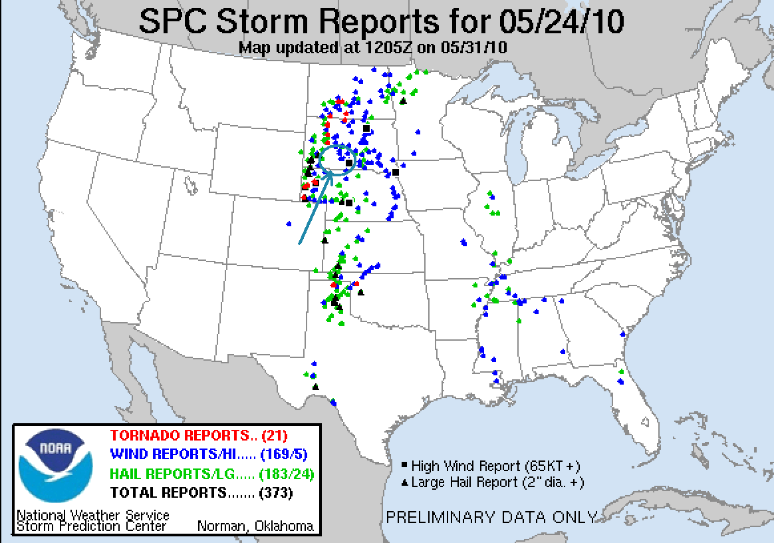
Tour 3 Day 8, May 25th 2010:
This was starting to seem a little too easy! Starting the day in Valentine, NE, we had a long way to go to get to our target area: Southwest Kansas / Southeast Colorado. The play was to watch storms develop on the dry line and then cross the stalled front into the highly unstable air to their east and go crazy.
We blasted down from Nebraska and managed to get to Scott City, KS in time for storms to start firing on the dry line along the Kansas / Colorado border. We proceeded to Garden City and then west to Lakin, then decided to head south again towards Ulysses in order to target a storm which had a reported wall cloud and had produced at least one funnel. This would end up costing us as the storm we targeted croaked, while another storm to the north near Tribune produced several landspouts that we missed as we reversed course in Syracuse and charged to the north, but couldn’t get to the storm in time. Crossing directly to the south of the meso of the now drying Tribune storm, we headed west into Colorado and turned south at Sheridan Lake to target a cell that had just been tornado warned about 80 miles to the south near Walsh, CO. The Tribune storm would much later reorganize and produce tornadoes near Gove, KD.
It seems that the forecasted 500 mb winds must not have verified, because all of the storms appeared either anchored to the dry line or barely moving. As we headed south to the Walsh storm then cut across the front of the anchored supercell by turning east at Holly, CO, to our north was a beautifully structured low precipitation supercell with a very low hanging wall cloud that should have been dying but it kept it’s act together for a while, spinning away as we drove from the northwest side of our target all the way to the southeast side without it moving much at all.
Our supercell was a nicely structured classic supercell with a broad base, but without a well defined wall cloud. We jumped south from Manter, KS and stopped to watch the structure north of Richfield while Roger took a group down a dirt road west to try and get hail for his Boeing contract. While we waited the updraft really reorganized and pretty soon there was a solid wall cloud with rapid rotation, but it couldn’t get down to the ground. The storm had beautiful structure and was highly electrified. Unfortunately, Roger couldn’t get down the road because of mud and had to come back.
This led to a really bizarre (in a good way) occurrence that shows just how lucky this tour was. We cut back across the still barely moving storm and headed southwest, again skirting the core and this time getting a little bit of hail, so that Roger could again look for big hail. After crossing back into Colorado, we stopped in Bartlett and tried to proceed down a dirt road towards Stonington, but it was too muddy, so vans 2 and 3 waited at the pavement while Roger eased his van down the road to collect hail. About this time, it started raining pretty heavily at our location as another cell coming up from the southwest began to interact with ours. Shortly after that I noticed an area to our east was spinning like a top. I mentioned it to Tom over the radio and though it looked like a meso-cyclone I was not sure what I was seeing because it didn’t make sense that it would be there. I continued to observe as the rotation got closer, and abruptly the rain stopped. At this point I was starting to think I should tell Tom that we should move a couple of hundred yards down the road just to be safe, but as it looked to me like the rotation would pass to the east I didn’t say anything. Suddenly, about 100 yards down the road, the trees started shredding and a tornado formed and whizzed across the road at an angle, passing about 50 yards from us!! I screamed for Matt to blast west and we hurried down the road with Tom’s van following, but it was obvious that the tornado had already crossed and we weren’t at risk, so we moved back up the road along with van 2, and to the north of us in the field just across the road, a big cone tornado had formed and was churning away with a big debris fan! I jumped out of the van and started snapping stills and video as the tornado gracefully slid along in the field for about 10 minutes, and then it finished with a spectacular ropeout! And we got to see it all because we just happened to be sitting there collecting hail!
Once the tornado finished, we were getting low on fuel, so we headed to Springfield, CO to gas up and then went up to Lamar where we stopped for the night.
What a crazy day!! I was more than satisfied with the structure of the LP and classic supercells to call it a successful day, but instead we ended up getting our second really close photogenic tornado of the tour!
We are now at 17 tornadoes in 6 different states and 6 tornado days for the tour, which I’m told is a record number of tornado days for an SLT tour. It was a long driving day with a total of 731 miles traveled, for a tour total of 4609 miles for the trip.

Day 8 Route and Storm Report:

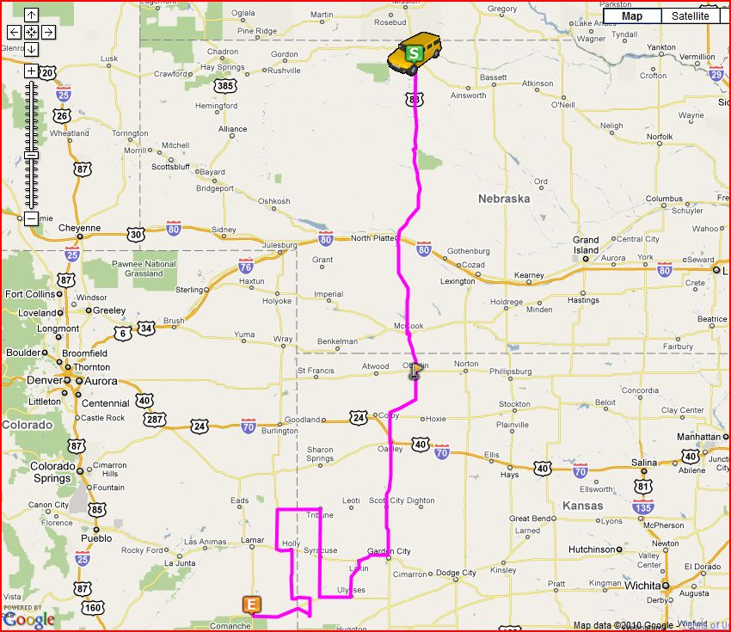
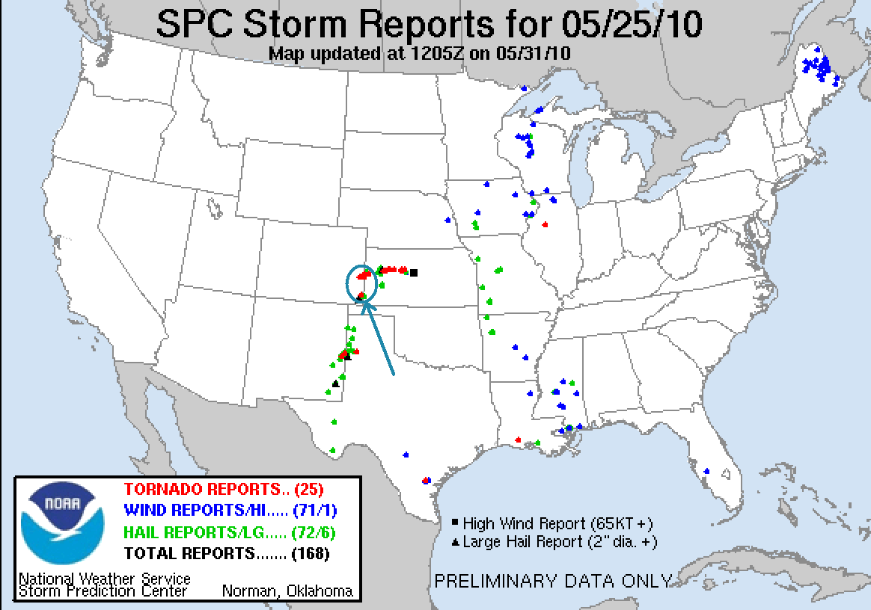

Tour 3 Day 9, May 26th 2010:
Starting the day in Lamar, CO, we expected to chase in Northeast Colorado. As we headed north up to Limon, a storm fired up near Denver and quickly got a very beefy radar signature. Before long the storm had a tornado warning right over Denver International Airport. The storm appeared to be nearly anchored and based on the hail reports was obviously a prolific hailer (later, the storm was all over TV for dropping nearly a foot of hail, some as large as baseballs, over Commerce City). We turned north at Bennett and headed towards Prospect Valley, with the storm moving only 5-10 mph so it was easy to intercept. It had a very broad base and soon produced a very nice wall cloud just northwest of our position. We watched at the storm tried to cycle wall clouds several times, and each time the inflow suddenly picked up, but the cloud base was too high and there must have been too little low level shear for the rotation to focus.
Eventually the wall cloud faded and we decided to head into the hail core to see if we could find big hail piled to the sides of the road. We drove through a small hail core not far from Keenesburg, but didn’t find too much in terms of hail on the ground. As we headed back south, another hail core opened and we stopped to get pounded by the ping-pong ball sized hail. Because of the direction of the wind, I was able to open my window and listen to them bouncing off the vans, the pavement, and everything else, which was pretty fun. After the hail abated, and after more than a couple of hail dings to the vans, we moved east of town and watched the storm slowly move towards us. The structure was very impressive with a massive soda can updraft spinning like a top, but alas the storm was too high based and other than being a prolific hailer for hours, would never come close to dropping a tornado again.
Meanwhile another good-looking storm was slowly moving north off the Palmer Divide near Agate and was soon tornado warned. After some minutes of deliberation, we decided to blow off our storm and head for it. We blasted south over dirt roads, but once we got to the storm it collapsed completely, dropping a little hail on us but that was it. At that point, we declared "show over" and headed for our hotel in Colby, KS, with a brief stop to take a look at some storms that had fired on the boundary near Denver.
Total mileage for the day was 557 miles for a tour total of 5166.

Day 9 Route and Storm Report:

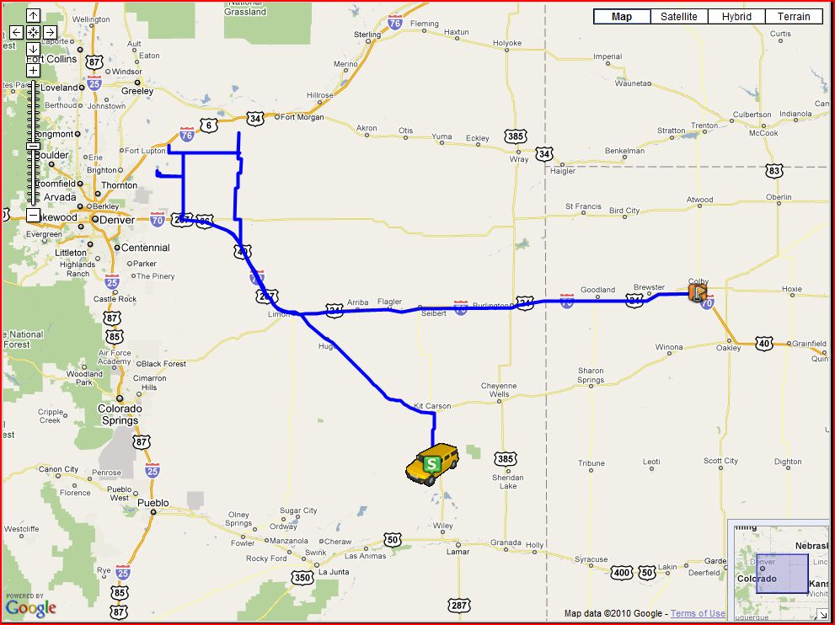

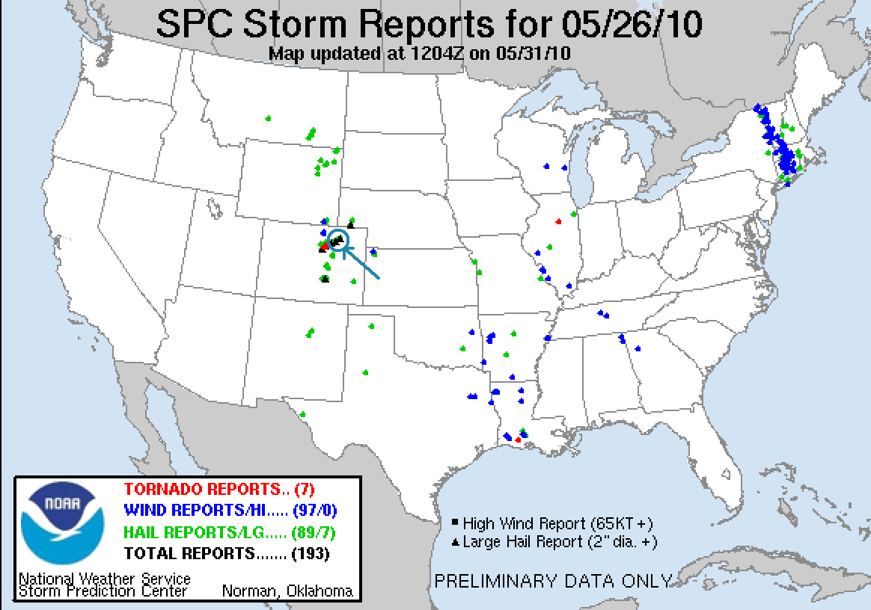
Tour 3 Day 10, May 27th 2010:
This was just a travel day from Colby back to Oklahoma City, OK.
455 miles for a final tour total of: 5621.
What a great tour! Especially with what the models were predicted about a week before:
8 out of 10 chase days,
6 tornado days
Tornadoes in 6 different states (Texas, Oklahoma,Wyoming, South Dakota, Kansas, Colorado)
17 tornadoes total.
Day 10 Route:

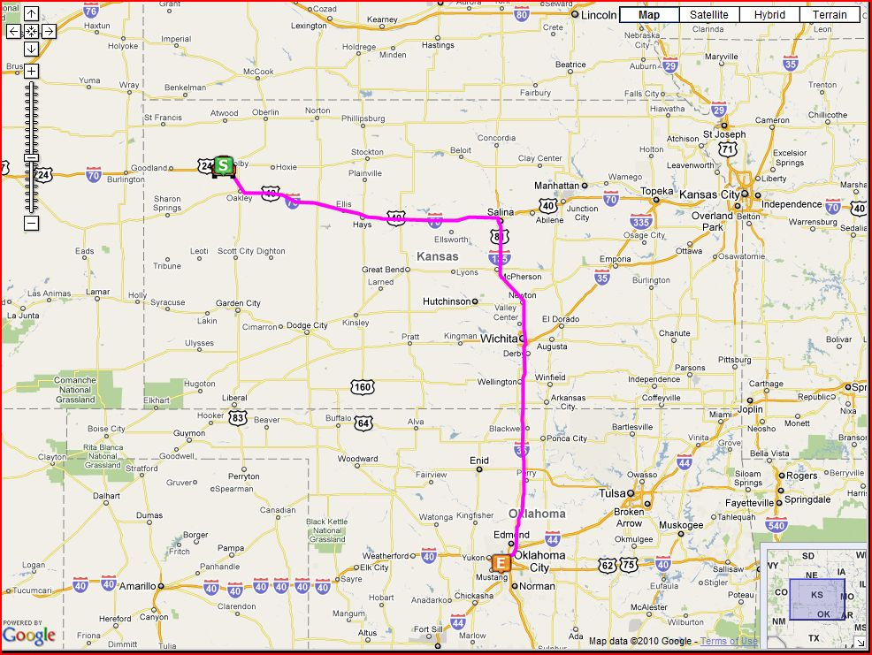

Complete Tour Route:

